Shabbos Stories for
Parshas shoftim 5777
Volume 8, Issue 53 4 Elul 5777/ August 26, 2017
Printed L’illuy nishmas Nechama bas R’ Noach, a”h

For a free subscription, please forward your request to keren18@juno.com

Better to Die Because
Of Learning Torah

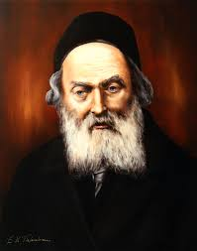
The Chofetz Chaim, zt”l

Rabbi Shlomo HaKohen, OB”M, was known as a very wise man who mastered the entire breadth of the Torah. The Chofetz Chaim knew him in his youth and told many people of how dedicated Rav Shlomo was to learn every available moment.
Between the ages of thirteen and seventeen, Rav Shlomo became mortally ill and the doctors told him to take it easy due to a weak heart, which meant “no learning.” They warned him that if he didn’t heed their word, he would die.
Rav Shlomo answered them: If I don’t learn Torah, my NOT learning will kill me, as I cannot live without it. Better to die because I learned Torah than because I didn’t learn!”
Indeed, the Chofetz Chaim would become very emotional when telling the story and would repeat Rav Shlomo’s classic refrain.
Comment: The Talmud (Shabbos 83b) writes that one should not stop learning Torah even at the hour of one’s death, which is hinted to in this week’s portion (Bamidbar 19:14). Similarly, shortly after their wedding, Rav Michel Feinstein’s wife came to speak to him. He asked her if it can wait until he was finished learning. To that, she replied, “what do you mean by ‘finished?” Paused or interrupted? Maybe. Finished? Not an option, as long as one is alive.

Reprinted from the Parshas Chukos 5777 email of the Torah Sweets Weekly.

The Power of a Small Hammer to Joyfully
Perform the Will of Hashem



Rebbe Mottel Slonimer zy'a writes (Maamar Mordechai p.342): Two tzaddikim made a pact that whoever dies first would come to his friend in a dream and tell him what happened in his judgment.
One of them was niftar, and soon afterwards, he came to his friend in a dream to reveal what happened to him in heaven. He said, "When the court reviewed my deeds, they saw that everything was perfect.
“But I had one sin, the sin of shochad (taking bribes). Because once, when I was serving as the head of the beis din, one of the parties placed money into my pocket without me knowing. For this, I was told that I would need to go to Gehinom.

Expresses His Desire
To Avoid Gehinom
“I told the court that I don’t want to go there, so they brought me to a very large building, gave me a small hammer, and said, 'Demolish this building with the hammer. When you finish, you will go to Gan Eden.'
"I was devastated. It seemed that I would be working on knocking down the building for many years. It was a very large building and I only had a small hammer to work with.
"But then I thought: Why did I wear tallis and tefillin every day, during my lifetime? Why did I study Torah and keep the mitzvos? Wasn't it because I chose to do Hashem' will? Well, right now, it is Hashem's will that I break this large building with this hammer. So why should I be upset? This is Hashem's will, and I will do it with joy – even if it would take me many years.

Raises the Hammer
With a Joyous Heart
“With a joyous heart, I raised the hammer and hit the building with all my might. The entire building collapsed, and I was swiftly brought to my place in Gan Eden."
This story reminds us that sometimes, it seems that it will take forever to achieve a certain deed, but we may discover that it can be accomplished quickly. The same will occur when we put up a fight against the yetzer hara. It seems impossible, but it isn't. It is very likely that one strong blow against the yetzer hara won't be enough, but if one is persistent, he will see that overcoming the yetzer hara and change isn't as hard as it originally seemed.

Reprinted from the Parshat Shoftim 5776 email of Torah Wellsprings: Collected Thoughts from Rabbi Elimelech Biderman.
Fundraise with Emunah
By Rabbi David Ashear

Many people spend time fundraising for worthy institutions and organizations. It is a difficult job, which can be both embarrassing and frustrating at times. It is incumbent on those who are approached to be as polite as they can be. Even if they cannot give, they should at least leave the fundraiser with encouragement, saying something like, "I'm sorry I'm not able to give at the moment. Tizkeh L'Mitzvot for your efforts. Keep up the good work! B'ezrat Hashem, I hope to be able to give another time."
Nevertheless, it does happen that people respond nastily, and fundraisers get discouraged. They must remember that they are doing the work of Hashem, enabling Torah and Chesed organizations to continue. Hashem, as always, is really the one bringing the money in. If a fundraiser tried someone and was turned down, all it means is that Hashem is going to bring the money through someone else. They should never get frustrated or hold grudges towards people. Rather, they should channel their emotions to ask Hashem for help with the next prospect.
When we do all we can, Hashem will bless our efforts. The money may not necessarily come the way we planned. Hashem has many ways and can always help, even if the situation looks very bleak. If we maintain our composure and keep a smile on our face, knowing we're doing Hashem's work, then we are an automatic success.
A Rosh Yeshiva in Israel recently told me that he had to pay the rabbis salaries and was very behind. He stayed up late for many nights making phone calls to America, seeking financial help. When payday arrived, he was still $3600 short, which was the amount owed to one of the rabbis. The Rosh Yeshiva was standing on the front porch of the Yeshiva, when that rabbi approached him to ask for his check. The Rosh Yeshiva said, "I'm sorry. I really did all I can, but I don't have the money for you right now. There is really nothing else left for me to do. I tried every contact I have. I don't know anybody else. Now it's in Hashem's hands."
Less than ten seconds later, a man from New York walked by and said, "Hi Rabbi. I have an envelope that was sent for you from someone in New York." The Rosh Yeshiva opened it and saw that it was a check for $3600. He said, "ישתבח שמו-Thank You Hashem!" and was able to pay that last salary on time.
It was very strange that he received a check from that donor, who we'll call Joe. Joe had made an annual pledge that he had just paid two weeks before. He has been giving to the Yeshiva since its inception and never gave two checks in the same year, let alone just two weeks apart.
That night, the Rosh Yeshiva's brother, who lives in New Jersey, called to ask if he received a donation from Joe. "Yes," he replied, "How did you know?" He said that he had been at a Sefer Torah dedication a few days before and took a picture in which he noticed Joe and his father in the background, both with big smiles on their faces.
The Rosh Yeshiva's brother was friends with Joe and knew how much Joe enjoyed seeing his father happy. So he sent him the picture with a note, "Your father looks so happy. Enjoy it."
Joe was touched and replied, "What's the name of your brother's Yeshiva in Israel again? I'm going to send him a donation." From that, he sent the exact amount which arrived at the exact second it was needed.
Hashem has many ways to help. We should do our part with joy, never getting frustrated or upset, and continue to pray to Hashem to send us the help we need to do His holy work.

Reprinted from the August 17, 2017 email of Emunah Dailey

The Blindfolding of
The Chozeh of Lublin

The Chozeh of Lublin, O”BM, wished to avoid seeing unholy sights in the streets of his town, so he decided that he would wear a blindfold whenever he walked home from the Beis Medrash (house of study). He continued this practice for seven years.
After that time, the Chozeh removed the blindfold and found that he had been blessed with a miraculous gift of far-reaching sight, with which he was able to see things that were happening many miles away from him.
A certain chassid (follower of the Rebbe), who lived in the same town as the Chozeh, also wished to possess this miraculous ability. He, too, adopted the practice of blindfolding himself when he left his home until he was safely inside the Beis Medrash.
At the end of the seven years, when the chassid removed the covering from his eyes, he was sorely disappointed. Not only had he NOT been blessed with a special sight, but because he had worn the blindfold for seven years, his vision had deteriorated.
The chassid ran to the Chozeh and cried, “I did exactly what the Rebbe did. I didn’t look at the streets of the world for seven years. Why have I not received the Rebbe’s miraculous gift of sight and my vision got worse?”
The Chozeh smiled sadly and gently told the Chassid “The reason you covered your eyes was in order to see, whereas my reason was in order NOT to see.”
Comment: As we embark on the process of self-evaluation this coming week with the onset of Elul, we will attempt to feature stories and insights that assist us in reflecting on our character and behavior. The first idea to think about: When we perform a Mitzvah, are we thinking about what its meant to refine in us, or using it for selfish ends?
For example, we know the teaching (Talmud, Bava Kamma 92a) that “he who prays for another is answered first.” However, people who mainly pray for others with a selfish intention, are abusing this teaching and are not in a good position to have it fulfilled.
It would be wise to make a list of five Mitzvos we do but don’t feel great about and dissect what’s driving us to do them. Sometimes, we will find we have missed the point of the Mitzvah entirely and must reboot. (Story from Rabbi Dovid Goldwasser.)

Reprinted from the Parshat Re’eh 5777 email of Torah Sweets Weekly.

A Second Chance at Life

I read a story recently that is told by a young man visiting Israel back in August 2001, which can be a very important wake-up call for all of us as we enter the month of Elul and prepare ourselves for Teshuvah.
“I was working in a summer camp in Israel for my third summer in a row, and Thursdays were usually the day that I’d be with our cab driver from morning to night, running all over Jerusalem doing errands.
Every time we passed through the center of town around lunchtime, the driver would pull up onto the curb on the corner of Yafo and King George, and I would run into Sbarros to grab him a slice of spinach pizza and a diet coke. I’d bring it back into the car for him, and we’d continue on our way.
Thursday August 9th, 2001 started off no different. As I was crossing Yafo Street about to enter Sbarros Pizza, the driver, for no reason whatsoever, ran across the street from where he was waiting for me with his car, grabbed me by the shirt, and told me not to bother going in. He decided that we were too pressed for time and that he was not in the mood for pizza.

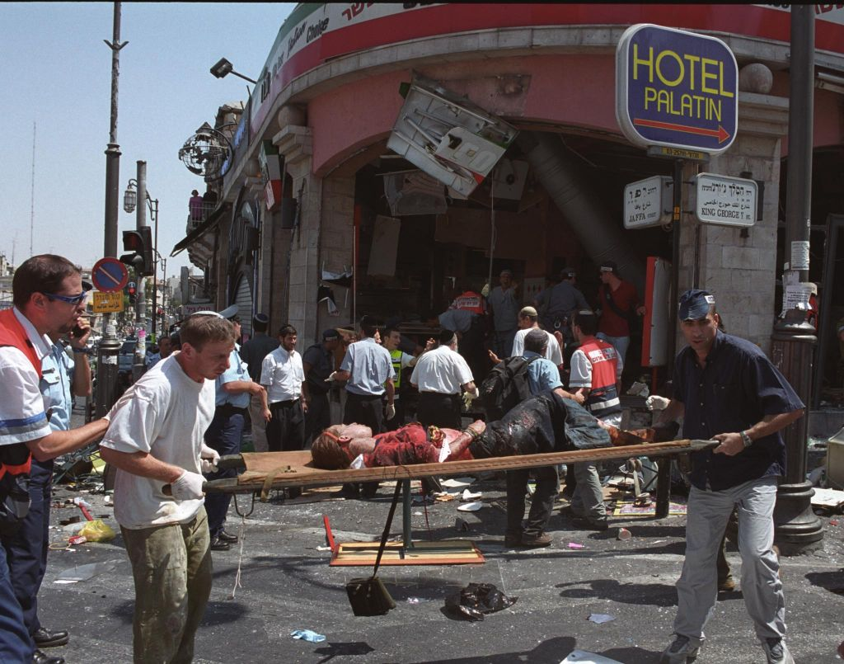
Rescuers trying to save lives of victims of the terrorists bombing of Sbarros.

That had NEVER happened before. Standing in the middle of the street, I argued with him. I told him it’ll only take me two minutes. Finally, as the light was about to change, I gave in. I crossed back with him and got into his car. We made a right turn onto Strauss towards Geulah, and as we approached the first traffic light (by Bikur Cholim Hospital), we heard a huge explosion.
Just 90 seconds after I was about to walk into Sbarros, a terrorist detonated a bomb injuring 130 people and claiming the lives of 15 innocent men, women and children. There is no way to explain what happened on that day or how I still feel about it up to this day. I thank G-d for sparing me and for giving me a second chance at life.
While I’m FAR from being perfect, I hope that I have done things over the years to make G-d feel that it was worth it. Sometimes, we can easily see G-d’s hand. Other times, as it must be for those who were injured or for those who lost loved ones on that day, we are left not knowing. We are left without answers. We are left grappling for faith in the dark. I am certain about one thing though: G-d is great and every day of life is a gift. August 9th is my annual reminder of my commitment to being a good Jew and to making G-d proud of me.”

Reprinted from the Parshat Re’eh 5777 email of Jack E. Rahmey with the Guidance and Teachings of Rabbi Amram Sananes

The Miser and the Dead Man
By Elchonon Isaacs

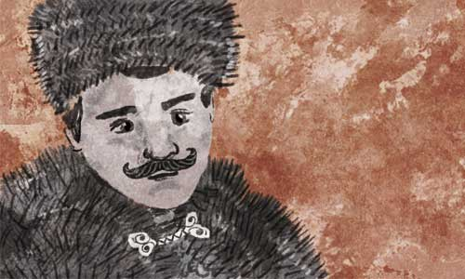

Pinchas was a humble lumber merchant. With time, his business flourished and he became a wealthy man. At first, the community was pleased with the progress he had made, as his success was good for the financial needs of the community. But little by little, Pinchas began to alienate himself from the community and their needs.
The time came when Pinchas no longer felt comfortable living in the Jewish community, and he moved to the other side of town where he built himself a large, well-guarded mansion.
His new choice of residence curtailed his giving of charity even more. At first, if someone knocked on the door, they’d receive a small sum. But soon enough, his donations dwindled, until they ceased completely. The administrators of the community funds removed his name from their lists of potential benefactors.
It happened one frigid night that a passerby noticed the mezuzah on Pinchas’s door and knocked. Luckily for the traveler, Pinchas was not home and the butler, feeling sorry for him, let him in.
The guest soon recovered from the cold, and the butler promptly told him about his boss’s history and character. He suggested that he find other accommodations, as his master did not like guests.
As they were talking, they heard a carriage pull up, and in walked Pinchas, wrapped in his fur coat. His reaction to the guest was quick. “What is this? A soup kitchen?! Get out of here now!” he shouted.
The next day, news spread that a stranger had died on the streets not far from Pinchas’s mansion. The story did not move Pinchas in the slightest. He knew who the person was, but he did not let it bother him.
That night, he had a dream. Two robust men broke into his house and began dragging him, saying, “Come with us.”
Pinchas asked in surprise, “Where are we going?”
“To a court case held by Rabbi Mordechai Shraga Friedman, the tzaddik[righteous person] and rebbe of Husyatin in Ukraine.”
“But why?” Pinchas asked.
“Everything will be known to you at the right time,” they answered bluntly.
He soon found himself in a large yard surrounding a beautiful house. At first he was intrigued by the scene, but when he was brought inside to a packed room, fear began to overtake him as he heard the masses call out that a path be made for the chief judge, the Rebbe of Husyatin. The rebbe entered and took his seat in between two other judges who were already waiting.
Pinchas immediately recognized the plaintiff; it was the poor traveler from the previous night. The dead man began his accusation by recounting how hungry and weak he was when he stood at the door of the mansion, while Pinchas stood there still as a stone and ignored his pleading.
The man outlined the last few minutes of his life after he was thrown out, including all the grim details. “My last ounce of energy left me, and there was no salvation for me. After many days of existing on an empty stomach, my hunger and the bitter cold did me in.”
“Do you have anything to say in your defense?” asked the rebbe.
Pinchas was silent. For the first time he felt remorse and was embarrassed of his actions.
After deliberating with the other judges, the rebbe turned to Pinchas and said, “You should sell your property and divide it in two. One half you should give to the widow of the poor man, and the other half you should keep for your family. If you agree to this sentence, change your ways and open your doors to anyone who is poor your soul will have a tikkun (rectification).”
Pinchas woke up soaked in a sweat. He tried to ignore the dream, pushing it out of his mind. But it kept coming back. It gave him no rest until he decided to travel to Husyatin.
When he arrived at the rebbe’s house in Husyatin, his heart started pounding. He remembered the courtyard and the structure of the house from his dream! His knees were shaking as he walked into the study hall; it all looked exactly like the courtroom from his dream.
A large crowd was listening to a discourse that was being given by the rebbe. Under the cover of the crowd, Pinchas became more confident, and he tried to get a peek at the tzaddik. There was no doubt this was the chief judge from his dream.
Suddenly, a narrow path cleared. Pinchas didn’t understand the movement of the rebbe’s finger, gesturing for him to come forward. Those standing near him said, “The rebbe is summoning you.”
Pinchas felt faint. With shaky legs, he made his way up to the rebbe and came face to face with the tzaddik who said sharply, “Remember to follow the verdict and you will merit a tikkun.”
At that moment, Pinchas passed out. And when he came to, he was a changed man. Pinchas knew with absolute certainty that he would do as he was told. He was filled with deep remorse, and wanted to correct his wicked ways and return to his community.

Reprinted from the Parshat Re’eh 5777 email of Chabad.Org Magazine. (Translated and adapted from Sichat Hashavuah 607.)
The Rav of Lodz and the Stingy Wealthy Man
By Rabbi Ozer Alport



Rabbi Eliyahu Chaim Meisels, the Rav of Lodz in Poland, was renowned for his concern for the poor and downtrodden. On one fierce winter day, he knocked on the door of a wealthy, but stingy, man in his town to solicit a donation.
After exchanging greetings, the man gestured that Rabbi Meisels should enter, but he remained outside and began his appeal. The rich man was puzzled by the rabbi's behavior, but he attempted to listen out of respect. After a few minutes he grew so cold that he was unable to continue. He interrupted the rabbi and begged him to come inside.
The sagacious rabbi explained, "I am here to collect money for a family which can't even afford to build a fire on a day like today. If we enter your warm home, you won't be able to relate to their suffering. Only by discussing their plight here at your door are you able to understand the magnitude of their pain." Appreciating both the rabbi's wisdom as well as the extent of the family's anguish, the miser gave a generous donation.
It is difficult for most of us to relate to the daily suffering that many unfortunately know. Now that we understand that empathizing with their plights is an integral part of giving tzedakah, we should try our utmost, whether by volunteering at a soup kitchen or by walking through the park on a bitter winter night, to work on personally experiencing and feeling their pain. Our desire to generously assist them will naturally follow, and in so doing, we will be helping not only the poor but also ourselves.

Reprinted from the Parshas Re’eh 5777 email of Shabbos Candle Lighting.

The Trustworthiness of
Rabbi Yisrael Salanter
By Rabbi Raymond Beyda

Rabbi Yisrael Salanter was one of the giants of European Jewry 150 years ago. He is known as the one who popularized the study of mussar “ Jewish ethics to the Torah Jew. One time he entered a shul in a town where he was not known.
A man in the shul approached him and revealed that he was having guests and requested that Rav Yisrael do the shehitah, the complex ritual slaughtering required to make the chickens he wanted to serve kosher. The Rabbi asked that the would-be host wait until the next day before he would respond.
The next day before the man could ask for his decision Rav Yisrael asked the man: “Could you lend me 50,000 rubles?”
“50,000 rubles”, the man screeched in response, “I hardly know you. How do I know I could trust you for such a large loan?”
“You don’t know me? You seem to know me well enough to trust my skill at slaughtering your chickens. You, therefore, certainly should trust me with your money”, was the wise man’s quick rebuttal.

Reprinted from the Parshas Re’eh 5777 email of Shabbos Candle Lighting.

The Transformation of Rav Yehuda Laib Chasman
By Rabbi Mordechai Kamenetzky

Rav Yehuda Laib Chasman was considered to be one of the luminaries of the mussar movement. Before he immersed himself completely in the world of Torah and mussar, he had a business that sold flour to bakers.
He would devote a portion of his day to his business and the remaining time he would spend at the famed Talmud Torah of Kelm under the tutelage of Rabbi Simcha Zissel Ziv, the illustrious Alter of Kelm.
One day on the way into the Yeshiva, Rav Ziv called Reb Yehuda Laib over to the side and pointed to the white powder that covered the sleeve of his jacket. Rabbi Chasman took this observation to be a clear moralistic evaluation.
Rabbi Ziv is pointing out that the flour is becoming part of me. If it is already all over my garments, and it is still with me when I leave my store, then it has become too much a part of me.
With that, he made a personal decision that changed his life completely. He returned home, and figured out together with his wife that the amount of their current assets would more than cover any outstanding debts and allow them to sustain themselves. They sold the business, and Rabbi Chasman enrolled full-time at the Volozhiner Yeshiva, eventually emerging the great luminary whom we all revere.

Reprinted from the Parshas Re’eh 5777 email of Shabbos Candle Lighting.

The Crystal Bell:
It's An Old Story.

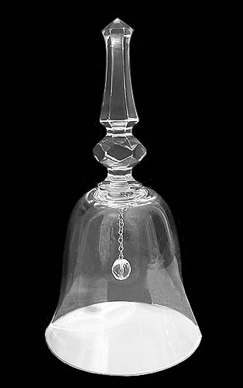

A poor beggar goes from house to house collecting alms for his impoverished family. Knocking on the door of one glorious home, he is greeted graciously, given some money, and encouraged to join the family for supper.
At dinner, other beggars and wayfarers sup at the wealthy family's expansive table.
For each course, from appetizers to dessert, the host rings a crystal bell and waiters appear with delectable delights. Our beggar is totally amazed that simply by jingling a small bell, such lavish results can be achieved.
At the end of the meal the host offers the guests anything they want from amongst his many possessions. Our poor beggar asks for the wonderful crystal bell.
Arriving home, the beggar asks his wife to set their tiny table.
"But we have no food to eat. I was waiting for you to return before I went to buy some beets and potatoes."
"Just set the table, my dear. And leave all the rest to me," said the beggar confidently. "I have a surprise for you."
So the wife dutifully set the table and seated herself and all of the children around it.
Our beggar sat down and slowly and carefully unwrapped the crystal bell that had been in his pocket.
Boldly, he rang the bell and waited. Nothing happened. He rang the bell again and waited. Again nothing happened. He continued ringing, until he was afraid that the crystal bell would break.
"What are you doing?" his wife asked him.
The husband proceeded to describe what had happened in the wealthy man's house and how each time the bell was rung luscious food was served.
"My dear husband," the woman said patiently, "the bell works only for those who have labored in advance so that they have something to serve. Your wealthy host worked hard to earn the money to hire workers who purchase and prepare the food. It is only after a tremendous amount of energy is invested that there such an amazing result is achieved. Nothing comes without toil."
It's comparable to young children who, accustomed to seeing their parents using credit cards, paypal or square cash, are told by their parents when they want an expensive toy: "We don't have any money right now."
"Well, just take out your phone," is the inevitable and childishly logical retort of the naive youngster.
The parent patiently explains, "You can't take money out unless you first put money in."
Nothing comes without toil; you can't take something out unless you put it in first.
What is true for a lavish meal or money is certainly true of Judaism.
If we want our children to appreciate and value their Jewish traditions, we have to work assiduously at developing that appreciation by surrounding them with Jewish traditions.
If we want to feel close to our Creator, we have to enhance our relationship with G-d through prayer and mitzvot.
If we want to better understand our purpose in life as individuals and as a people, we have to study Torah and Jewish philosophy.
We have to put effort in if we want to get something back. As the Talmud teaches, "According to the labor is the reward."

Reprinted from the Parshat Matos-Masei 5777 issue of L’Chaim Weekly, a publication of the Lubavitch Youth Organization in Brooklyn, NY.

