SUPPLEMENTARY Stories
For Parshas Nitzavim-vayeilech 5777
Printed L’illuy nishmas Nechama bas R’ Noach, a”h
Vol. 1, Issue #15 (Whole Number #15) 25 Elul 5777/Sept. 16 2017

For a free copy, please forward your request to keren18@juno.com

Story #977

Hospitality Repercussions
By Dovid Sholom Pape
From the desk of Yerachmiel Tilles
editor@ascentofsafed.com

When Avraham and Sara were informed by G-d that they were going to be blessed with a child in their old age, they were in the midst of performing the Mitzvah of Hachnassat Orchim--Taking care of guests.
This demonstrates that the Mitzvah of taking care of guests has an essential connection with our lives as Jews, because the child that was born became the father of the whole Jewish people, including every one of us.
Let me share with you a story that happened in 1977. My wife and I were then with Chabad in Buffalo.
As in most cities in America today, in Buffalo there are no more corner stores. If you need to do some shopping, you have to go to the mall. And so, one day, my wife and I got in the car to go to Wegman’s, a large supermarket.
A lot of people pass through Buffalo on their way to Niagara Falls, or other places in Canada. Often they call Chabad and ask if there is a place where they can stay for Shabbos. This happens a lot. I remember when I lived in London that it was the same. People were always passing through on their way to other destinations, and needed a place to stay for a day or two.
Just that morning, some people had complained about this kind of behavior. They felt that it wasn’t right; people were just taking advantage, and instead of hosting them, we should just direct them to the nearest hotel.
I mentioned this conversation to my wife, and said that it didn’t seem right to me. After all, why were we in Buffalo if not to be of help to others? Wasn’t that why the Rebbe had sent us?
We had hardly gone two or three minutes, when I noticed that we needed gas, and turned into the gas station on the corner.
As I got out to open the gas tank, a man in his fifties got out of his car and began walking towards me. I noticed that he reached in his back pocket and pulled out a yarmulke.
“Shalom,” he greeted me with a smile. “Do you know where I can find a hotel?”
I could tell from his accent that he was Israeli.
“Dear G-d,” I said to myself. Are you testing me? I just finished talking to my wife about this.”
“Just a minute,” I replied, turning back to speak to my wife again.
Rabbi Dworkin [the deceased former chief rabbinical authority of Crown Heights - YT] used to say that a husband shouldn’t bring guests home without permission from his wife, and vice versa.
“Shulamit,” I said, “this man just asked me where he could find a hotel. Can we invite him to stay with us?”
“Absolutely,” she agreed at once.
I turned back to him. “Why don’t you come and stay with us?” I said.
“Oh no, we couldn’t do that,” he said. “That’s very kind of you, but there are five of us. We couldn’t all stay with you. Please just tell me where there is a hotel. We only need to stay one night.”
“Just a minute,” I said, laughing to myself. “G-d, are You upping the stakes?”
I turned back to my wife. “He’s says there are five of them. Can we handle that?”
“Not a problem,” she replied.
Well, it took some convincing to get him to agree, but in the end he did agree, and we turned around and brought the whole lot back to our apartment. We only had two bedrooms, but with a couch and two cots, it worked out fine. One of them had an aunt who lived nearby. And one of them slept on a blanket on the carpet.
What should I say? They were the nicest people. We had a wonderful time together. They were all musicians on their way to perform a concert in Toronto for Yom Ha-Atzme’ut, a father, and two sons, a son-in-law, and a drummer. We talked and talked till the wee hours, late at night. They were full of questions about the Lubavitcher Rebbe, and were thirsty to hear stories about him.
I remember telling them an amazing story I had heard from Rabbi Nachman Sudak [the chief emissary of the Lubavitcher Rebbe to England, now deceased --YT] about Arik Sharon and the Rebbe before the Yom Kippur war. And how, when General Sharon came out of his private audience with the Rebbe, he said to the yeshiva students standing there, “Boys, as great as you think your Rebbe is, you don’t know even a bit of what he really is.”
The next day we all got up early and went to the Chabad House for the morning prayers. They helped make the quorum of 10, and everyone was grateful for that. When we came back for breakfast, the father went out and bought a tricycle at a garage sale for our 2 year old son. During the Blessings-After-a-Meal, they added in a lot of personal blessings for us, and especially for my wife who was in her seventh month.
It was a wonderful experience. We parted on the best of terms.

Six months later I came to New York to be at the big farbrengen for the Chasidic festival of Yud-Tes Kislev. As I stood there, waiting for the farbrengen to start, I felt a tap on my shoulder. It was the younger brother.
“Do you remember me?” he said. “I live here in Crown Heights now! Yes. I started learning in the Yeshiva [for those without a strong Torah background--YT] Hadar HaTorah. My brother is in Queens, and all the family are getting more involved in Judaism! All because of the night we spent in your house.”
After that, Baruch Hashem, their lives developed in a very positive way as they became more and more involved with Chabad and the Rebbe, eventually getting married, and having families.
We remained best of friends till the present day.
In their careers as musicians, they met with great success, and their relationship with Chabad and the Rebbe played a very important role, and has had a powerful influence on Jewish music. Every year on [the intermediate days of the festival of] Sukkot, thousands upon thousands of people rejoice and dance to the joyous music of Yosi & Avi Piamenta.

Piamenta Brothers in concert Yosi on electric guitar and Avi playing his power flute.
That’s their story. It all started from the mitzvah of hospitality.
For many years, Avi has asked me to write it up. I thought this week [of the Torah reading that features the mitzvah of hospitality, and only a few weeks after Yosi’s passing --YT] it would be appropriate.
Source: Adapted and supplemented by Yerachmiel Tilles from a Nov. 2015 weekly mailing of Rabbi Dovid-Sholom Pape, editor of The Moshiach Times -- a weekly children’s magazine, to his personal list.
Editor’s note: Yosi Piamenta was known for introducing the electric guitar to Jewish music. He was widely acknowledged by rock critics, including Rolling Stone, as a guitar virtuoso.
Connections: 1) Elul 8 (this year: Sept 11!) is the first yahrzeit of Yosi Piamenta (November 29, 1951 August 23, 2015). 2) Taking place in Tsfat this week is its 29thannual 3-day Klezmer Music Festival, at which in previous years the Piementa Brothers occasionally played (and at ASCENT afterwards!)

Reprinted from the Parshas Va’eschanan 5776 email of KabbalaOnline.org, a project of Ascent Institute in Safed, Israel.
Hank Greenberg’s
30th Yahrzeit
By Irwin Cohen

Time flies.
It was some 30 years ago – September 4, 1986. I was sitting in my Tiger Stadium office when the call came.
“Hank Greenberg died,” the voice on the other end said. It was the first of several calls from media types wanting reaction to the news.
I never saw Greenberg play; his last season in Detroit was in 1946 and the following year he ended his playing career with the Pittsburgh Pirates.
Greenberg became the regular first baseman for the Tigers early in the 1933 season, the same year Franklin Delano Roosevelt became president and Hitler took over in Germany. For the rest of the 1930s and into the next decade, Greenberg was a source of nachas to the American Jewish community while it anguished over the fate of Europe’s Jews.
Throughout the years I met many older women who didn’t know or care much about baseball but who attended Tigers games just to see and root for Greenberg. The tall, handsome, charismatic ballplayer topped several polls during his playing days as the most heroic figure among Jews in America.

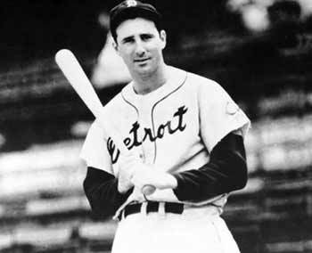
Hank Greenberg

I met Hank Greenberg for the first time in 1983, when he was 72. His hair was thinner and he looked pretty close to his playing weight. It was a beautiful June Sunday and the Tigers had scheduled a ceremony to retire his uniform number between games of a doubleheader.
I wasn’t working for the Tigers yet and was known in the baseball world as a writer and photographer. I was granted time to interview the legendary Greenberg and invited to be on the field between games to take photos of the proceedings. It was the most memorable day of my time in baseball.
I started working for the Tigers the following year. It was a great year for me as well as for the team and the city as the Tigers rolled through the regular season and won the World Series.
Greenberg was invited to throw out the first pitch prior to one of the Series games in Detroit but begged off. He wanted to come but was deeply concerned about spasms in his back and legs that affected his gait. The doctors couldn’t figure out the cause and the problem worsened as the calendar turned to 1985. Hank had a burning sensation in his stomach and trouble eating. He lost weight. Tests eventually revealed a tumor on one of his kidneys. Now Greenberg had a word for his health problems – cancer.
Hank had a kidney removed, began light workouts, and started to gain back some weight. His wife saw to it that he had the best care available and respected her famous husband’s wishes to keep his condition from all, including their inner social circle.
The situation worsened after Hank turned 75 on the first day of 1986. He needed crutches just to get around his house. Eventually he became completely bedridden.
The end came on September 4, when Hank didn’t wake up.
He was a great personality and a great ballplayer – certainly the greatest Jewish player of all time.
Greenberg posted a .313 career batting average with 331 home runs despite missing four and a half seasons to military service. If you add bases on balls to his hits, his average would be .410. Translation: was on base 41 times out of a hundred.
Compare those stats to Joe DiMaggio’s. DiMag had a career .325 average and hit 361 home runs, but he had 1,628 more career at-bats than Greenberg. Even with more career at-bats than Greenberg, he walked less (790 to Greenberg’s 852) and Joltin’ Joe’s on base percentage was .395, 25 points less than Hank’s.
Greenberg also bested DiMaggio in the long ball department as he homered every 15.69 at-bat while the Yankee Clipper managed a round-tripper ever 18.89 times at the plate.
Let’s remember Hank Greenberg’s yahrzeit, the 30th of Av, which falls this year on Sept. 3.

Irwin Cohen
About the Author: Author, columnist, and public speaker Irwin Cohen headed a national baseball publication for five years and worked for a major league team, becoming the first Orthodox Jew to earn a World Series ring. His column appears the second week of each month. He can be reached in his suburban Detroit area dugout at irdav@sbcglobal.net

Reprinted from the August 10, 2016 email of the Jewish Press.

One Home. One Heart
By Ramona Freedman

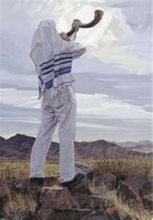

Certain things come easy. It’s not hard to love chocolate. It’s not a stretch to take the proverbial road less travelled given half a chance. And it sure isn’t a problem to enjoy the odd swill of a quality red. When it comes to Jews, wherever we are around the planet … the honest truth is it ain’t hard to be a Zionist.
It makes so much sense. There we were, sporadic, nomadic, dotted across this big, wide world. Friends came and went, our foes never really more than a stone’s throw away. Centuries go by, we succeed, and we are dispersed. We are beaten. We keep quiet. It rapidly turns into a nightmare. Our families are targeted, murdered. Darkness descends.
And miraculously (seriously, how else?) the blessed State of Israel is born. And we fall in love with our baby. We want to feed it, nurture it. Call us armchair Zionists, call us what you will! From all corners of the globe we send money, supplies, Aussie gum tree saplings! We kiss the ancient outer walls of the Kotel. We thank G-d, we cry, we rejoice.
Against this backdrop, sitting in the Diaspora, we are fierce in our loyalty.
Picture this: Teenage girl with big 1980s hair. Attends Zionist youth group. First generation Australian. Older relatives traumatised from the horrors of World War II. Passionately Zionist. Devotedly carries a photo of Israeli soccer team players in her wallet!
Her entire crew went to Israel after high school. She didn’t. She walked into university at age 17 and got busy. Heads down, and all that … other opportunities came her way. She got married, became a mum, and was thrown into a chaotic internal war against an enemy within: Breast Cancer. She won! And the rebuilding began.
Nineteen-and-a-half years go by since her last visit to Israel. And through an academic opportunity with her (clever, impressive) daughter, she finds herself en route once more. She boards El Al, she can’t stop crying. This passion, this love, this longing had inadvertently, inexplicably, unconsciously been suppressed. A true connectedness emerged. She pulled her primary school Hebrew from the dusty recesses of her mind. She landed.
And the tears didn’t stop flowing (cynics may say … well, anyone would bawl after travelling for such a stupid amount of time only to arrive at 2am with no luggage). She knew better. She had come home. And she was absorbing it all. The last time she’d stepped on this hallowed ground, she’d been young, before life knocked her around … just a little.
Israel. Standing at the Kotel, head on ancient stones, note earnestly written to Hashem. The power of prayer. She ate every kosher delicacy conceivable! Absorbing all with her family. Meeting kind relatives who hadn’t seen her in two decades. She was home. How did she know? Her heart was full. Ironically, on the recently declared ‘Day of Rage’, she was at peace.
She slid along the slippery well-worn stones of the Old City, sipping freshly squeezed ruby red grapefruit juice. And she couldn’t be happier. Too many of us prioritise seeing other lands. That’s all well and good.
Find a way to visit the land of Milk and Honey – enjoy those kosher Magnums (such a treat for us Aussies!) and Soak.It.Up! You will cry to leave Israel. It has my unashamedly Zionistic heart. So start planning that next trip … actually, let’s all just make Aliyah already!
Be’shana Habah b’Yerushalayim!

Ramona Freedman is the Author of “Moving Home: My Path to Jewish Observance” & Director of Kesher Communications.

With a Jewish Mayor and Thriving Community, Anchorage Explores Its Roots
By Faygie Levy Holt

Alaska museum turns its attention to the state's early Jewish settlers

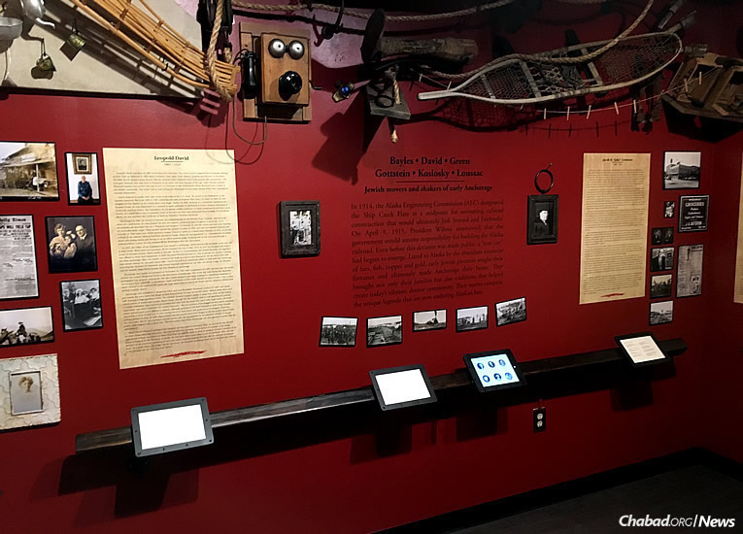
The second permanent exhibit at the Alaska Jewish Museum, titled “Jewish Movers and Shakers in Early Anchorage,” displays the lives of six families who lived in Anchorage in the early 1900s (Photo: Lisa J. Siefert)
Summer means a few things in Alaska: the earth peeks out beneath the snow, the days become extremely long, and cruise ship after cruise ship arrives with tourists from around the world for seasonal, historical and nature-related trips.
For many visitors, the Alaska Jewish Museum has become a must-see stop when in Anchorage. Founded in 2013 under the auspices of Chabad of Alaska, the Jewish museum now has two permanent exhibits, with a third in the works.

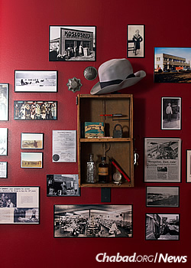
With the success of two exhibits, a third is in the works, slated to open in 2017. (Photo: Lisa J. Siefert)

The first exhibit “On Wings of Eagles: Alaska’s Contribution to Operation Magic Carpet,” focuses on the heroic efforts of Alaska Airlines pilots in bringing Jews from Yemen to Israel from 1948-1950. The second exhibit, which opened earlier this year, focuses on an even earlier time period—the Jewish residents of Anchorage in the early 20th century.
“Visitors are not only surprised that there were Jews in Anchorage at the turn of the 20th century, but that Jews were here even before the sale of the Alaskan territory to the United States in 1867,” says museum curator Leslie Fried.
“Jewish Movers and Shakers in Early Anchorage” displays the lives of six families—the Bayles, David, Koslosky, Gottstein, Green and Loussac families—who lived in Anchorage in the early 1900s. It features photographs, audio testimonies from family members, diary entries, newspaper clippings and personal artifacts.
“It gives a little historical view of Alaska—that the Jews are not recent arrivals. They are part of the history of Alaska, part of the fundamental pioneering picture of Alaska,” says Perry Green, whose father, David Green, was one of the Jewish founders of Anchorage. “Jews have been aviators and storekeepers, dog-runners and postmasters. Many of the small villages have roots with Jewish traders.”

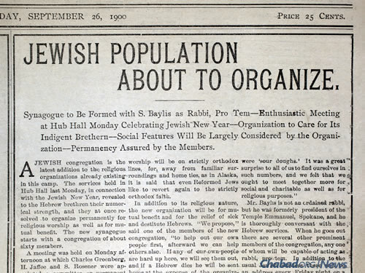
A Sept. 26, 1900 article reports a synagogue forming in Anchorage, an organization to care for the indigent and plans for the High Holidays. (Photo courtesy of Sandy Harper)
Green, who also contributed an oral history to the exhibit, adds that the museum display shows that “Jews have always been community-minded, and that it was a very open and loving community.”
Like many who came to Alaska at that time, the Jewish pioneers featured in the exhibit came to Alaska seeking prosperity and business opportunity. Some worked in the fur trade; others opened shops and banks. They were active in building their future homes and city. One of those early residents, Leopold David, even served as the first mayor of Anchorage.
Early Jewish residents in Anchorage didn’t have a formal shul or even a rabbi. Events were hosted in storefronts or private homes, with the Bayles family arranging to have a Torah scroll brought to the city. (Another Bayles family member brought a Torah to Fairbanks as well.)
Rabbi Yosef Greenberg, co-director of the Lubavitch Jewish Center of Alaska with his wife, Esther—Chabad-Lubavitch emissaries who have served Jews in the state for 25 years now—emphasizes that the six featured families represent more than just a pioneering spirit.

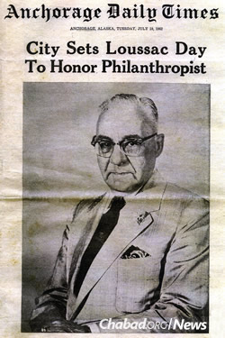
July 10, 1962: Anchorage sets a day to honor philanthropist Zachariah Joshua Loussac, who served as the city’s mayor from 1948 to 1951. (Photo courtesy of Sandy Harper)

“When Anchorage was a little town of less than 2,000 people and the Jewish community was almost nonexistent, these families came here and became active members of the city,” he explains. “They were deeply connected to their Judaism.”
Loussac, for instance, was not only a businessman; like David and Bayles before him, he became mayor of Anchorage. Greenberg notes that “he created a foundation in Anchorage for education and gave away half of his money. Loussac helped build the biggest library in Anchorage. Everyone knows his name.”
The rabbi adds that timing of the exhibit is perfect: The current mayor of Anchorage, elected last year, is also Jewish. “The exhibit really shows what the Jews did and have done for Alaska, and it’s amazing how the circle has come around with our current mayor, Ethan Berkowitz.”

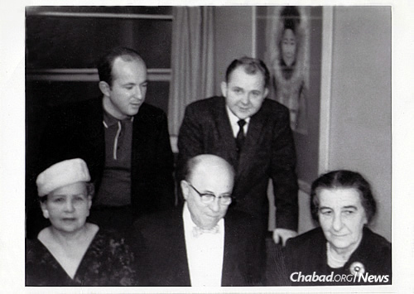
Years before becoming prime minister of Israel, Golda Meir, right, visited the
Greens and other Jewish families in Alaska, circa 1962. (Photo courtesy of the Estate of David Green)

‘Tolerance and Understanding’
Several thousand people have come through the museum since it opened three years ago. Given its success so far in reaching out to Alaskan tourists and residents, plans are underway for additional exhibits.
“The museum is not only affecting local Jews and local residents, but people worldwide,” explains Greenberg. “When you have museum that shows how non-Jews saved Jews, it encourages other people; it helps create tolerance and understanding of different cultures,” he says. “Anchorage’s history is a great example of this.”
And while visitors are there, many also choose to spend Shabbat in a hotel near the Chabad center so they can attend services, and join in for Shabbat dinner on Friday night or Shabbat luncheon on Saturday.

Rabbi Yosef Greenberg, co-director of the Lubavitch Jewish Center of Alaska, often wraps tefillin with Jewish residents and visitors alike.

“One of the most common scenes here are as follows: Tourists visit the museum and since the Lubavitch center is nearby, they come to check it out. We take them upstairs to the sanctuary, where they can see the Chugach Mountains from our tall windows. We hand out Shabbat candles and lighting times to women. We offer men a chance to put on tefillin and say the Shema prayer, and almost 99 percent of them agree,” relates Greenberg. “Even though some have not put on tefillin for years—as many as 40 or 50 years, and some never at all—almost without failure they are inspired to by the fact that there are Jews here in Alaska.”
Several thousand people have come through the museum since it opened in 2013.
The next museum exhibit, slated to open in 2017, will focus on the unsuccessful Alaska Resettlement Plan that sought to bring Jews fleeing Europe and the Nazis to the Alaskan frontier during World War II.

“The Miracle That Didn’t Happen: Failure of the Alaska Resettlement Plan” depicts European Jews who tried to get to Alaska territory between the years 1938 and 1941, and how that plan was shot down in Congress. According to Fried, there were a number of factors why, including the United States coming out of isolationism, anti-Semitism, etc.

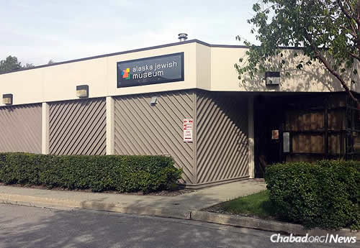

Because the nature of the exhibit is one of deep sadness—as any Holocaust exhibit would be—the museum will also add an unrelated display featuring artifacts from Jewish families across Alaska, both recent ones and those from the past. Items to be shown include a High Holiday machzor in Hebrew andYiddish that was used by a resident of Juneau, Alaska in 1900; and a dog-race harness from Alaskan resident Fred Agree, who in the 1980s became the first Jewish musher to finish the famed Iditarod sled race.
“We don’t want to show all bad news,” says Fried. “It’s as important to celebrate as it is to remember.”
For more information about the Alaska Jewish Museum, click http://www.alaskajewishmuseum.com/

Reprinted from the Parshas Devorim 5776 email of Chabad.Org Magazine.

