SUPPLEMENTARY SHABBOS Stories
Parshas beha’alosecho 5777
Printed L’illuy nishmas Nechama bas R’ Noach, a”h
Volume 1, Issue #1 (Whole Number #1) 16 Sivan 5777/June 10, 2017

For a free copy, please forward your request to keren18@juno.com

This Portuguese Diplomat Was Disgraced For Saving Jews. Now, He's Getting His Due.
By Nathan Guttman

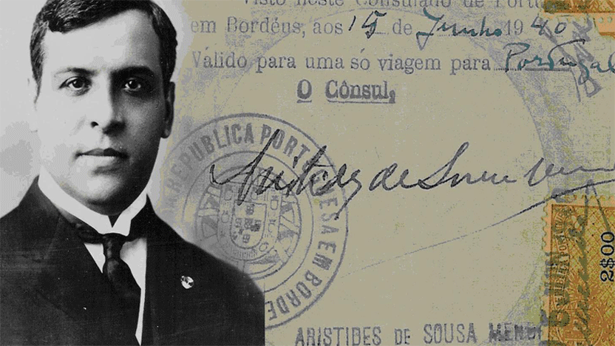
On a sunny Sunday morning in late April, the family of an unheralded hero diplomat during the Holocaust took one more step forward in their effort to rehabilitate his ruined name.
Aristides de Sousa Mendes, the Portuguese envoy who saved 30,000 people during World War II — 10,000 of them Jewish — was consigned to ignominy by his own government as a reward for his achievement. Stripped of his job and pension, he and his family were forced into a life of poverty in the years following World War II.
But on April 19, he was honored by Washington, D.C.’s Adas Israel Congregation and inducted into that power shul’s Garden of the Righteous memorial.
For his grandchildren, assembled from the United States, Canada and Europe, the ceremony was yet another testimony to the injustice done to their grandfather by his government, one that brought misery to his life and led his children to flee their homeland. It is an injustice even Portugal has come to recognize.
“I think my grandfather would be very proud and happy,” said Linda Mendes, who now lives in Montreal. “He’d be so proud that it’s not only Portugal, but that so many human beings know about his story.”
This coming June, family members and relatives of those rescued by the Portuguese diplomat will mark the 75-year anniversary of Sousa Mendes’s frantic attempt to save as many Europeans as he could from the hands of the Nazis, by issuing thousands of visas within several days before being ordered back to Lisbon, Portugal by the country’s dictator, Antonio Salazar. The celebration will mark the culmination of a decades-long effort to not just clear Sousa Mendes’s name, but to honor it in the history of democratic Portugal.
While pleased that the world has corrected the wrongdoing done to their grandfather, many of Sousa Mendes’s descendants still carry the scars passed on to them by their parents, the children of Sousa Mendes. Due to their father’s actions during World War II, these offspring endured long years of humiliation and hardship.
“My father couldn’t go to high school,” Linda Mendes recalled. “No one wanted to be seen with Aristides and his family. People would cross the street not to meet Aristides. It was a very hard time.”
Aristides de Sousa Mendes, who was born to an aristocratic family in 1885, took his place in Portugal’s foreign service alongside his twin brother Cesar de Sousa Mendes. For years, he served across the globe, including in the United States, before his final post as consul general in Bourdeax, France in 1939.
A devout Catholic, Sousa Mendes, who had 15 children, took time off every day to pray the Rosary.
His position in Southern France became critical as Nazi forces moved to take over the country. Portugal, officially neutral, shut its gates to refugees fleeing the Third Reich following an order by Salazar, known as “circular 14,” that forbade issuing visas to Jews and other Europeans expelled from their countries.
But a steady stream of refugees, viewing Portugal as their last way out of Europe, gathered outside the consulate in Bordeaux pleading for visas. This is when Sousa Mendes met Rabbi Chaim Kruger, a Polish refugee who told the Portuguese diplomat he would not accept his own visa until all the other refugees waiting got theirs as well.
Stating, “I would rather stand with G-d against man than with man against G-d,” Sousa Mendes, assisted by his wife, children and Kruger, created on June 16, 1940 a visa assembly line working around the clock. The emergency set-up produced an estimated 30,000 visas, a third of them for Jews. Spanish artist Salvador Dali, Margaret and H.A. Rey, authors of the children’s classic “Curious George,” and Crown Prince Otto von Habsburg were also among the visa recipients, as were Kruger and his family.
When the Germans took over Bordeaux, Sousa Mendes travelled to nearby concentrations of refugees, issuing more visas before being called back on July 8. In Lisbon, he was charged with disobedience and stripped of his diplomatic titles and benefits. At the order of the regime, his former colleagues turned their backs on Sousa Mendes, who was not allowed to go back to practicing law and could not find a job. His family was shunned and condemned to poverty.
“My father had told me of times when he would be in class and they would ask him, ‘Are you the son of Aristides or Cesar?’ And when he’d say Aristides, they’d say, ‘Don’t even take the test, you’ll fail,’” said granddaughter Sheila Abranches-Pierce, who lives in California. “It was very rough. They went from a comfortable life to a life of burning doors to stay warm in the winter time.” One by one, as they reached adulthood, Sousa Mendes’s children left Portugal and resettled in other countries. From abroad, they launched their battle to restore Sousa Mendes’s name.
Sousa Mendes’s story has been described by Israeli historian Yehuda Bauer as “perhaps the largest rescue action by a single individual during the Holocaust.” But it resembles that of several other international diplomats during World War II who defied their countries’ indifference to the plight of European Jews and used their power to issue visas as a lifeline. As with Sousa Mendes, many of these men’s good deeds also did not go unpunished.
The most well-known member of this group is Swedish diplomat Raoul Wallenberg, who helped save an estimated 100,000 Hungarian Jews and was later imprisoned by the Soviet Union. Soviet authorities never acknowledged holding him or revealed his fate. But he is presumed to have died in jail. Others include Japan’s Chiune Sugihara, who as vice consul in Lithuania helped some 6,000 Jews escape Nazi occupation and enter Japan; Chinese diplomat Feng-Shan Ho, who defied his government’s orders and issued visas for Austrian Jews after the Nazi takeover; Giorgio Perlasca, an Italian diplomat, who gave fake passports to Hungarian Jews; and Britain’s Frank Foley, a secret service agent, who was credited with saving 10,000 Jews by allowing them to pass through passport control to reach safety without papers.
The April 19 ceremony at Adas Israel Congregation featured a full production of the oratorio “Aristides,” a piece about Sousa Mendes written by Neely Bruce. It also brought Sousa Mendes’s descendants together with the children of Jews who were saved thanks to his efforts. Many of the second generation survivors were not aware of the fact that their parents were able to leave Europe only due to visas that Sousa Mendes issued. Jane Friedman, a Washington journalist whose grandparents and uncle, Belgian Jews, were among those saved by the Portuguese diplomat, is now working with the Sousa Mendes Foundation to try and locate descendants of the 30,000 visa recipients. It is a slow process and so far only 3,000 have been found.
“People that he saved had no idea who he was,” Friedman said. “We were all alike. We knew that our families got Portuguese visas but had no idea who Sousa Mendes was.”
The Foundation’s next goal is to restore the Sousa Mendes family house in the village of Cabanas de Viriato in central Portugal and to turn it into a museum.
This would mark the final phase in rehabilitating Sousa Mendes’s legacy in Portugal. His work was first recognized by Israel’s Yad Vashem in 1966, when he was declared a “righteous among the nations” 12 years after his death. The U.S. Congress honored him in 1986. But back in Portugal the process was longer. Recovering from years of dictatorship, Portugal granted Sousa Mendes its highest medal of honor in 1987 and a year later the parliament restored his diplomatic rank and dismissed the charges against him.
Speaking at the ceremony at Adas Israel, Portugal’s ambassador to Washington, Nuno Brito, said that after decades of silence, the Portuguese people now cherish Sousa
The Portugese envoy saved 30,000 people — 10,000 of them Jews.
Mendes’s achievement. Brito also noted his country’s recent decision to allow descendants of Portuguese Jews to reclaim their citizenship. “It’s never too late to do the right thing,” Brito said.
Aristides de Sousa Mendes’s son, Louis-Philippe de Sousa Mendes, the second youngest, did not live to see Portugal’s acceptance of his father come full circle. His son, Gerald Mendes, who now lives in Paris, said his father died a few months before the parliament officially rehabilitated Sousa Mendes. Gerald Sousa Mendes grew up hearing the story of his father’s last goodbye to Aristides de Sousa Mendes, when he boarded a ship leaving Portugal — the last child to leave a country that turned its back on the family. But, he said, no one in the family ever had second thoughts about what their father had done.
“As he put it — he couldn’t have acted differently,” Gerald Mendes said of his grandfather. “He had to save these people. The human side sometimes is more important than the laws.”
Contact Nathan Guttman at guttman@forward.com

Reprinted from the April 28, 2015 email of JNS. The article originally appeared in the April 26, 2015 edition of the Forward.com

How I Discovered I Was Jewish: Finding My
Jewish Roots in China
By Sasson Goldfan

Growing up, I was unaware of my Jewish heritage. My mother converted to Christianity before she married my father, and she actively hid our Jewish roots from my sister and me. Considering that all our relatives on her side of the family are unambiguously Jewish, this was no simple task, and as we grew older we became suspicious.
But when we asked, our mother explained that the rest of the family had converted to Judaism when she was in college. This seemed a bit suspect, but having no more than a general knowledge of Judaism, we figured it was just like any other religion that people join and leave easily.
My first real clue came when I was 17 and visiting my Orthodox cousins. They kept trying to convince me that I was Jewish, and I kept denying it. The conversation went something like this:
“You’re Jewish.”
“No, I’m not. I don’t believe in G-d.”
“It doesn’t matter. You’re Jewish because your mother is Jewish.”
“But my mother isn’t Jewish, she’s Christian.”
“Your mother is Jewish because her mother is Jewish, and that makes you Jewish.”
This is the point where the wheels really started turning for me—the realization that Jewishness is hereditary through the mother, and the understanding that people don’t generally convert to Judaism casually, especially not entire extended families.
Four years later, my uncle came to visit me in Santa Cruz, where I was studying. This was the first time I had met with him one-on-one as an adult, and I seized the opportunity to ask him point blank, “So, Ray, are we Jewish?”
“So Jewish,” was his answer.
He explained that not only were we Jewish, but that growing up, he, my mother and all their siblings had attended Hebrew school and synagogue, and keptShabbat. As you can imagine, this was a major revelation.
Because I’m clearly of mixed race, people have always been curious about my background. Throughout my childhood, I would answer, “My dad is Chinese and my mom is Heinz 57,” which was another way of saying, “some kind of generic blend of white.”
But now I had suddenly acquired a second race, only it wasn’t quite a race, or a religion, or an ethnicity. All of a sudden I had discovered that I was a Jew, and I had no idea what that actually meant. I did know, however, that it was a big deal. And I knew I was now part of a very clannish, cohesive group with an intense shared history of genocide, persecution, controversy, and a disproportionately prominent role in the course of world history.
Frankly, it was a lot to swallow.
My sister thought so too—I called her as soon as I found out.
“I knew it,” she said. I could tell she was narrowing her eyes conspiratorially. “So what does that mean?” she asked.
“I don’t know! But it’s definitely something . . . I think we get to go to Israel for free.”
“Do we want to go to Israel?”
“For free? Of course!”
“Haha, you already sound like a Jew!”
And that’s pretty much how we left it. I never did manage to take that Birthright trip, and aside from some Jewish girlfriends, I had little to no contact with the Jewish community, culture or religion for the next seven years.
After graduating from college, I floated from job to job for a few years. Eventually I ended up working in a Chinese-style teahouse in Austin, Texas, performing a traditional tea service known as gong fu cha.
I had always identified with my Chinese heritage, and despite growing up without the language, I had cultivated an interest in Chinese culture from a young age. The job consisted primarily of serving tea and being charming, and I met a lot of customers with connections in China. In 2010, after receiving my tax return and an unsolicited tarot reading, I moved to Chengdu, China, to work for an environmental nonprofit organization doing freshwater conservation research.
By early 2012 I was fluent in Chinese, working multiple jobs and renting a small apartment by the river. My Jewish heritage was, for the most part, just an excuse to get drunk whenever I met traveling Israelis. Then my eldest Orthodox cousin, who confused me all those years ago, came to visit. She brought a siddur and began to introduce me to Jewish prayer, and eventually took me to my first Purim party.
The party was held at the Chabad House of Chengdu. The young Israeli rabbi, Dovi Henig, had arrived with his wife just a week earlier, and the Purim party was their first major event. Dovi and I had an instant rapport; he was fascinated by my almost complete ignorance of my own heritage, and seemed to take genuine pleasure in answering my questions about the most basic aspects of Judaism. I ended up visiting him nearly every day for the next two weeks, and by the end of the month he had bar mitzvahed me.
Now, here I am, writing an article for a website whose name I would not have been able to pronounce just one year ago. I’ve celebrated Purim, Pesach, Lag BaOmer and many Shabbatot, and I’ve put on tefillin almost a dozen times.
Do I know now what it means to be Jewish? Not really. It’s something I’m learning about slowly. But I have discovered what it feels like to be Jewish.
It feels like being part of a family.

Reprinted from the website of Chabad.Org
After Lying In Ruins for 30 Years, Lebanon’s Only Synagogue Has Been Restored
By Hannah Jewell

Beirut’s Maghen Abraham synagogue was left in tatters by the Lebanese civil war, but a project led by the country’s tiny Jewish community will see it open its doors again.

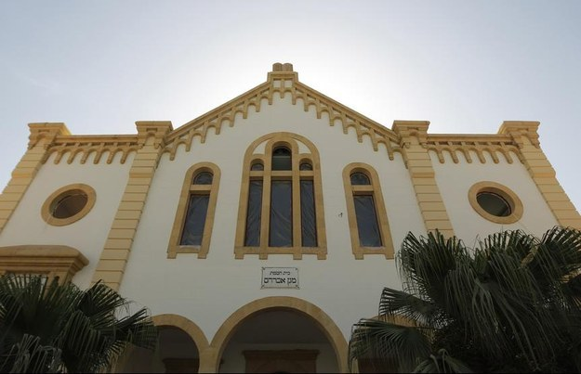
Photo by JOSEPH EID/AFP / Getty Images

A promising story of religious cooperation in the Middle East may seem unlikely at the end of a summer of sectarian violence across the region. But a Lebanese project to rebuild its one and only synagogue project offers a tiny glimmer of optimism.
Beirut’s Maghen Abraham synagogue (pictured above in 2010) was originally built in 1925 to serve the city’s centuries-old Jewish quarter. The Jewish community in Lebanon has a long and vibrant history, once providing sanctuary to Jews fleeing the Spanish Inquisition in the 15th century, and continuing to grow in the 1940s as it absorbed refugees from Nazi Europe. By the 1960s, up to 22,000 Jews were integrated into Lebanese society, with Judaism counted among the country’s 18 officially recognized groups.
When sectarian tensions erupted into civil war in 1975, however, many Jews left for Europe and the Americas. The central location of the Jewish quarter, trapped between the Christian and Muslim sections of a divided Beirut, made it a key battleground in a war that pitted dozens of militias against one another and wrought unfathomable destruction across the entire country.
When Israel invaded Lebanon in 1982, its forces shelled the Jewish quarter while fighting the Palestine Liberation Organization (PLO), blowing a gaping hole in the roof of the Maghen Abraham.
For the next 27 years, both the Lebanese Jewish community and the synagogue that had formed its religious heart lay in ruins.
The Lebanese government approved the synagogue’s reconstruction in 2009 with the support of all political parties, including the militant Hezbollah movement. The project, costing hundreds of thousands of dollars, has mostly been funded by private donations from Jewish funders both in Lebanon and abroad, including some of those Lebanese Jews who left during the civil war.
The Lebanese Jewish Community Council shared photos last week on its Facebook page showing the interior of the Maghen Abraham as it nears completion, along with a hopeful message for religious pluralism in Lebanon, which it refers to as “the last refuge for the minorities of the Middle East”.
The reconstruction effort has largely been organized by Isaac Arazi, a self-appointed leader of the Lebanese Jewish community. Arazi has said that he hopes to help rebuild the dwindling Jewish community of Lebanon, which now numbers around 200 people, in addition to the synagogue itself.

Reprinted from the September 2, 2014 website of Buzzfeed.

At a Camp for Hasidic Boys, Studying Faith Is Their Daily Exercise
By Joseph Berger

MONTICELLO, N.Y. — Although they are at the heart of one of the nation’s largest sleep-away boys’ camps, the dozen basketball courts at Camp Rav Tov D’Satmar are crumbling from disuse, with weeds sprouting from cracked playing surfaces and hoops either sheared off or rusting.
The baseball fields, which like the courts are left from when the sprawling property was the Kutsher’s Sports Academy, are overgrown, the basepaths hard to spot, the ramshackle bleachers near collapse.
Sports like basketball and baseball are not the point of a summer at Rav Tov, a camp for 3,000 Hasidic boys that is 90 miles north of New York City in the middle of what was once the Catskill borscht belt. Indeed, those sports are forbidden.
“Our rabbi doesn’t want it,” said Zelig Parnes, 13, who was dressed on a sunny July day in a black silken coat bound by a sash at the waist and a beaver homburglike hat that framed his long sidelocks.
With similar garb, Lazer Berkowitz, 13, agreed.
Camp Rav Tov (the name means “lots of good”) is not your summer camp of color wars, campfires and lanyards. Instead, these boys, ages 9 to 13, rise at 6:45 every morning and study the Torah or the Talmud before breakfast, eat and then study some more — a total of more than six hours throughout the day. They bend or sway animatedly over dog-eared volumes of the Talmud at long plywood desks and grapple with such questions as, in Zelig’s words, “If someone borrows a cow and the cow dies, does he have to pay the man who loaned it?” Almost no one is well tanned.
“When you’re learning you have geshmack,” said Lazer, using the Yiddish word for savor to explain why he prefers studying Gemara to playing basketball.
There is a camp motorboat and a livestock pen. But even leisure-time activities tend toward the Talmudic.
Once a summer, a sheep is sheared to show the boys the source of wool used in the tzitzit — the fringes attached to a prayer shawl or a poncholike ritual undergarment. They view a display of miniature models of the Holy Temple and other iconic Jewish sites. On the yahrzeit, or anniversary, of the death of Rabbi Joel Teitelbaum, who established the Satmar sect in the United States with a scattering of Hungarian Holocaust survivors, the boys take buses to Kiryas Joel, N.Y., to visit his grave (according to the Western calendar he died on Aug. 19, 1979).

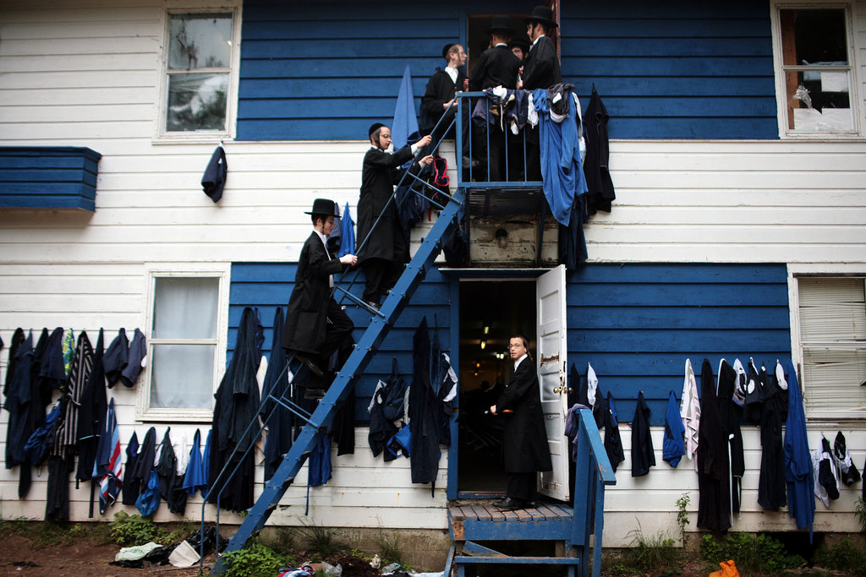
MONTICELLO, N.Y. — Although they are at the heart of one of the nation’s largest sleep-away boys’ camps, the dozen basketball courts at Camp Rav Tov D’Satmar are crumbling from disuse, with weeds sprouting from cracked playing surfaces and hoops either sheared off or rusting.

It was Rabbi Teitelbaum who said that those who grew up playing ball would spend time playing ball as adults.
“It’s like smoking: You get more and more addicted,” Yoel Landau, the camp manager, explained of the power of sporting activities.
The boys, like campers everywhere, savor time with friends, many of whom they know from Williamsburg, Brooklyn, where many of them live. They say they love the camp food. They relish the chances to scamper across the green fields.
The cost for nine weeks at the camp averages $1,500, depending on family income, and many of the boys’ parents vacation in the bungalow colonies around Monticello.
“When the boys are here nine weeks, they’re away from all the problems of the city,” Mr. Landau said. “The drugs, the busyness, the heat. Here they can study. Their head is more relaxed. That’s why Rabbi Joel made this camp.”
Rav Tov, which leased the property from Kutsher’s in 2008 (when it moved to Great Barrington, Mass.) and now owns it, is one of seven camps operated by one of the two Satmar factions. The Aroynem, which operates Rav Tov, also runs Machne Bais Rochel D’Satmar, a camp for 2,200 girls in nearby South Fallsburg. There, in addition to swimming sessions and cultural trips, the girls can spend summer days learning how to cook, shop and care for children. The Zaloynim have their own camps.
At Rav Tov, the boys swim (the Talmud instructs fathers to teach their sons to swim), hike occasionally in the woods and play Frisbee. There are races, though those too have an instructional purpose. In one, boys sprint back and forth gathering “tickets” with the names of Talmud portions that their fathers are studying. Zelig, the camper, also points out that six times a day they have to climb the stairs of the three-story pedestrian bridge that connects the clusters of bunks to the cluster of classroom buildings.
“You can lose a lot of weight that way,” he said.
But even exercise is hedged by rigorous Hasidic traditions. Men and women — the wives and daughters of the camp’s teachers and counselors — swim at separate sessions, and the pool is hidden behind a tall plywood fence, to safeguard modesty.
On a recent day in Rabbi Chaim Teller’s class, two dozen 10- and 11-year-olds were learning about the lulav and esrog — the palm frond and citron that combined with myrtle and willow are brandished and shaken during prayers for the Sukkot holiday. Rabbi Teller asked, If a lulav is borrowed, does it fulfill the Torah’s commandment? The rabbinical debate concludes that it must be owned the first day but can be borrowed the second day, Rabbi Teller said. The boys seemed to hang on his words.
“It’s a lot of fun,” Mr. Landau said. “They don’t feel like they miss something. Their minds are busy all day.”

Reprinted from the August 7, 2014 edition of The New York Times.
Meet New York’s
Torah Truck King
By Sam Kestenbaum

I found Rabbi Shulem Korn in Queens as he was assembling one of his famous Torah Trucks. A white pickup was hooked to an ornately decorated trailer, a dramatic scene of Mount Sinai, surrounded by lightening, emblazoned on the side.

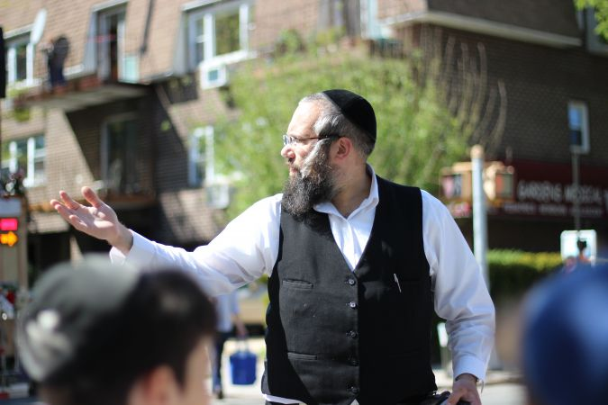
Photo by Sam Kesterbaum

I’d been trying to track down the rabbi for months, celebrated in New York for his Torah dedication ceremonies, but he’d been too busy to take my calls — the Torah business, he explained, was booming.
Holy Business: A crowd in Kew Gardens gathers for a Torah dedication ceremony underneath a canopy.
But Korn had finally texted me an address, in Kew Gardens, where he would be holding one of his Torah parades — part sacred rite, part block party — and he said I could come for a ride-along.
In front of us, a Torah Truck took shape. A ceremonial canopy was assembled; speakers and a keyboard unpacked. The set-up just needed the final touch. Korn excused himself and disappeared inside the vehicle, reaching in the maze of electrical wires. He flipped a switch and huge red crown, blinking with lights atop the trailer, began to move in slow circles.

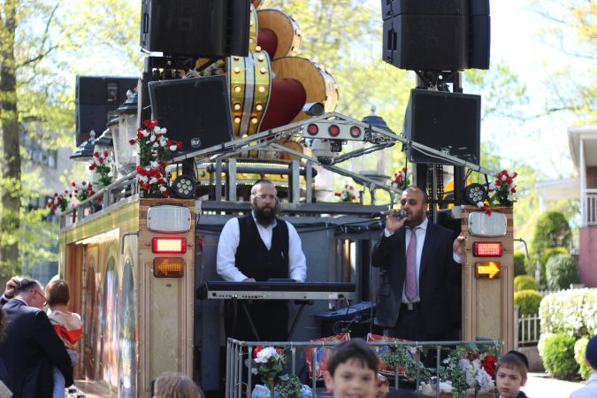
Photo by Sam Kestenbaum

“When you have a crown,” he motioned, “You’re a king.”
For months, I had seen Korn and his fleet of trucks from afar, rolling down Brooklyn streets, lights flickering from their roofs, thronged by dancing Hasids in Orthodox neighborhoods. One afternoon I pulled one man aside to ask what the party was about. What were these trucks that turned otherwise sleepy neighborhoods into holy block parties? Hebrew music, synthesizer wailing, echoed for blocks.
He was surprised I didn’t know. “This?” he said. “That’s Rabbi Korn, the king of the Torah Trucks.”
Korn helps communities celebrate a sacred occasion: the “bringing in” of a new Torah. It can take over a year to fully write a Torah, a long, meticulous process done by hand. The Torah’s completion, often dedicated to an individual or community, is akin to other life cycle events, like a bar mitzvah or wedding.
When a Torah has been inscribed, Korn will ferry the sacred scroll from the scribe to synagogue, where it will be housed — this might involve a longer drive, or simply a slow parade down one or two blocks.
What’s more, Korn has a corner on this niche market.
No one else on the East Coast holds events quite like this. Jews of all denominations and stripes — Satmar, Lubavitcher, Bobov, Modern Orthodox, Conservative — go to Korn when they need a Torah party. A trained musician, Korn plays the keyboard and is often accompanied by a singer. While one of his assistants drives the truck, Korn stands in the back of the trailer, presiding over the revelry.
Korn said he’s traveled as far as Canada and Florida to host parades, but it’s really in New York’s Orthodox enclaves that he finds most of his work.
Around fifteen years ago, some of his community had their doubts about whether his enterprise would take off, he confided.
The first parade Korn organized was during the Second Intifada. A New Square man’s wife and young child had been killed in a deadly bus attack in central Jerusalem; a Torah was being written and dedicated in their honor.
“What can we do to make something special for them?” Korn asked. Along with his brothers, who helped launch the business and still help with his operation, they organized the ceremony.
At the beginning Korn and his brothers might only hold five ceremonies a year; now they happen almost every weekend. He keeps his trucks in a garage in his hometown of Monsey, where he has his workshop. Ceremonies cost anywhere from $1,000 to $3,000. He now has two trucks; a third is in the works. In total he has a crew of seven.
Korn had along two helpers, quiet Hasids from Monsey named Moishy and Chaim, just old enough to have started growing mustaches. Korn gave orders in Yiddish into a walky-talky. “These are my best guys,” Korn said, as he gestured where to place the canopy.
A crowd had formed outside the Shaare Tova Synagogue, milling in the grass, waiting for the parade to kick off. Korn’s walky-talky buzzed and he carefully backed up the trailer. Inside, the final touches were put on the Torah; community members lined up to sit with the Torah scribe, posing for photos. Some drank whisky and vodka and patted each other on the back.
Helping Hand: Chaim Shpira, one of Korn’s assistants, hands out flags to the crowd.
The Torah was carefully rolled up and carried outside. On cue, the two young men from Monsey hopped in the bed of the truck; Korn took his place at the keyboard. Children were hoisted on shoulders and the dancing began.

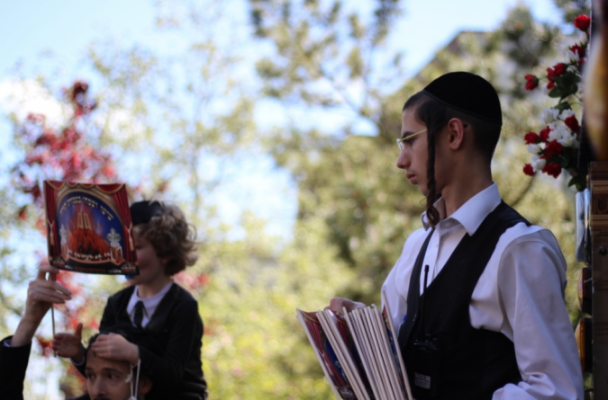
Photo by Sam Kestenbaum

The streets had been temporarily blocked off and the crowd filed down the middle of the road. Traffic came to a halt.
The truck began a slow crawl uphill as the singer, a clean shaven man with a yarmulke, ran through crowd favorites. One of Korn’s assistants hopped out of the truck and passed out flags for the children to wave.
Passersby stopped and gawked. One Hispanic man, walking his dog, looked confused. “I’ve never seen anything like that,” he said. “But it’s beautiful.”
Korn wore a look of extreme focus. He had envisioned this entire production — designing the truck and canopy and engineering the sound system, altogether it might take $100,000 to build one of the trucks and trailers — but now Korn seemed to turn inward, focused only on the music.
Local rabbis danced arm in arm. This was a Modern Orthodox community, so women were also participating, dancing (carefully, with high heels) in their own circle alongside the men.
One man who helped with the organizing, Rabbi Chaim Eli Welcher, seemed pleased. He adjusted his fedora in the sun. “I was worried about the weather,” he said. The morning had been overcast. “So I asked Rabbi Korn if he had plans for what would happen if it rained. The rabbi told me, ‘I could write a novel about the number of times it rained and the morning and the sun came out.’ So we went ahead.” The parade lasted no longer than half an hour.

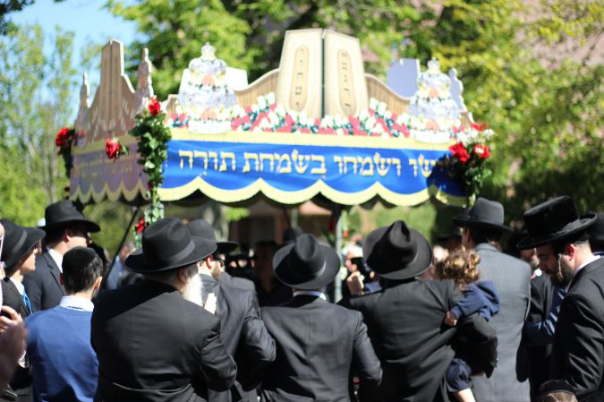
Photo by Sam Kesterbaum
Reaching their destination, Yeshiva Tifereth Moshe, the Torah was carried into the basement amidst more dancing.
Korn finished the final number, dismounted the trailer and let his helpers dismantle the setup. “I had no competitors to look at and copy when I designed all of this,” he said. Within a few minutes the entire trailer had been broken down, packed up and covered with a tarp. “It all fits together like a puzzle.”
New York’s king of the Torah Trucks rested in the shade for a moment as the crowd dispersed, some stopping to shake his hand or take down his number.
Years ago, some of Korn’s peers had their doubts about whether these Torah parades would take off. “People didn’t think you could make a business out of this,” Korn said. “It’s a new kind of business — not like a drycleaner or a grocery. It’s holy business.”

Reprinted from the May 18, 2016 edition of the Forward.

