SUPPLEMENTARY Stories
For Parshas shoftim 5777
Printed L’illuy nishmas Nechama bas R’ Noach, a”h
Vol. 1, Issue #12 (Whole Number #12) Elul 5777/Aug. 26, 2017

For a free copy, please forward your request to keren18@juno.com

From Baptist Minister
To Orthodox Jew
By Ronda Robinson

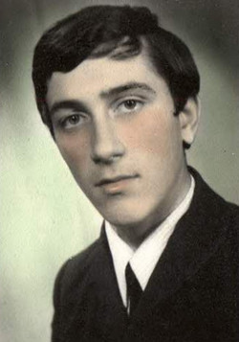
Jean Boldor, age 18

Moshe Boldor’s harrowing odyssey from hunted renegade in Communist Romania to freedom in the U.S. as an observant Jew.

Jean Boldor was an auto mechanic and driver for the Director of Mines in Romania, in 1983. He wanted to escape the Communist country where he was born and freely study the Bible. “In a Communist country, you cannot do anything you want,” he says.
The Romanian government forced citizens to celebrate Communist holidays. Boldor thirsted for more. “For whatever reason I was attached to the Old Testament,” he recalls, “and read about the people of Israel and the prophets. It fascinated me how God took the people of Israel from the land of Egypt.”
Always drawn to Biblical learning, Boldor didn’t know until much later that he had Jewish roots. His great-great-great-grandmother was Jewish. From there, the trail grows cold. The Jewish community in his native Lupeni was decimated during World War II, when Romania became a satellite of Nazi Germany and Jews lost their shops and citizenship. At the end of the war thousands of Jews fled Romania. It is estimated that by the end of the 1960s, the Romanian Jewish community numbered no more than 100,000.
Wanting to share the joy he found, Boldor began to teach the Bible to young people. “The Communists did not look kindly upon my involvement, so I was taken to the police station many times to be interrogated, handcuffed and beaten – and given time to reflect on my activity.”
Lay people like Boldor were arrested for asserting their religious beliefs; they weren’t allowed to have Bibles. At age 20, he applied to emigrate to the United States where he could pursue Bible studies.
“From that moment on, I was followed everywhere because I was considered a threat to Communism,” he remembers. “When you applied to leave, they thought you were a danger.”
For five years Boldor lingered in Romania with no end in sight. Life was growing more difficult, so he decided to run away but was caught on a train headed toward the Yugoslavian border.
Military police put him under 24-hour arrest in a room full of screaming people with broken arms and broken feet who received no medical attention. They told him of being beaten with AK-47 assault rifles. After paying a monetary penalty, he was freed and went home.
Then in August 1988, Boldor and a friend, Ion, tried to flee again, going by train and on foot to the border. “I prayed to God to save me. I read Psalms when I had a few minutes. We went three days without drinking any water,” he says.
Villagers saw the two men and alerted the military who surrounded them. The soldiers began to beat them.
“Usually beatings were so bad that very few survived the next week,” Boldor says, “But one sergeant saw that I had a book of Psalms and ordered the soldiers not to touch me. Once again I saw the Hand of God and I thanked Him.”
He was put in military prison for two weeks. Then a friend in Austria sent Boldor $100 through his bank, which was used to bribe an Army captain to let Boldor and Ion go free.

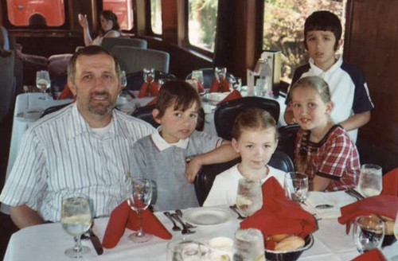
Moshe Boldor with his four children Sara, Amos, Ruth and Isaac

They began plotting their third escape.
“I read in the Book of Esther that Mordechai and Esther fasted three days and three nights to save the Jewish nation from Haman, so I did the same. I fasted three days and nights and cried to God to help us this time succeed.”
Boldor’s prayers were answered. In September 1988 he and Ion took a train to the Yugoslavian border. They jumped out at a station close to the border and hid in a stand of hay. They slept by day and walked or crawled by night.
When they reached Yugoslavia they walked to Belgrade, about 500 km, 310 miles. In Belgrade they climbed atop a train to Ljubljana, the capital of Slovenia, to avoid detection by the police.
From Ljubljana they hopped a train to Germany and Austria and at last arrived at a refugee camp near Vienna, their clothes full of dust and oil. Their treacherous two-week journey was over.
“It’s hard to describe what it means to be free and alive after such a long and dangerous trip. When we got there we found out that 180 people had been killed by the Romanian border. So God once again saved my life,” says Boldor.
He kept a promise to God to study the Bible if he survived. As a refugee from a Communist country, he obtained a visa from Canada, where he learned Biblical Hebrew and earned a bachelor’s degree in religious education at a Christian college. He also became an ordained Baptist minister.

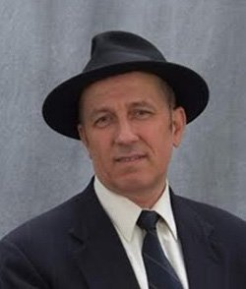
Moshe today, in Seattle

Eventually Boldor married, had four children and moved to Seattle, Washington, where he started a small business taking care of seniors. It was during his first trip to Israel in 2004 and visiting the Cave of Machpelach in Hevron where the patriarchs and matriarchs are buried that the Baptist minister had a spiritual crisis. He had always believed Abraham was buried in Shechem, as the Christian Bible stated. Now he found otherwise. He started to compare the Hebrew and Christian Bibles and saw other discrepancies. Torah won him over.
“When I went to Israel I saw the beauty of Judaism and Shabbat. It was life-changing for me. The Torah passages came alive,” he says. He followed the murmurings of his heart as a child and decided to convert to Judaism.
Back home in Seattle he resigned his pulpit, began going to synagogue and learn Torah intensely, and started keeping the laws of Torah. The conversion process took 10 years. The former Baptist minister, who changed his name to Moshe, now keeps a kosher home and prays with a minyan three times a day.
His marriage didn’t withstand the changes. His wife didn’t want to convert to Judaism and the couple divorced. Two of their children converted and became religious, with one of the daughters making aliyah.
Boldor, 56, studies through an online yeshiva and makes Torah the center of his life. “It is really great to be part of the Jewish nation and follow in Avraham’s footsteps.” Today he owns and manages a nursing home in Seattle.

He transforms the hardships he endured to help others. “I am thankful to God because I was able to come home to Torah and Israel and I am trying to help other Jews. The time is not too late to come home and join the Jewish nation of Israel through following the Torah.
“Sometimes I cry living here in America. In Romania they handcuffed me, tortured me, put me in prison for reading and learning the Torah. Here we have freedom but sometimes it is wasted. My prayer is for God to use me to help other Jews appreciate the beauty of Torah.”

Reprinted from the Parshas Toldos 5777 email of Aish.com website.

Ruth Gruber, a Fearless Chronicler of the Jewish Struggle, Dies at 105
By Robert D. McFadden

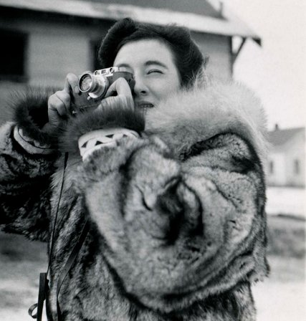
Ms. Gruber in Alaska in 1941. She documented Stalin’s gulags and life in Nazi Germany. CreditReel Inheritance Films

Ruth Gruber, a photojournalist and author who documented Stalin’s gulags, life in Nazi Germany and the plight of Jewish refugees intercepted by the British on the infamous passage of the Exodus to Palestine in 1947, died on Thursday at her home in Manhattan. She was 105.
Her son, David Michaels, confirmed her death.
Ms. Gruber called herself a witness, and in an era of barbarities and war that left countless Jews displaced and stateless, she often crossed the line from journalist to human rights advocate, reporting as well as shaping events that became the headlines and historical footnotes of the 20th century.

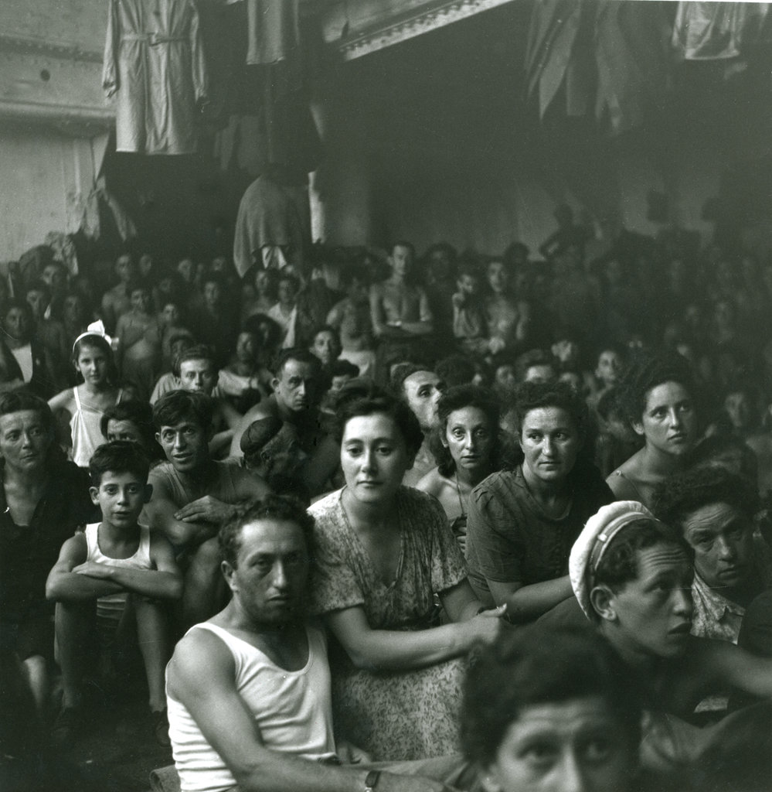
In July 1947, 4,515 refugees were captured by the British as they headed for Palestine aboard the steamship Exodus 1947. The photojournalist and writer Ruth Gruber reported on the episode. (Photo Credit – Ruth Gruber)
Over seven decades, she was a correspondent in Europe and the Middle East and wrote 19 books, mostly based on her own experiences. Acting for President Franklin D. Roosevelt, she escorted nearly 1,000 refugees from 19 Nazi-occupied nations to a safe haven in the United States on a perilous trans-Atlantic crossing in 1944. They included the only large contingent of Jews allowed into America during World War II.
As with many of her exploits, the rescue became the subject of one of her books, “Haven: The Dramatic Story of 1,000 World War II Refugees and How They Came to America” (1983). It was made into a two-part CBS mini-series in 2001, starring Natasha Richardson as Ms. Gruber.
Ms. Gruber was in Jerusalem in July 1947 to cover a United Nations conference when she learned that a Chesapeake Bay steamer — refitted by the paramilitary group Haganah as a transport for Jewish immigrants and renamed the Exodus 1947 — had been intercepted by British warships as it approached Palestine, overloaded with 4,515 refugees, including many orphans and Holocaust survivors. She rushed to the Port of Haifa to report on the episode.
The vessel, listing and damaged in an offshore attack that left three dead and 120 injured, was seized by the British. Turned back within sight of the Promised Land, the refugees were transferred to prison ships and returned to Germany, where they were interned in fenced compounds reminiscent of the Nazi concentration camps.
Ms. Gruber, acting as a pool reporter for news organizations, photographed and wrote about horrific conditions aboard the ships and in the camps. The international outcry that followed profoundly embarrassed the British, who were then governing Palestine under a 1922 League of Nations mandate, and helped pave the way for Israeli independence in 1948 and the eventual resettlement of nearly all the interned Jews.
The story was chronicled in Ms. Gruber’s 1948 book, “Destination Palestine: The Story of the Haganah Ship Exodus 1947.” (The book was updated in 1999 and in 2007 as “Exodus 1947: The Ship That Launched a Nation.”)
The episode was also the basis of the Leon Uris novel “Exodus,” published in 1958, and of Otto Preminger’s 1960 film adaptation, which starred Paul Newman. A documentary film, “Exodus 1947,” narrated by the CBS News reporter Morley Safer, was broadcast on PBS in 1997.
Ms. Gruber, who worked for The New York Herald Tribune, The New York Post and, briefly, The New York Times, covered the Nuremberg war-crimes trials and many events in the history of Israel, including its war for independence. In 1952, she escorted Eleanor Roosevelt on a visit to development sites in Israel.
Her empathetic coverage, she often said, was rooted in her pride as a Jew and as a journalist with a mission.
“I had two tools to fight injustice — words and images, my typewriter and my camera,” she told a United Jewish Federation seminar at the University of Pittsburgh in 2001. “I just felt that I had to fight evil, and I’ve felt like that since I was 20 years old. And I’ve never been an observer. I have to live a story to write it.”
Ruth Gruber was born in Brooklyn on Sept. 30, 1911, to David and Gussie Gruber, Jewish immigrants from Eastern Europe. A brilliant student, she held abiding passions for Judaism and German culture, including Goethe, Nietzsche, Schiller and Schopenhauer. She graduated from Bushwick High School at 15 and New York University at 18, by then already fluent in German.

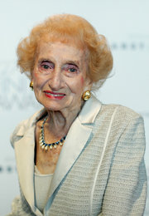
Ms. Gruber in New York in 2011.
CreditJemal Countess/Getty Images

On fellowships, she earned a master’s degree in German at the University of Wisconsin at 19 and a doctorate in German literature at the University of Cologne at 20, one of the youngest ever to achieve that distinction. In 1932, on the eve of Hitler’s rise to power, she traveled across Germany, saw festering anti-Semitism, even attended Nazi rallies and once saw Hitler deliver a tirade.
She returned to New York and, after reporting locally for The Times, joined The Herald Tribune in 1935. She was soon crossing Soviet Russia on assignment.
“I am experiencing that feeling of zest which goes with exploration,” she wrote as she flew over the snowcapped Urals on a 6,000-mile trek to Siberia. “I am in the thick of an historic moment. I am in an era in the making.”
She looked like the early Hollywood star Myrna Loy (who was only six years older than Ms. Gruber): small and delicate, with a pointed chin and high cheekbones — a strange, incongruous young woman among the kulak prisoners and soldiers aboard the Trans-Siberian Railway, bound for the mills, ports and labor camps. It was wondrous stuff for The Trib and for another book, “I Went to the Soviet Arctic” (1939).
After completing a task for Interior Secretary Harold L. Ickes in 1941 — to assess Alaska’s prospects for homesteading postwar G.I.s — Ms. Gruber took on a mission for President Roosevelt in 1944, escorting 984 refugees to America on a ship that ran a U-boat gantlet. Skirting Jewish immigration quotas, the president invited them as “guest” visitors. With Ms. Gruber’s lobbying, they held out near Oswego, N.Y., and applied for residency in 1946.
In 1951 she married Philip H. Michaels, a New York lawyer who died in 1968. In 1974 she married Henry J. Rosner, an official at New York City’s social services and human resources agencies. He died in 1982.
Besides her son, an assistant secretary of labor in the Obama administration, she is survived by a daughter, Celia Michaels, a former CBS News editor who covered the war in Lebanon in 1980; two stepdaughters, Jeri Drucker and Elaine Rosner-Jeria; nine grandchildren; and six great-grandchildren. Another stepdaughter, the writer Barbara Seaman, died in 2008.
Ms. Gruber was the subject of a documentary film, “Ahead of Time,” in 2010. She received many humanitarian awards and counted Eleanor Roosevelt, David Ben-Gurion and Golda Meir as friends.
In her later years she continued to write articles and books and lectured widely. Her last book was “Witness: One of the Great Correspondents of the Twentieth Century Tells Her Story” (2007).
As she told an audience at Stony Brook University in 2008, she always knew how to be in the right place at the right time.
“Whenever I saw that Jews were in danger,” she said, “I covered that story.”

Reprinted from the November 18, 2016 edition of The New York Times.

Wall Street Journal Op-Ed

Free Rubashkin Now
By Charles B. Renfrew and James H. Reynolds

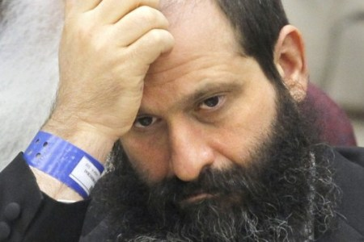

One of the Roman poet Juvenal’s best-known lines is quis custodiet ipsos custodes. Who will watch the watchers? Some 2,000 years later, this question is especially relevant for America’s criminal-justice system, given the power wielded by federal prosecutors. Too often their profound authority leads to significant abuse, as demonstrated by the case of Sholom Rubashkin.
Mr. Rubashkin, a 57-year-old father of 10, is the former vice president of Agriprocessors, a kosher food processor based in Postville, Iowa. On May 12, 2008, U.S. Immigration and Customs Enforcement agents raided the company’s plant and arrested hundreds of the firm’s workers who were undocumented immigrants. This led the company to file for bankruptcy several months later.
Shortly thereafter, Mr. Rubashkin was arrested by federal officials and charged with fraud in the U.S. District Court, where one of us formerly served. The government alleged that he illegally shifted money that should have been deposited as collateral for a loan from the St. Louis-based First Bank.
Although Mr. Rubashkin was convicted, he did not intend to cause any loss to the bank. But the federal prosecutors who charged him wanted to extract a pound of flesh, and then some—even at the cost of illegally overstepping their bounds and interfering in the bankrupt company’s sale.
As part of its bankruptcy filing, independent assessors valued Agriprocessors’ assets at $68.6 million. Yet evidence that the prosecutors hid and that Mr. Rubashkin’s attorneys found over the past few years proves that the prosecutors stymied the bankruptcy trustee from making a sale to prospective buyers at a reasonable price. Instead, they warned that buyers would forfeit the business if any member of the Rubashkin family maintained a connection to the firm, although no other family member had been charged.
Moreover, the Rubashkins’ involvement was a critical part of Agriprocessors’ value. The Orthodox Jewish family—especially Sholom’s father, the company’s founder—had significant institutional knowledge and expertise in the kosher food-processing business. Absent the family’s know-how, the company became significantly less attractive to buyers.
The prosecutors achieved their intended goal. Nine prospective bidders walked away from the sale—including one that had offered $40 million. The business was sold for $8.5 million, a fraction of its actual worth, ensuring that the bank would not be paid back for the money it was owed. Even the bank, the victim in the case, objected in writing to the prosecutors concerning the government’s actions. Here, too, the prosecutors unjustly concealed the bank’s objections from the defense.
Under federal mandatory-minimum sentencing guidelines for bank fraud, an offender’s sentence is directly linked to the loss incurred by the bank that was defrauded. The prosecutors’ meddling meant that the bank incurred a $27 million loss. This enabled the prosecutors to seek a staggering life-in-prison sentence for Mr. Rubashkin, which they later lowered to a still unacceptable quarter-century. The prosecutors concealed their role by soliciting false testimony from Paula Roby, counsel for the bankruptcy trustee, who said that the prosecutors did not interfere in the bankruptcy sale process. At sentencing, the prosecutors misled the court into believing this meddling never happened, a fact that was only recently discovered.
Mr. Rubashkin was found guilty on financial-fraud charges and sentenced to 27 years behind bars. Had justice truly been served, he would have received less than four years. In April 2010, after the conviction but prior to sentencing, a bipartisan group of six former attorneys general and more than a dozen other prominent legal experts wrote a letter to the judge in which they urged her to show Mr. Rubashkin leniency.
This call has grown into a clamor in the intervening six years. In April, a bipartisan group of four former U.S. attorneys general, two former FBI directors and dozens of law professors and former Justice Department officials wrote to the current U.S. Attorney for the Northern District of Iowa, Kevin Techau. They described Mr. Rubashkin’s sentence as “patently unjust” and asked him to act to remedy what the letter called “shocking new evidence that prosecutors in your office knowingly presented false and misleading testimony at the sentencing hearing.”
Mr. Rubashkin has now served more than seven years of his sentence—more than twice as much as he would have served had his punishment fit his crime. Every day that he spends in prison is a day that he should be spending as a free man, with his family.
That is why we urge President Obama to pardon Mr. Rubashkin before he leaves office in January. Congress should also take steps to rein in the serious problem of prosecutorial abuse, which has elicited bipartisan concern from many lawyers, legal scholars and federal judges. One possible reform includes making it a felony for prosecutors to knowingly conceal or alter evidence that bears on a case’s outcome.
The watchers must be watched. If they are not, the criminal-justice system will too often deliver the kind of injustice that Sholom Rubashkin is experiencing.
About the authors: Mr. Renfrew was a U.S. District Court judge in the Northern District of California (1972-80) and U.S. deputy attorney general (1980-81). Mr. Reynolds was the U.S. attorney for the Northern District of Iowa (1976-82).
{Matzav.com}

Reprinted from the November 27, 2016 edition of The Wall Street Journal.

Posthumous Honor for US Officer Who Saved 200 Jewish GIs from the Nazis — and Never Told a Soul
By Cathryn J. Prince
With a Nazi pistol pointed at his head, Master Sgt. Roddie Edmonds refused to reveal which of his soldiers were Jews. This week he was recognized for his bravery
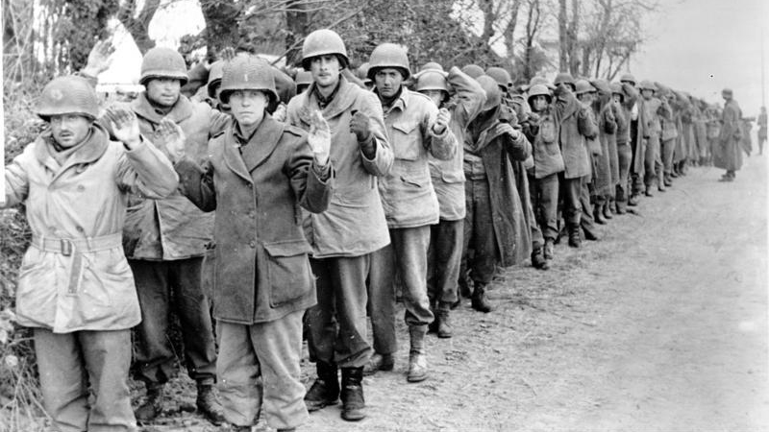
NEW YORK — In a singular act of humanity and defiance, Master Sgt. Roddie Edmonds stood up to a German commandant and saved 200 American Jewish GIs from transportation to a slave labor camp.
It was 1945 and Edmonds had been a prisoner of war in Stalag IX-A, a German POW camp for less than a month. As the highest-ranking officer there, he was responsible for the camp’s 1,292 American POWs – 200 of whom were Jewish.
Throughout the war, the Wehrmacht either murdered Jewish soldiers captured on the Eastern Front or sent them to extermination camps. Jewish soldiers captured on the Western Front could be sent to Berga, a slave labor camp where survival rates were dismal.
Because of this policy the US military told its Jewish soldiers that if they were captured they should destroy evidence of their faith, such as dog tags, which were stamped with the letter H for Hebrew, or personal prayer books that some soldiers carried.

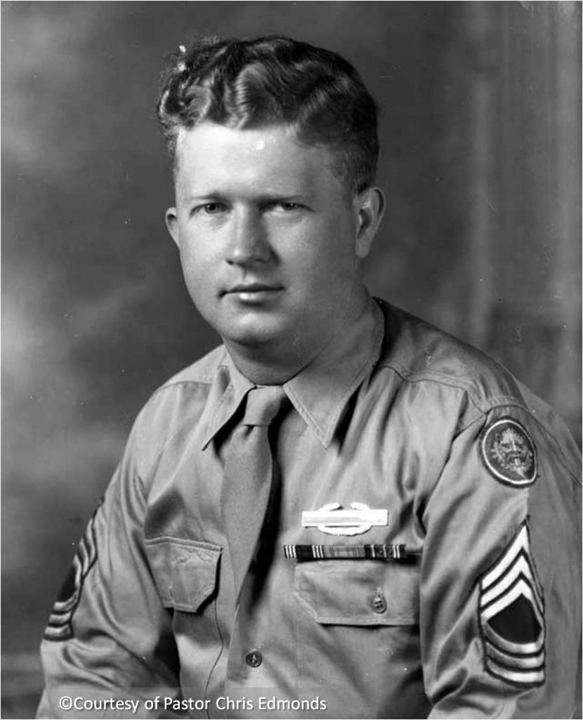
Master Sgt. Roddie Edmonds. (Courtesy Chris Edmonds)

Edmonds, who died in 1985, never spoke about the story. In fact, had it not been for his granddaughter’s college assignment many decades later, the officer’s story might have remained forever untold. But thanks to the subsequent persistence of Edmonds’ son, Pastor Chris Edmonds, the heroic story surfaced.
On Monday night the Jewish Foundation for the Righteous posthumously honored Edmonds with its “Yehi Or” (Let There Be Light) Award.
To understand why Edmonds never spoke about his courage — not to his wife, his children, nor to his grandchildren — is to understand something about the man himself.
“He was a man of faith. He never bragged on anything but G-d. Well, maybe his sons sometimes,” said Edmonds in a telephone interview days before he was scheduled to accept the award on his father’s behalf at The New York Public Library.
JFR chairman Harvey Schulweis also noted Edmonds’ humility.
“Over the years we have worked with and honored many Holocaust survivors and their rescuers, but the story of Roddie Edmonds saving 200 Jewish-American soldiers truly distinguishes the man and leader he was. Though unfortunately we were not privileged enough to honor him during his lifetime, we hope that this year’s Yehi Ohr Award will show the gratitude and appreciation that our nation has on behalf of his heroic actions that day,” JFR chairman Harvey Schulweis said.
Several of the surviving Jewish GIs Edmonds saved attended the private event.

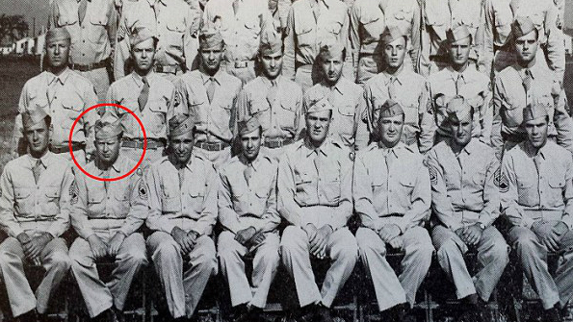
Master Sgt. Roddie Edmonds, circled in red, at Camp Atterbury. (Courtesy Chris Edmonds)

Edmonds landed in Europe in the autumn of 1944 with the 106th Infantry Division, and then fought his way to the Belgian-German border as part of the 422nd Infantry Regiment.
On December 16, he found himself involved in what came to be known as the Battle of the Bulge. On December 17, he had his last hot meal.
“Believe me when I tell you we really had to keep our heads down. This was no picnic,” Edmonds wrote in his wartime diary.
Though outgunned and outmanned, the Americans delayed the Germans long enough to allow General George Patton’s Third Army to ultimately come to the rescue.
But the rescue came too late for the 422nd regiment; Germany’s Second SS Panzer Division encircled them, and on December 19, Edmonds became one of thousands of Americans taken prisoner.
“We surrendered to avoid slaughter. We were marched without food and water, except for the few sugar beets we found along the road and puddles,” the 25-year-old wrote in his diary shortly after being transported to the camp which held upwards of 50,000 Allied soldiers near Ziegenhain.
As the highest-ranking office there, Edmonds, responsible for the camp’s 1,292 American POWs, relied on his faith and sense of duty to keep the men safe and to keep morale as high as possible, said his son Chris.
One day in January 1945, a month after his capture, the Germans ordered all Jewish POWs to report outside their barracks the following morning. Edmonds knew what awaited the Jewish men under his command, so he decided to resist the directive. He ordered all his men — Jews and non-Jews alike — to fall out the following morning.
Upon seeing all the soldiers lined up, the camp’s commandant, Major Siegmann, approached Edmonds. He ordered Edmonds to identify the Jewish soldiers.
“We are all Jews here,” Edmonds said.
Irate, the commandant jammed his pistol against Edmonds’ head and repeated the order. Again, Edmonds refused.
‘We are all Jews here’
“According to the Geneva Convention, we only have to give our name, rank and serial number. If you shoot me, you will have to shoot all of us, and after the war you will be tried for war crimes,” Edmonds had said, according to one of the men saved that day.
The younger Edmonds regards all 1,292 men as heroes.
“When Dad got the orders and told his men that they were not giving up the Jewish soldiers, they could have said no,” he said. “When the commandant pressed the gun against my father some of the men could have pointed out the Jews. None of them did that. They all stood together.”
“What he did [that morning] sent an incredible bolt of hope through the men. They saw they could resist. They saw they could survive,” Edmonds said.
After 100 days of captivity and near-starvation, the elder Edmonds returned to his home near Knoxville, Tennessee. He found work at Oakridge National Labs, and then, because he had joined the National Guard, he was again deployed, this time to Korea. He came home, married, and had two sons. He coached their baseball teams and worked in sales.
He spoke little of his wartime experience and nothing of that day.
‘I asked him about it several times as a teenager and in college. He’d say “Son, there are just some things I’d rather not talk about”‘

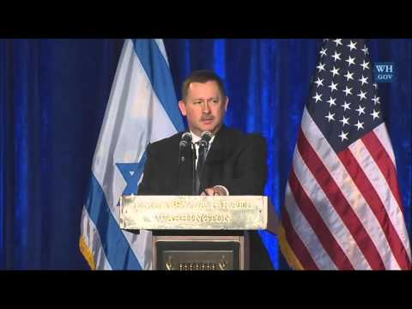
“I asked him about it several times as a teenager and in college. He’d say ‘Son, there are just some things I’d rather not talk about,’ and tell us to read the diary,” Edmonds said.
They remained in the dark until several years ago when one of son Chris Edmonds’ daughters started working on a college assignment that required her to make a video about a family member. Her grandmother gave her the diary her husband Roddie had kept during his time as a POW.
The JFR award comes just a year after Edmonds became the only American soldier, and one of just five Americans, named Righteous Among Nations by Yad Vashem. He is also the only Righteous Among Nations to have saved American Jews.
Edmonds, “was a leader who wouldn’t ask his men to do anything he wouldn’t do,” said son Chris.
“This story is a clarion call to love one another regardless of our choices, or faith. He stood against oppression. He stood for decency. He stood for humanity. This thing we call life — it’s about all of us, not one of us,” Edmonds said.
“This award is called ‘Let There Be Light.’ Dad would light up a room,” said Edmonds. “When he left you would wish he were still there.”

Reprinted from the November 30, 2016 edition of The Israel Times.

