Parshas Pinchos – פרשת התמיד
Olympic athletes dedicate their entire lives to prepare for the moment they hope will bring home the gold. It’s amazing how years of intense training and focus are invested in pursuit of their dream to achieve the epitome of success in their field of endeavor. All this effort is put in even though there are numerous other athletes who hope to take the gold as well. They may never come close. They may never make it onto the Olympic team at all. Yet, they will doggedly pursue their goal with a single-mindedness and relentless, grueling effort that is an achievement in itself.
The mark of the true Oveid Hashem is his similar single-mindedness to focus his כוחותon עבודת המידות והמצוותin an effort to attain perfection and create נחת רוחfor the Eibishter. There may be others who do it better. He may never achieve recognition as one of the GedolaiHaDor. But every day he focuses his energies with renewed focus and effort.
The Ribono shel Olam brought each of us into this world to accomplish some תיקוןthat may only come about from the one time we made the effort. An entire lifetime may be invested in preparation for one moment of perfection in Middos or Mitzvos. Chazal teach of the Malochim that are created in order to say Shira once and then plunge into the נהר דינור, a river of fire, to disappear forever. R’ Chaim Mintz, shlit”a, once said that Chazal don’t just impart heavenly trivia because it’s so interesting. There’s always a lesson to be learned. The lesson here is to be prepared and ready for the moment that we will achieve our תיקון. It may only a one time effort that will have made a lifetime of focus pay off.
There is a Mesorah that the ChachamTzvi, while yet a Bachur, spent a period of time as a boarder in the home of an ancestor of the Rothschilds. The Baal HaBayis was a wealthy magnate and his family lived very comfortably. The young TalmidChochom took no notice of the opulence surrounding him as he devoted night and day to his learning. Often, to the chagrin of some of the household, he would return to his lodgings very late at night. They found it disturbing that he followed his own schedule with disregard to the others. The Baal HaBayis refused to say anything to the young ChachamTzvi. He felt it was a privilege and Zechus to have this light of Torah shining in his home.
One day, the Baal HaBayis had experienced some rough dealings in his business. He came home very short-tempered. When the ChachamTzvi came in once again at a late hour, the Baal HaBayis lashed out at him for his inconsideration. As soon as he said his biting words, he became overwhelmed with shame for being פוגעin Kovod HaTorah. He broke down in tears and begged מחילה. The next day a delegation arrived from out-of-town to offer the already famed TalmidChochom the position of Rov in their city. The ChachamTzvi accepted and immediately packed his bags.
In taking leave of his host, the ChachamTzvi informed him of the reward awaiting him for the efforts the Baal HaBayis made to be anאכסניא לתורה. It was destined that I leave here today. Had you controlled yourself just one more day, you would have merited generations of GedolaiHaDor. Instead, as a reward for hosting me all this time, you will enjoy generations of greatness in material wealth instead.
We may never realize when we have achieved our goal. Ours is to maintain focus and go for the gold.
Have a wonderful Shabbos, yk
L’RavchaD’milsa
Thursday, Parshas Pinchos - 22 Tamuz
R’ Shlomo Karlin (1740 or 1738 -1792). A student of the Maggid of Mezritch, as well as of RavAharonHaGadol of Karlin, whom he succeeded in 1772. He died Al Kiddush HaShem, stabbed by a Cossack while in the midst of the Amida prayer.

Erev Shabbos Kodesh Parshas Pinchos - 23 Tamuz
Earliest Shabbos of the year in the Southern Hemisphere
Rabbeinu Moshe Cordeveroauthor of TomerDevorah, composer of Selichos Yom Kippur Kattan. (1522-1570). The Remak was the son of Rav Yaakov, one of the exiles from Cardova, Spain. He studied under the great kabbalists Rav Shlomo HaLeviAlkabetz (who would become his brother-in-law) and Rav Yosef Karo. Rav Chaim Vital was among his greatest talmidim. He was the author of TomerDevora and PardesRimonim. In the latter book, he systematized all kabbalistic knowledge that had been revealed until then. In his sefer, Ohr Ne’erav, he explains the necessity of studying Kabbalah but also criticizes those who study this subject without prior Torah knowledge, pointing out that one must first study Torah, Mishnah, and Gemara before studying Kabbalah. He also wrote a comprehensive commentary on the Zohar entitled Ohr Yakar, but it was not published for 400 years. Publication of this multi-volume work was finally begun in 1962 and completed in 1989. Although he served as Rosh Yeshiva and as a Dayan, his fame rests on his contribution to Kabbalistic literature and thought.

Shabbos Kodesh Parshas Pinchos -24 Tamuz
Shabbos MevorchimChodesh Menachem Av
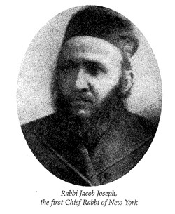
Rabbi Yaakov Yosef (1840-1902). Born in Krozhe, a province of Kovno, he studied in the Volozhin yeshiva under the Netziv, where he was known as "Rav Yaakov Charif" because of his sharp mind. He was one of the foremost students of RavYisraelSalanter. In 1888, he accepted an invitation and became the first and only Chief Rabbi of New York, as elected by the Association of American Orthodox Hebrew Congregations. He also took an active role in establishing the Etz Chaim Yeshiva, founded in 1866. He authored Le'Beis Yaakov.

Mon., Parshas Matos-Masei - 26 Tamuz
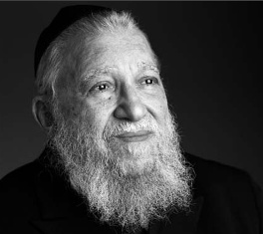
RavNachman Bulman (1925-2002). His parents, Reb Meir and Ettel Bulman were Gerrerchasidim who had moved to the Lower East Side from Poland. Reb Meir had lost his first wife in childbirth and his second wife in a pogrom. He had also lost two children. In their 40s, the Bulmans received the ImreiEmes of Ger for a bracha for children. The result of that blessing was Nachman, who was born in New York. He attended Yeshivas Rabbenu Yitzchak Elchonon and then studied in its rabbinical program. He received semicha and a B.A. (in philosophy) from Yeshiva College. During the week, he learned in the Litvishe yeshiva way. On Shabbos and Yom Tov he absorbed the atmosphere of his parents' Polisheshteibel with a love of chassidus. For years, he was also a frequent visitor at the tishin of the ModzitzerRebbe, RavShaulYedidyaTaub. In 1950, Reb Nachman married Shaindel Freund, his aiysheschayil for 52 years. He found a position in the town of Danville, Virginia, a small Orthodox community which consisted of about 30 families. He held the position for 3 years. From 1953-1954, Rabbi Bulman served as mashgiach in Yeshivas Rabbeinu Yitzchak Elchonon. He was once again pulled to the world of rabbonus when he became rov in South Fallsburg, N.Y., in 1954. During this time, he founded the National Conference of Synagogue Youth (NCSY), together with Rabbis Weitman, Goodman, and Chait. His next position was as head of AdasJeshurun synagogue in Newport News, Virginia, beginning in 1957. Rabbi Bulman then returned to his position as mashgiach in Yeshiva University from 1962-1963, and then worked for Torah Umesorah from 1963-1967. In 1967, he took his next rabbinical position as the rav of the Young Israel of Far Rockaway. During this time, he founded Sarah Schenirer High School and Seminary in 1968, and the Yeshiva of Far Rockaway (Yeshivas DerechEison), and he taught in both places.

Tues., Parshas Matos-Masei 27 Tamuz
Yoseif HaTzaddik ben Yaakov Avinu
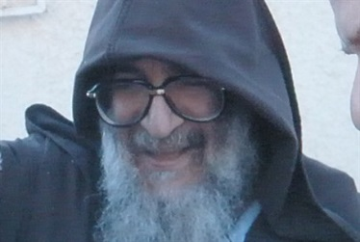
Baba ElazaarAbuchatzeira(1948-2011) of Be’erSheva. Grandson of the legendary Baba Sali, ADMO”R R’ Yisroel Abuchatzeira. Felled by the hand of a knife-wielding madman.

Wedns., Parshas Matos-Masei – 28 Tamuz
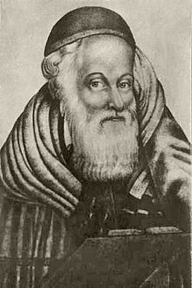
Rav Moshe Teitelbaum, avbeis din of Ujhely, Hungary (1759-1841), author ofYismach Moshe, founder of Satmar and Sighet dynasties. He was a direct descendent of the Rema. He served as Rav and Av Beis Din of Shinova at the age of 26. He made a shiduch with his only daughter to a chasid of the Choseh of Lublin, and shortly thereafter became of follower himself. He taught RavYechezkelShragaHalberstam of Shinova.

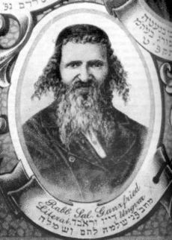
Rav Shlomo Ganzfried (1804-1886), author of KitzurShulchanAruch. born in Ungwar, Hungary. His father died while he was still young, and he was raised by the Rav of Ungwar, RavTzvi Hirsch Heller. Other works includeKessesHaSofer, a halachic primer for Sofrim.Pnei Shlomo and Sheim Yosef on Shas.TorasZevach, a halakhic handbook Shochtim.SeferApiryon, a commentary on Chumash.LechemV'simlah on the laws of Niddah. OhaleiSheim on the official spellings of Hebrew names, as pertaining to gittin.SeferGaluy A letter written at the time of the Congress of 1869.

Rav Sinai of Zhemigrod (1870-1941) Rav Chaim of Sanz especially treasured his fourth son, Rav Baruch of Gorlitz, saying that a lofty soul such as his had not descended to the world for the past three hundred years. When he was fourteen, Rav Baruch married the daughter of RavYekusielYehudahTeitelbaum, the Yitav Lev of Sighet and a talmid of Rav Chaim Sanzer, and in 1870, Rav Sinai was born to the couple, in Rudnik. After reaching adulthood, Rav Sinai served as rav for several years in Gorlitz and Koloshitz, before taking over a permanent position in Zmigród, a scenic mountain town about 150 kilometers from Cracow, where Jews had lived since at least 1410. Zmigród had a relatively small community - a 1900 census records it having 1,240 Jews out of a total population of 2,249. Nowadays, this region of Austrian-controlled Galicia is part of Poland. He escaped the Nazis by fleeing to Lemberg, Galicia, but was exiled to Siberia by the Soviets. He did not survive the trip.
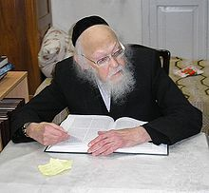
Harav Yoseif SholomEliyashav (1910-2012)

Thursday, 29 Tamuz-Erev Rosh Chodesh Menachem Av, Yom Kippur Koton
RavYochananHaSandler

Rav Shlomo Yitzchaki (Rashi) (1040-1105). He traced his ancestry through the Tanna'imRavYochananHaSandlar and Hillel the Elder back to King Dovid. He received his early talmudic training from his father, Rav Yitzchak. At a young age he went to Worms, Germany, to broaden his knowledge under Rav Yaakov ben Yakar. At the age of 25 he returned to his native Troyes. Amazingly, Rashi accomplished all his work during the Period of the Crusades, when life was extremely dangerous for the Jews. Rashi had three daughters, who were great scholars in their own right, but also were married to men of greatness, and had children known as the "BaaleiTosafos," the most famous of whom, Rav Yaakov ben Meir, was known as Rabbeinu Tam.

Rav Yehoshua Boaz, the ShilteiHagibborim, Italian commentator to Rif (1612)

Erev Shabbos KodeshParshas Matos-Masei, Rosh Chodesh Menachem Av
AharonHakohen
Elazar ben AharonHakohen
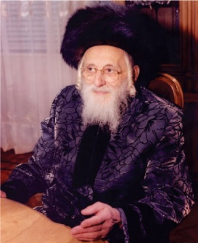
Rav Shlomo Halberstam (1908-2000), son of Rav Ben Zion, grandson of Rav Shlomo, founder of the Bobov dynasty. At the outbreak of World War II, he and his father escaped to Lemberg. On the fourth of Av 1942 his father was killed, and Rav Shlomo escaped to the Bochnia Ghetto. In Bochnia, the Rav lost his Rebbetzin and two children. He managed to escape with his only surviving child, Naftali, to Budapest, and then to Bucharest. Rav Shlomo is believed to have been the last remaining Chassidic rabbi to have survived the Holocaust. Born in the Galicia region of central Europe, RavHalberstam arrived in the United States in 1946, alone and indigent after his group was largely obliterated by the Nazis. During the war, Halberstam dressed up as a nun in order to rescue other Jews, hiding them in the false bottom of a coal truck. The BoboverRov is widely credited with rebuilding the Bobover community in the United States and spearheading the creation of numerous Bobovercommunities and institutions around the globe.

Subscription to the weekly Timely Messages Dvar Torah/L’RavchaD’Milsa Weekly Almanac at
timelymessagesweekly@gmail.com and now available for download at www.parshasheets.com

