

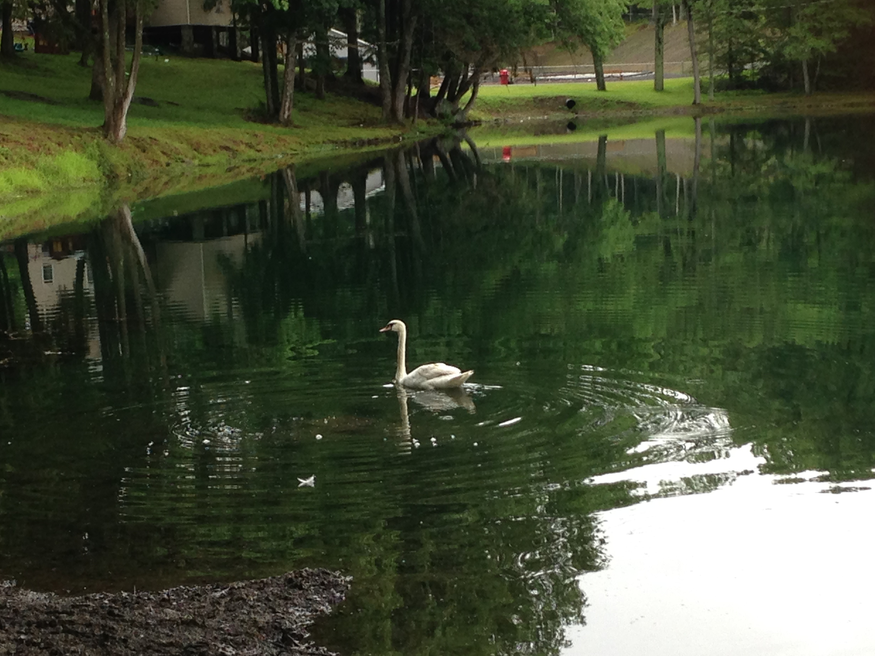
“RABBI’S MUSINGS (& AMUSINGS)”
Erev Shabbos Kodesh Parshas Chukas
Pirkei Avos perek 5
9 Tamuz 5776/ July 15 2016

Last week, Rabbis Noach Sauber and Hersh Kasirer, the learning directors at Camp Dora Golding, launched what they called the “Say Thank You” program. Rabbi Sauber introduced the program by reiterating to the campers about the great importance of reciting berachos as a way of thanking Hashem for all the gifts we take for granted every day. Then he explained that for the next week, each afternoon during 'Rest Period', when campers frequent and patronize camp's canteen, he and/or another rebbe would be stationed on the canteen porch with a marker in hand. Every time a camper would recite a beracha out loud a box would be filled in on a large poster especially made for this program. The goal was to have 2500 berachos recited carefully by the end of the week.
What made the program even more meaningful was that it was dedicated in loving memory of Rabbi Kasirer's father, Rav Moshe ben Tzvi Halevi, who was niftar less than a month ago.
The “Say Thank You” program began on Sunday and was an immediate success. There was an immediate heightened awareness regarding saying berachos generally all around camp, even not during Rest Period.
On Tuesday morning, Rabbi Sauber was going for an early morning walk when he noticed a lone white swan swimming serenely in camp's lake.
It was bizarre because in his over two decades coming to camp, Rabbi Sauber (as well as myself) never remember ever seeing a swan in the lake. The swan remained there throughout the day, swimming peacefully on the lake, even as campers boated alongside it. It became an instant camp celebrity, and was even named Poochy (I didn't chose the name; I'm just the reporter).
Then suddenly, as soon as mincha ended, many of us saw the swan take off and fly over the shul and out of camp. It has not been seen since. (There are signs posted in camp promising a reward for anyone who returns Poochy to the lake).
So what's the big deal you ask? We were very intrigued by the sudden mysterious appearance of the pristine white swan for almost an entire day. As per Rabbi Sauber's suggestion, I looked up in Perek Shirah what shirah the swan sings to Hashem. It turns out the swan is not directly mentioned. But there is the “avaz shebabayis” which is translated as a duck, which the swan is closely related. (In the Artscroll edition of Perek Shirah the picture of the avaz shebabayis is of a swan). What is the shirah of that species?
Remarkably, it’s shirah is “Hodu laHashem kiru b’shemo - praise Hashem, call out in His Name”. I don't know if there is any other animal's shirah that seems more directly connected to the recitation of berachos.
By Thursday afternoon (a day earlier than expected) camp reached the 2500 berachos mark. The entire camp enjoyed a special dessert on Shabbos in celebration.
It seems somewhat eerie that a swan settled on the lake in the center of camp for an entire day, right in the middle of the berachos contest.
But if you're not easily moved by such occurrences and aren't impressed with Poochy's berachos connection, still this article can serve as a chizuk and reminder for all of us to try to recite berachos with a little more fervor and feeling.
It's been said so often that the key to happiness is not having more but appreciating more. So whether you hear the swan sing “Hodu laHashem” or not, we must make sure that we fulfill that song to the best of our ability!
Shabbat Shalom & Good Shabbos,
R’ Dani and Chani Staum

