Shabbos Stories for
Parshas Nitzavim-vayeilech 5777
Volume 8, Issue 56 25 Elul 5777/ September 16, 2017
Printed L’illuy nishmas Nechama bas R’ Noach, a”h

For a free subscription, please forward your request to keren18@juno.com

Rabbi Yosef Zundel of
Salant and the Widow

A widow once approached Rabbi Yosef Zundel of Salant, O” BM.
“Excuse me,” she said, “but for the last hour I have been looking for a water carrier. Would you like to earn a few Perutos (pennies)? Please go and draw me a few pails of water, and carry them to my home.”
She had mistaken him for an elderly pauper. Rav Yosef Zundel happily complied and carried five full water pails to the widow’s home. When he had completed the task, the woman attempted to pay him. Rav Yosef Zundel, however, didn’t want to be paid for his work, and told her that he would permit her to pay him the next time he would draw water for her.
Sometime later, the widow was informed of the true identity of her “water carrier.” Horrified, she ran to the house of Rav Yosef Zundel and begged him for forgiveness.
“Forgiveness for what?” asked Rav Yosef Zundel. “On the contrary, I owe you a heartfelt thanks for giving me the opportunity to utilize my body in the performance of an act of kindness.”
Comment: [Last] week’s portion contains a double reminder for us to follow in Hashem’s ways (Devarim 26:17 &28:9). The Talmud (Sotah 14a) delineates the actions of Hashem: He clothed the naked (Adam and Chava), visits the sick (Avraham Avinu), comforted the mourners (after Sarah’s death), buried the dead (Moshe Rabeinu), and so on.
The Talmud states that by doing these things we will be considered walking after Hashem. We should also learn to imitate Hashem’s character traits. The Talmud (Shabbos 133b) states” just as Hashem is compassionate and merciful so should you be.” Just as Hashem has a special place in His heart (so to speak) for orphans and widows, so too, we should go out of our way for the downtrodden. When Rabbi Yisroel Salanter, O”BM, sent students to bake Matzos with a widow, he instructed them to make the Matzos kosher. When the students asked Rav Salanter what that meant, the Rav replied that due to her tragedy this woman is very sensitive. “She might not have all the ingredients ready to go when you arrive – be patient with her. Make the experience for her a wholesome and kosher one!”

Reprinted from the Parshas Ki Savo 5777 email of Torah Sweets Weekly.

Story#1030

The Divorce Solution
From the desk of Yerachmiel Tilles
editor@ascentofsafed.com

In 1740, the Baal Shem Tov came to visit the city of Slutsk. Many of the local inhabitants came to greet him. Among them was the aged scholar, Rabbi Uri Nosson Nata, who as a youth was known as the ilui of Karinik, near Brisk.
His son, Shlomo, who had initially been educated at home by his father, left home at the age of fourteen to seek the scholarly environment of Yeshivas - first in Vilna, then in Jorodna, and then in Cracow. There he had met a prominent scholar, Rabbi Menachem Aryeh, who was one of the hidden righteous. Reb Menachem accepted him as his disciple in the study of chassiduton condition that their connection is kept secret.
At the age of twenty-two, Shlomo returned to his childhood home in Slutsk. His father was overjoyed with his progress in learning, and arranged a marriage with the daughter of the leaseholder of an inn, Reb Eliyahu Moshe, who lived in a nearby village.
About a half a year after their marriage, however, the young wife tragically, lost her sanity. Since she was not in a mental state to legally accept a bill of divorce, Reb Shlomo was unable to remarry.
During the Baal Shem Tov's visit to Slutsk, Shlomo's father, Uri Noson Nata, described their sad situation to him and asked for his advice and blessing. Soon thereafter, the unfortunate young woman's father, Eliyahu Moshe, also approached the Baal Shem Tov and asked for his advice and a blessing for her recovery.
Later the same day, the Baal Shem Tov invited both fathers to meet with him together. He politely asked if either of them bore a grudge against the other. The bridegroom's father, Reb Uri Nosson Nata, had nothing but praise for his mechutan (relative by marriage), the bride's father. He extolled that despite the pressure of business, the innkeeper fixed times for the study of Torah, maintained a hospitable house that was open to all comers, supported Talmudic scholars generously, and maintained his son-in-law in the most respectable manner.
Since Shlomo had been mentioned, his father-in-law, Eliyahu Moshe, now spoke most highly of his noble character. He was clearly proud of his son-in-law who, in addition to his assiduous study schedule, always found time on weekdays to conduct study circles for the simple farming folk who lived round about, teaching them Chumash with Rashi's commentary, and the moral lessons of Ayn Yaakov; and on Shabbos he would read for them from the Midrash and the Ethics of the Fathers.
While teaching, he imbued them with a brotherly love for each other, explaining to them that no man's profit ever came at the expense of that which Divine Providence had destined for another. In a word, he was well loved by the villagers from all around, and they all were praying that his young wife would be restored to complete health, and that he would return to teach them as in happier times.
The Baal Shem Tov listened carefully to both fathers, and then said: "With GÂ·d's help, I will be able to help the young woman return to complete health and restore her mind to its original clarity - but only on one condition: That when this happens the young couple not live together, and when several days have passed, and she is in a fit state according to the Torah Law to accept a Get (rabbinically sanctioned document of divorce), she accepts it from her husband with a willing heart."
The two fathers were stunned! Rabbi Uri Nosson Nata proposed various legal objections to such a divorce, and Reb Eliyahu Moshe argued that his daughter would be grieved by such a procedure, since she respected her husband highly. He was certain that his son-in-law would likewise be distressed. He himself was prepared to contribute an enormous sum to charity - in the merit of which he begged the Baal Shem Tov to pray for her recovery, but to allow the young couple to rejoin each other in the love and harmony to which they were accustomed.
The Baal Shem Tov answered unequivocally - that if they did not agree to the condition that he had stipulated, he would not be able to help them.
A few days later, they called on the Baal Shem Tov together with the young husband, and told him that they accepted his condition - though of course they could not guarantee that his stricken wife would agree. Upon hearing their reply, the Baal Shem Tov instructed Reb Eliyahu Moshe to immediately go home and tell his sick, ailing daughter that the Baal Shem Tov had come to Slutsk and had requested for her to come to speak with him about an important matter.
Hearing that, the two fathers looked at each other in amazement.
"But Rebbe, for the last six years," Eliyahu Moshe protested, "she has not uttered a syllable! She just sits between the stove and the wall, and can barely be fed. In a word, my poor daughter is utterly out of her mind. How can I possibly explain to her your request?"
The Baal Shem Tov did not reply.
Making his way homeward with a heavy heart, Eliyahu Moshe remarked to his mechutan that if the Baal Shem Tov had seen the state in which his daughter was to be found, he would not have spoken as he had. Uri Nosson Nata, in turn, sighed in sympathy from the depths of his heart for everyone suffering from this matter.
Not so his son, Shlomo. Before his marriage, when he had been a disciple of Rabbi Menachem Aryeh, he had been introduced to teachings of the Baal Shem Tov. Now that he had met him in person, and had heard his teachings, he became attached to him with all his heart. He therefore told his father-in-law that he thought they should follow the instructions of the Baal Shem Tov implicitly. Reb Uri Nosson Nata added that since they had already accepted the far more difficult condition of their daughter being crazy, they should certainly proceed to carry out the instruction that they attempt to speak to the young woman.
Opening the door to his house, Reb Eliyahu Moshe found his daughter sitting in her accustomed corner behind the stove. He told his wife all that the Baal Shem Tov had said, adding that he was widely reputed as a miracle worker.
To their amazement, their daughter suddenly rose from her. She approached her mother and father quietly, and in a voice they had not heard for six years, asked who was this person who worked wonders. They told her that the man about whom they were speaking was calleded the Baal Shem Tov, a renowned tzadik. She answered that before hearing any more, she first wanted to immerse herself in a mikveh for purification.
After going to the mikveh, the young woman began eating, speaking and sleeping as if completely normal, though she felt very weak. On the third day, she had a high fever and in her delirium spoke about the Baal Shem Tov. When her father heard her crying and asking to be taken to the wonder-worker, he was suddenly reminded of what the surprising sudden turn of events made him forget - that the Baal Shem Tov had asked to see her. He told her of the Baal Shem Tov's request and she was visibly happy to receive the message. On the very next day, accompanied her parents, she made the journey to Slutsk.
Reb Shlomo soon heard of his wife's recovery, for his father-in-law had sent a special messenger with the news. He now began to speak with his father about the principles of chassidus taught by the Baal Shem Tov. He explained the emphasis which the Baal Shem Tov gave to the mystical teachings of the Kabbalah; the workings of Divine Providence not only for man, but regarding all created things, even the inanimate; the intrinsic holiness and worth of even the simplest fellow Jew; the importance and obligation of Ahavas Yisrael; serving G-d with a joyful heart; and so on.
The aged scholar pondered these matters all day and throughout the following night. On the next day, he set out to tell the Baal Shem Tov what his son had told him of his teachings, and added that he desired to become his disciple. At the same meeting, he told the Baal Shem Tov of the good news that had just reached his son. The Baal Shem Tov replied that on that same day the young woman was again unwell, but that when her father would carry out his mission she would recover and come to see him.
When the young woman and her parents arrived at Slutsk, she and her husband entered the room of the Baal Shem Tov. He told them that they would have to divorce. With bitter tears, the unfortunate young woman told the Baal Shem Tov how highly she respected her husband for his refined character. If, however he decreed that they should divorce, he must surely know that she was unworthy of such a righteous husband, and felt it her duty to comply. Shlomo, likewise moved, told the Baal Shem Tov that his wife exemplified all the noble attributes by which the Sages define a good wife. If, however, the Baal Shem Tov ordered that they divorce, he too would be obey.
The Baal Shem Tov arranged to see them in four days; he would then arrange the legalities required by Jewish Law.
For the next three days the young couple and their parents fasted and prayed. On the fourth day, with heavy hearts, they made their way to the tzadik. They found a Rav, a scribe and two witnesses already waiting. The Baal Shem Tov asked them if they agreed wholeheartedly to the divorce. They answered that they believed that whatever the Baal Shem Tov told them would be for the best, and since they loved each other, each of them was willing to proceed with the divorce -- for the benefit of the other.
The Baal Shem Tov retired to another room and stayed there for some time.
When he returned he related the following: "Six years ago a threat of terrible suffering hung over your lives because of accusations of the Heavenly prosecuting angel. The Heavenly court's verdict was that you should both undergo the troubles that you have experienced these last six years. But now that you have shown great faith in my words, to the extent that you were both willing to proceed with a divorce. This very faith has freed you from the decree of the Heavenly court. The charge against you has been annulled. Live on happily together as man and wife. You have my blessing that your home be filled with sons, daughters and many grandchildren, and that you both live to a ripe old age."
The young couple remained in Slutsk for three years. They then lived in several major Jewish communities, until they moved to Liozna as chasidim of Rabbi Shneur-Zalman, the founder of the Chabad dynasty. In 1796 they settled in Eretz Yisrael, where they lived for fifteen years until Shlomo passed away at age 99.
~~~~~~~~~~~~~~~~~~~~
Source: Edited and supplemented by Yerachmiel Tilles from the adaption by Tzvi-Meir Cohn on his website //baalshemtov.com of a story in A Treasury of Chassidic Tales by S. Y. Zevin, as translated by Uri Kaploun.
Biographical note: Rabbi Yisrael ben Eliezer [of blessed memory: 18 Elul 5458 - 6 Sivan 5520 (Aug. 1698 - May 1760 C.E.)], the Baal Shem Tov [â€œMaster of the Good Nameâ€â€”often referred to as â€œthe Beshtâ€ for short], a unique and seminal figure in Jewish history, revealed his identity as an exceptionally holy person, on his 36th birthday, 18 Elul 5494 (1734 C.E.), and made the until-then underground Chasidic movement public. He wrote no books, although many works claim to contain his teachings. One available in English is the excellent annotated translation of Tzava'at Harivash, published by Kehos.
Connection: Seasonalâ€”Chai (18th) Elul is the anniversary of the birthday of the Baal Shem Tov in 1698, and of Rabbi Shneur-Zalman of Chabad (also mentioned at the end of the above story) in 1745.

Reprinted from the Parshat Ki Savo 5777 email of KabbalaOnline.org, a project of Ascent of Safed. www.ascentofsafed.com ascent@ascentofsafed.com

The Reward for Helping
A Poor Pregnant Woman
By Jack E. Rahmey

The following story is a living example of what that statement conveys: "There was a young girl in Israel who walked into a grocery store because she was hungry and had no money for food. On top of that she was single, pregnant and very depressed because she was contemplating terminating her pregnancy. The store owner noticed the girl and helped her with food and shelter and promised that if she would have the baby he would help her financially until she got back on her feet. She agreed and eventually became close with this grocer and his family. As time passed, she was able to get a job and care for her son on her own.
About twenty years later the grocer’s son was in the Israeli army when a sniper hit him. He would have died had it not been for another soldier that managed to reach him and bring him to safety. When the injured soldier recovered and came home, he told his parents what had happened. They wanted to find the soldier who had saved their son's life and thank him personally, but he was nowhere to be found. So they decided to put up a sign up in their store to see if the heroic mystery soldier would come forward.
About a year later, a woman noticed the sign. She said that she knew of the soldier they were looking for. The store owner asked if she knew of his whereabouts. She asked, Don't you recognize me? She reminded him that she had wandered into his store, a total stranger, pregnant and hungry, over twenty years ago. It was none other than her son who had saved their son's life on the battlefield."
From this story we can see how Tzedakah and Hesed really does save us from death and its prescription from the Torah for a life of success and happiness. Let's all take the opportunity to give as much Tzedakah as possible to the less fortunate among us and show Hashem that we appreciate all that He has given us which in turn allows us to give to others. Especially at this time, as we approach Rosh Hashanah, when we'll be praying to Hashem to judge us all for good! The Tzedakah that we give should be a merit for all of us to have a healthy and prosperous New Year! Amen!

Reprinted from the Parshat Ki Tavo 5777 email of Jack E. Rahmey with the Guidance and Teachings of Rabbi Amram Sananes.
The Rabbi and the Madman
By Rabbi Tuvia Bolton

Here is a story told some two hundred years ago. (Y'dion HaKfar 23.8.07) The Maggid of Kosnitz related the following story to his Chassidim.
Once, in a certain Jewish Polish village, the Rabbi was dying. The entire population of some two thousand people were gathered around his house waiting for the inevitable. He had been an excellent leader for almost seventy years; wise, loving, knowledgeable but stern and unyielding when necessary. But now, well into his nineties, he was on his deathbed.
Inside the house, feeling his end was moments away, he called his beloved pupil, Reb Avraham, to move closer and, in the presence of the elders of the community put his frail hands on his pupil’s head, blessed him to succeed as his successor, said the "Shma Yisroel" prayer, closed his eyes and peacefully returned his soul to its Creator.
The appointment was no surprise to anyone. Reb Avraham was a Torah genius, a charismatic speaker and leader and his fear of G-d and common sense were remarkable.
He had been at the Rabbi's side constantly since he mysteriously arrived some ten years ago and the Rabbi had been grooming him since then to take his place. But no one actually saw him arrive. Just one day the Rabbi was seen leaving his house with a young man that he said 'had been here for several months' and since then they never parted. But it was a small detail. No one doubted Reb Avraham's credentials.
After the days of mourning Reb Avraham began to fill the old Rabbi's place and everything returned to normal. He was busy day and night with the questions and problems of the community; making sure everything was according to Torah, making peace, deciding monetary issues, resolving quarrels, teaching Torah, providing for the poor and sick etc.
But one day an unusual problem arose; a madman entered their village.
He was filthy, disheveled, barefoot and was constantly jumping grunting like an animal or talking incoherently. And he was Jewish; occasionally he spouted sayings from the Talmud or from Psalms but he was very insane.
So the elders of the village went to Reb Avraham to ask him to pray for the unfortunate fellow.
But Reb Avraham refused. "What? Are my prayers any more potent than yours that I can exempt you from praying? Tonight we will all gather in the Synagogue and pray for him together.
A half hour later they were all saying Psalms and, strangely enough, the madman was there too, walking in a small circle in the corner looking at the ground before him and mumbling to himself non-stop.
But as soon as they finished the book for the first time and saw it had no effect Reb Avraham began to speak words of inspiration. The madman stood still, pointed a finger at Reb Avraham and yelled out to the startled crowd.
“What! He is going to inspire you? He is your Rabbi? Heh!! Why he and I sinned together! We left the Torah together!! Heh heh!! I'll even tell you the sins we did! Why, everything the worst gentiles do we did; we ate what they ate, drank what they drank and acted like they acted!! This you call your Rabbi??"
The entire congregation was stunned. Now he was offensive maybe he'll become violent. It was insanity. They all turned to the Rabbi to see what he would say, ready to throw the fellow out at a moment's notice.
The room was filled with silence, it was obvious that their Rabbi was going through some sort of inner turmoil and they were waiting to see the outcome. Several minutes passed and all eyes were on him.
“He's right!" Reb Avraham answered quietly. “Everything he said is true!” Again he was silent for several more minutes until finally he stood straight and said in a loud voice. "And I thank G-d for this moment!"
The crowd let out a gasp! And Reb Avraham continued.
“I didn’t recognize him when he came yesterday, but now I’m sure. Over twenty years ago we learned Torah together. We were both from the finest, most G-d fearing families and we excelled in our studies. Everyone predicted great things from us. But somehow we fell. It began slowly, we began reading foolish books, then hanging around with the gentiles until we decided to leave Judaism altogether and enjoy life. Just as he said.
“After a few years of this we finally parted our ways. I went into business while he went to university to learn philosophy. We wrote occasionally but finally we lost contact completely. I succeeded fantastically, married a gentile woman, built myself a palace with a huge estate and lived like royalty; no one had any inkling that I was a Jew. I even forgot it myself.
“But then one day when I was taking a stroll in one of my forests my dog began barking, broke away from me and ran to a spot not far from us. I approached and there lay the body of a dead Jew. "Probably some anti-Semite gentile murdered him" I thought to myself.
"Suddenly my entire being became filled with mercy. I called for my servants and ordered them to bury the man and put a marker on his grave. But from that moment something happened to me.
“I felt as though G-d sent this to awaken me to my true self. It was a sort of miracle. A few weeks later I went to the city, presented myself to the local Rabbi and told him I wanted to repent. At first he thought that I was a gentile and was either insane or trying to get him into trouble but finally he believed me. It was another miracle.
“He advised me to take a bag of money, write a note of divorce to my wife giving her all my riches and to flee to a Rabbi friend of his in a distant place to learn Torah. And that is what I did.
“Ten years ago I purposely arrived here in the dead of night so no one would see me. But when I began learning again I took to the Torah like a fish to water. In fact, with our Rabbi's guidance I remembered everything I had learned as a boy and in just a short time I became quite a scholar. But although I became the Rabbi of your community I somehow felt that it all happened too quickly and easily.
“Just now, when our visitor began to speak, my first reaction was to have him thrown out of the Synagogue. Then my second reaction was to deny it and then run away myself later tonight. I was ashamed to the bone. But now I realize that this too was a miracle of G-d; perhaps even more than the first miracles. I finally came face to face with myself.
“Now let's all pray for my friend.”
As soon as they all finished the next Psalm the sick fellow suddenly became calm, a normal expression returned to his face and he fell heavily into his seat a cured man.
"The reason I told this story" concluded the Rabbi of Kosnitz, is because it contains an important lesson.
"The miracles that brought Reb Avraham to repentance; finding the dead body, the Rabbi believing him, the ease with which he was able to leave his gentile life and remember all his Torah were almost obviously the hand of G-d; they put meaning and Judaism into his life.
“But the words of the madman were the opposite: they returned him to his past, to his selfish nature, to his own faults. And when he was able to see the hand of G-d in them; in even his faults, then he knew he had achieved true humility and truly could see, hear and feel G-dliness in all things and all occurrences:
“This is called true repentance or 'Tshuva'".

Reprinted from the Parshat Ki Savo 5777 email of Yeshiva Ohr Tmimim in Kfar Chabad, Israel.
L’Maaseh
The Defining Moment of
Rav Meir Chadosh

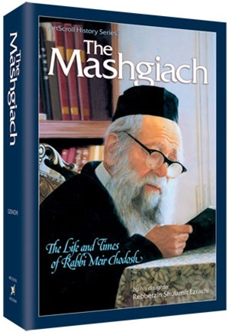
ArtScroll biography of Rav Meir Chadosh

Rav Meir Chadosh, zt”l, from the Slabodka Yeshivah, was someone who exemplified the fine Middah of Maavir a Midosav, he overlooked the faults of others and did not allow anything anyone did bother him. He accomplished this by working on it his entire life, as accomplishments like this do not just happen.
He managed to perfect this trait and teach it to his students, and everyone knew that he went to great measures to avoid hurting another’s feelings.
During World War I, it was a difficult time for European Jews. As usual, the Yeshivah Bachurim were the last to be thought of to receive any kind of aid or assistance. Rav Meir was a young Yeshivah student, and was running from place to place to seek refuge from the quickly approaching German army.
Together with a companion from the Yeshivah, they had just managed to reach a certain village where they stopped to rest for a moment, when the news suddenly arrived that the Germans were on the way.
In a panic, most of the villagers boarded their wagons and fled. The two Yeshivah students were not waiting around. Anxious to leave, they went to the outskirts of the village and waited for one of the wagons to pick them up. Suddenly, Rav Meir’s friend remembered that he had left something important in the village. He rushed back, and Rav Meir waited for him to return. One by one, the wagons passed him with the passengers calling out to him, “Quickly! Come with us! Why are you waiting here?”
He declined every ride. How could he desert his friend at a time like this? He realized that there would soon not be any more wagons leaving as they were almost all evacuated from the village, but he would not leave without his friend. Finally, he saw his friend running toward him. Just at the moment he reached Rav Meir, a wagon approached with room for only one passenger. Without a glance, his friend jumped onto the wagon with his bag, and left Rav Meir standing alone, stunned.
Rav Meir had waited so devotedly for his friend. Yet, he was left alone watching the dust of the wagon his friend was in. He had so much anger and disappointment that he said to himself, “If something like this ever happens again, I will not wait for anyone! I will just look after myself!”
Then, on the spot, he took it back and said, “Chas V’Shalom! Despite what just happened, I do not regret that I waited! It was worth it because of all the purity my Neshamah has gotten from it!”
In later years, Rav Meir Chadash would use this story as a lesson when teaching his students. He would tell them, “At that moment, despite my frustration, when I decided that I would act similarly again, something changed within me. I became a different person— a better person. That moment was a changing point in my life!”

Reprinted from the Parshas Ki Seitzei 5777 email of Torah U’Tefilah: A Collection of Inspiring Insights compiled by Rabbi Yehuda Winzelberg.
The Surfing Orthodox Rabbi Who Inspires Kids to Get Fit
By Adi Mahalel

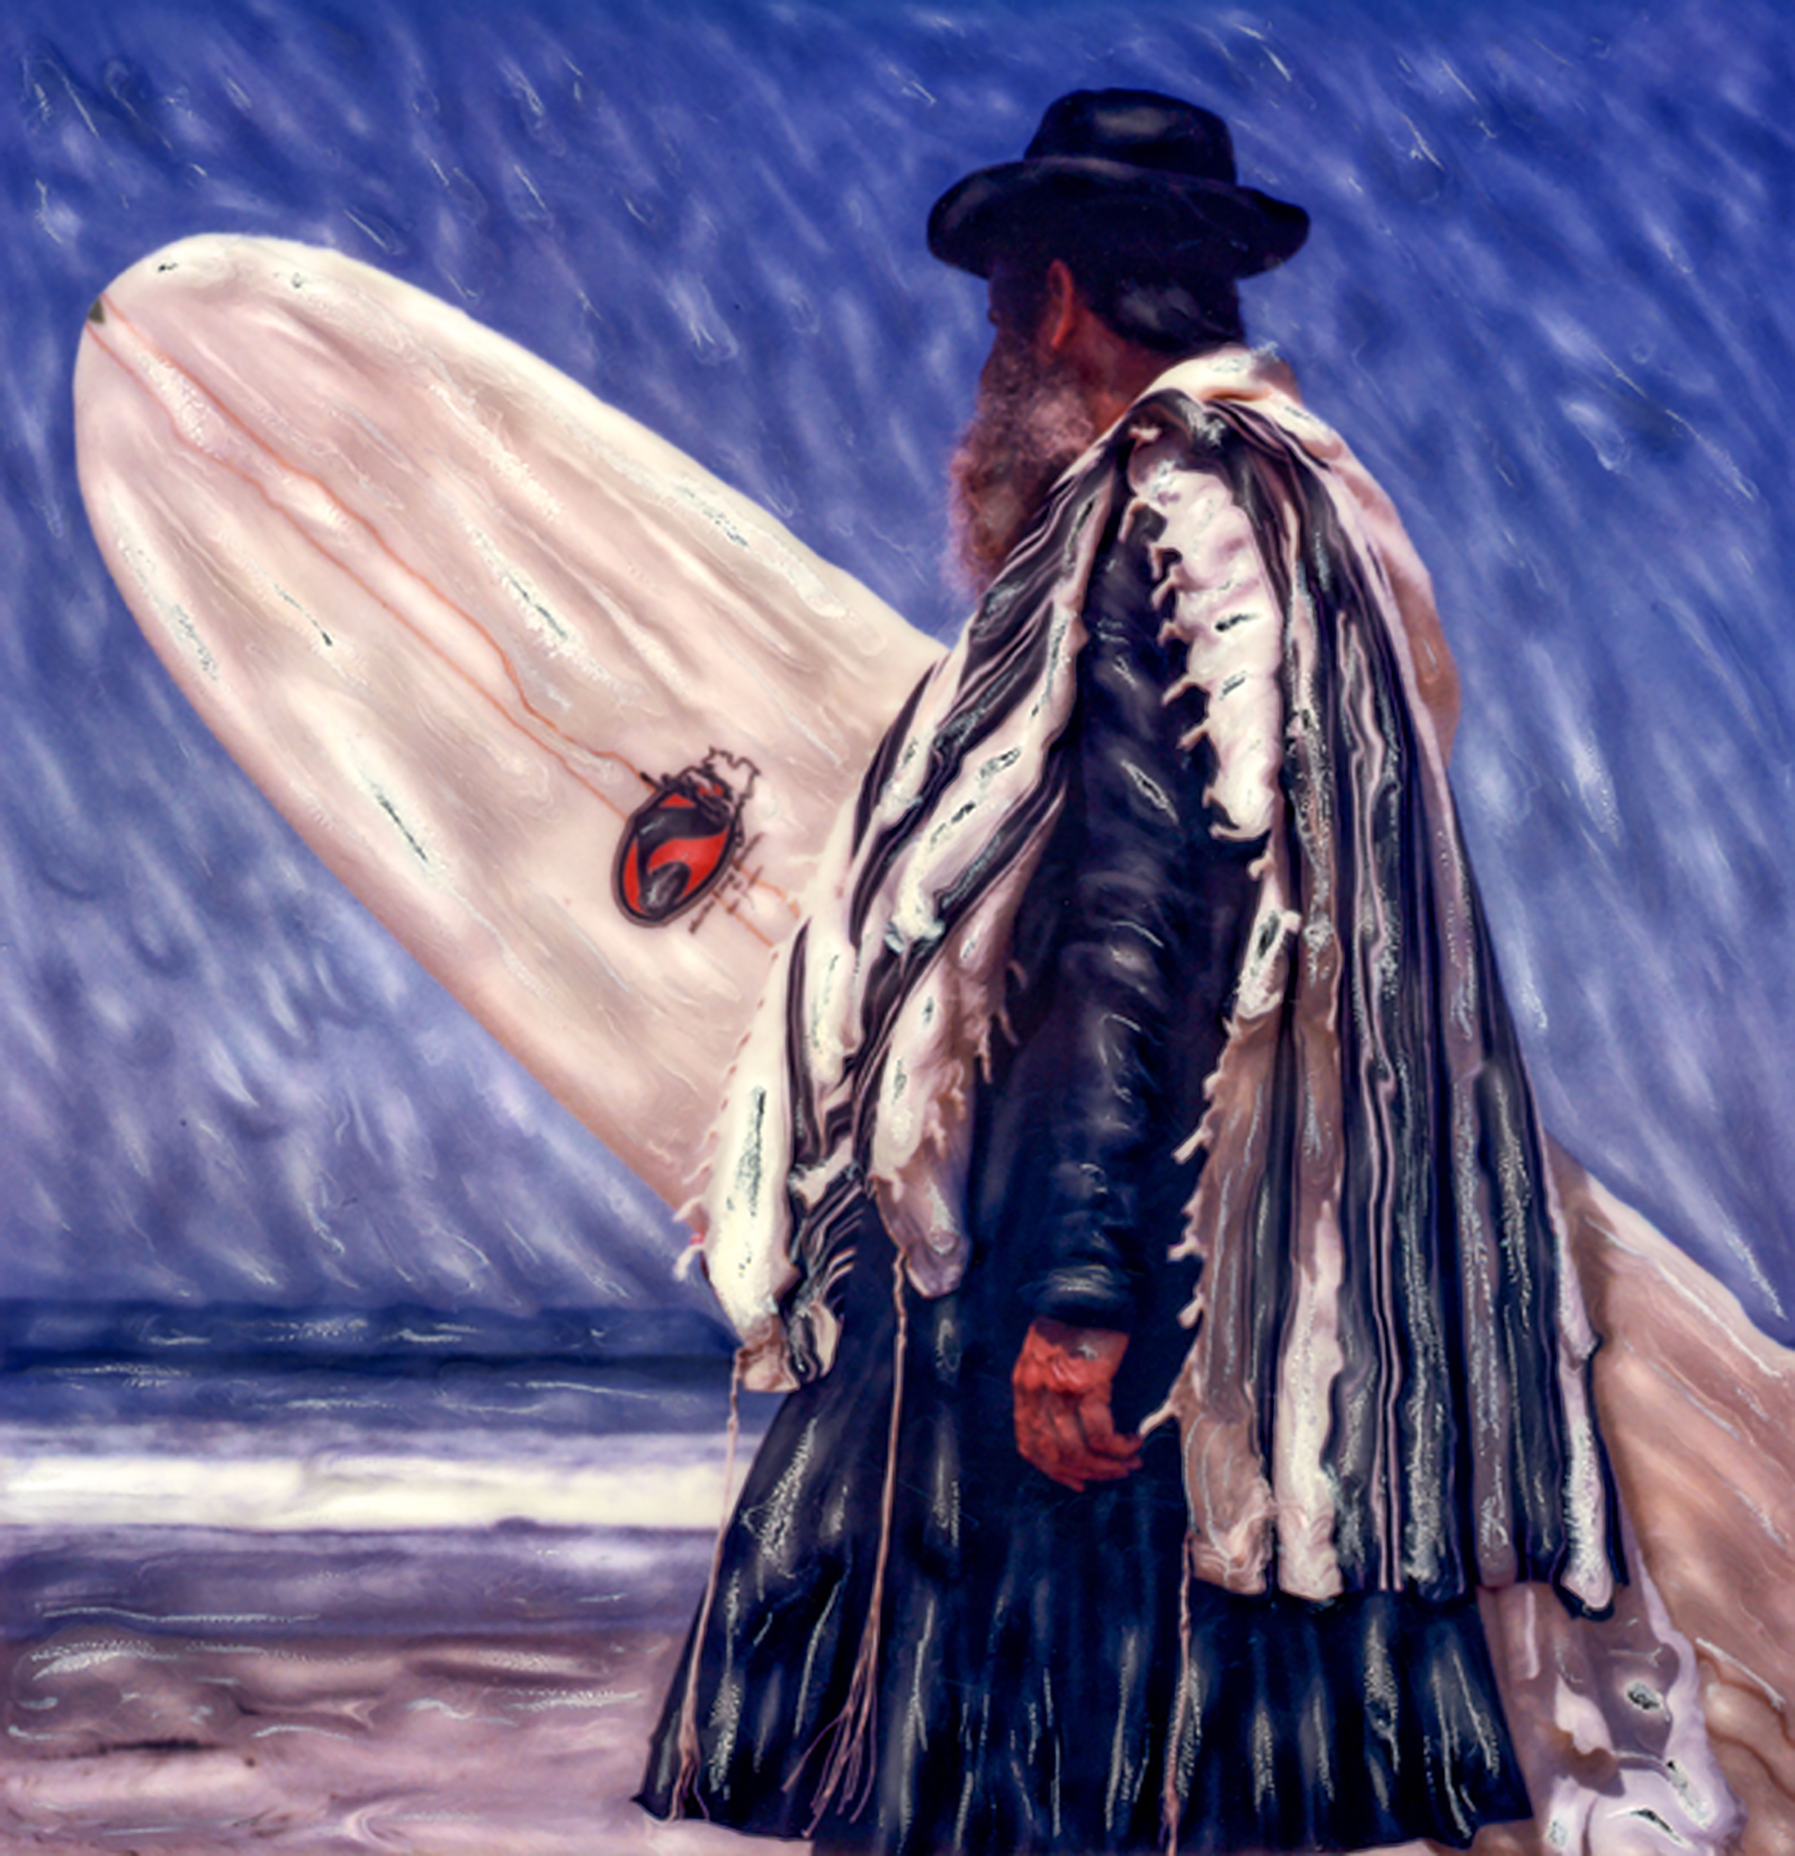

As a young boy growing up near the ocean in Los Angeles, Rabbi Nachum Shifren would often take a surfboard under his arm and hit the waves.
It wasn’t until he was 30, while living in Santa Barbara, that he became inspired by the local Chabad to become an Orthodox Jew. At this new stage in life, he was eager to draw people closer to Yiddishkeit, but at the same time he didn’t want to give up his love of surfing and of nature.
Not being a surfer myself, I decided to speak to Rabbi Shifren, hoping to better understand his intriguing character, which I soon realized was peppered with contradictions.
Knowing that traditional Jews have mostly fled from the ocean, I asked him how Orthodox Judaism and surfing could possibly go together.
“They don’t,” he replied. “I’m a pioneer. I’ve been involved with fitness and physical health all my life. I served in the Israeli army as a physical fitness instructor. Just as people study Mishna and Talmud, this too is a part of life.”
According to Shifren, it all has to do with knowing the Creator. He explains to me why people make a blessing if they don’t see the ocean for over thirty days. “The ocean was G-d’s first creation. It’s an amazing act, so powerful, so terrific and so beautiful. The waves are a sign of G-d’s strength. When you explain to people how the ocean connects to the act of creation, they start thinking: ‘This really is wonderful!’”
Shifren has written a book about his life-philosophy entitled Surfing Rabbi: A Kabbalistic Quest for Soul. Does surfing also carry a universal message for mankind? I ask. Can it bring peace and love between Jews and non-Jews?
“No question about it,” he answers immediately. “Surfing brings peace, harmony and a connection to the unity of G-d.” He plans to start an organization called the “Shloha Foundation” (shloha = shalom + aloha), to promote a holistic way of life through the ocean - a goal which could interest both Jews and non-Jews.
Shifren also hopes to inspire rabbis to begin encouraging their yeshiva students to engage in more physical activity – traditionally, a rarity in the yeshiva world. He gives private surfing lessons, and his students hail from all backgrounds. All six of his children, two of whom are on their way to becoming Chabad emissaries, know how to surf, and the whole family used to surf together.
“My kids are observant Jews, and observant Jews surf,” he tells me, half-joking. What I found especially difficult to grasp, though, is Rabbi Shifren’s politics. He aligns himself with the Tea Party, Donald Trump, the racist Jewish teachings of Rabbi Meir Kahane and the anti-Muslim group, the English Defense League, in England. Hearing him speak about peace, the ocean, spirituality, and surfing, you’d think he would believe in peace and harmony among all people without exception. But he doesn’t. And yet, he doesn’t deny that there are contradictions in his beliefs.
He bluntly says that he doesn’t mix surfing and politics. He argues, not so convincingly, that these are two separate spheres.
But how can you separate the beautiful noble ideas behind surfing from one’s politics? Especially when the politics include a message of hate?
“I don’t believe that all people are brothers,” he declares, “but I do believe that surfing can create unity between the nations of the world.” He’s willing to teach surfing to Arabs and Muslims, but won’t teach Jewish and non-Jewish students together because he believes that could encourage Jewish assimilation.
I mentioned that if he would teach Muslim and Jewish students together, it could improve understanding between them. But Rabbi Shifren didn’t seem convinced.

Reprinted from the September 7, 2017 email of The Forwards. This article originally appeared in the Yiddish Forverts. (Editor’s Note: The writer’s political opinions are not necessarily those of this Torah email.)

The Rasha and
The Cooked Egg



The Me'il Tzedakah (431) tells a story of a rasha who committed many sins throughout his lifetime. When he was ill, lying on his deathbed, his family asked him, "You haven't eaten anything all day. Why don't you eat something?"
He replied, "If you cook me an egg, I'll eat it."
Soon afterwards, a poor person came to the door, asking for tzedakah. The ill man said, "Give him the egg." That was the first and only tzedakah he gave in his lifetime.
Three days later, he was niftar. He appeared in a dream to his son and said, "Dear son, be cautious to do tzedakah, and you will earn Olam HaBa. I gave tzedakah just once, when I said to give the egg to the pauper, and that mitzvah tipped my judgment to the side of virtues and I merited Gan Eden."
How could only one good deed tip this rasha's judgment to the side of righteousness? The Me'il Tzedakah explains that the pauper would have died from hunger, if it weren't for the egg. The tzedakah saved his life. Therefore, he earned the credits of all the mitzvos the pauper, and the pauper's descendants, will do in the future. Although it was only one good deed, it was extremely significant, and it swayed his judgment to the side of virtue.

Reprinted from the Parshat Ki Savo 5777 email of Torah Wellsprings: Collected Thoughts from Rabbi Elimelech Biderman.

