A Moment with Rabbi Avigdor Miller Zt"l #335 (Understanding Dosonv'Aviram)A

ParshasKorach 5776

This email is transcribed from questions that were posed to Harav Miller by the audience at the Thursday night lectures.
To listen to the audio of this Q & A please dial: 201-676-3210
QUESTION:

How can we understand Dosonv'Aaviram, who were always so it seems at odds with Moshe Rabeinu?
ANSWER:
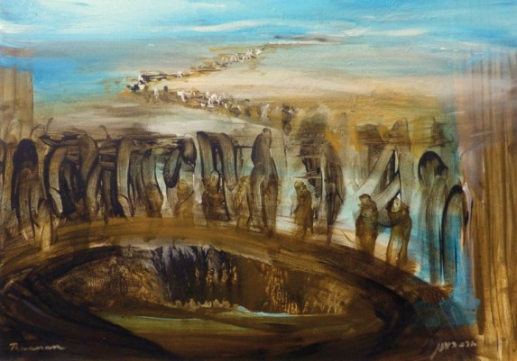
You must understand that Dosonv'Aviram stood at Har Sinai and they shoutedna'asehv'nishma with all their heart like everybody else did, and don't be deceived in that. Dosonv'Avirom had they been here today they would have been not among the highest of our Rabbinical authorities, they would have been glorious Rosh Hayeshiva;, they were great men. They were put through a terrible test: You know a great man can live in his own Yeshiva and he can flourish, he can be very righteous, because he's not put to the test of being inferior to somebody else.
Imagine you built up a big Yeshiva and you're saying glorious shiurim, then a Jew moved into your neighborhood and he started davening in your Yeshiva and you discover that he can say better shiurim than you can. No Rovshould be faced with such an ordeal. It would be wise to take him in a corner and say, you know you're so good that you shoulddaven someplace else. But suppose you can't do it, Dosonv'Aviram couldn't tell Moshe Rabeinu to go.
Moshe Rabeinu was away forty years in Midyan, during that time who was the father of the nation? Dosonv'Aviram and others were leading the nation! They were the zikneiYisroel! All of a sudden an upstart comes back from nowhere, from Midyan, he was lost for forty years, he was eighty years old, they were also old and he's telling them what to do.
Of course he's telling them b'shem Hashem, and they believed him, but it hurt them to no end. Had we been in their shoes I'm afraid what would have happened to us. I'm afraid we wouldn't have remained above ground. Therefore it was a terrible nisayon.
Good Shabbos To All

