A Moment with Rabbi Avigdor Miller Zt"l

Parshas Ki Seitzei 5776

#345(Acquiring Sensory Perception, Yiras Hashem, How?)

This email is transcribed from questions that were posed to Harav Miller by the audience at the Thursday night lectures.
To listen to the audio of this Q & A please dial: 201-676-3210

QUESTION:
How do we go about acquiring sensory perception of Yiras Hashem?
ANSWER:
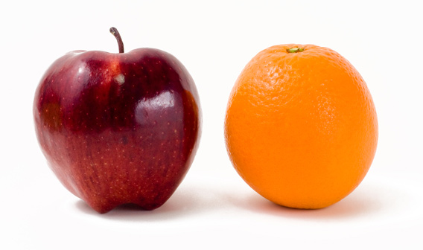
A young man came to me and he said that he has difficulty with Emunah, so I put on the table an orange and an apple. It brings us back to that subject which we can never have enough of, and you should realize that… you get sensory perception in one way, byBechina.
And I said to him, "Why is it that the orange is so beautifully colored on the outside and on the underside of the peel there's no color at all?" And answer that question...There's only one answer, this demonstrates that the color is for the purpose to be seen; there's nobody in the world that can refute that proof.
And why is it that all the fruits that are brightly colored on the outside, never have a bright color on the underside, if it's a thick skinned fruit. Why is it not in a single instance do you find bright colors on the underside of the peel and is colorless on the outside? That's a knockout! Look at all the fruits in the world and see if you can find a single instance where the underside of the peel is gaily colored and the outside is dull!
So he started stammering... evolution... so it means that this is the result of accidents. Alright, so why is it then, that today, in our time, after all we have written history for thousands of years, there's not a single recorded case of a fruit that suddenly by mutation developed with a bright color on the underside of the peel and colorless on the outside? There never was such a fruit.
Why is it that all fruits, every fruit in the world is green before it's ripe and when it ripens it changes its color? Now, when you study these things - seriously, not like people idly sitting back in the lecture hall and hearing it with one ear and it goes through the other, but you concentrate on that. Put an orange and an apple on your table when you're eating, during your meal time, you have nothing else to do… Look at the orange and the apple on the table, and do this for fifty years, fifty years. Someday it's going penetrate your awareness, that's the way to get daas.
Daas means you have to repeat over and over and then finally these great fruits become meaningful. That's only one way; there are other ways to do it too.

Good Shabbos To All

