SUPPLEMENTARY Stories
For Parshas pinchas 5777
Printed L’illuy nishmas Nechama bas R’ Noach, a”h
Volume 1, Issue #6 (Whole Number #6) 21 Tammuz 5777/July 15, 2017

For a free copy, please forward your request to keren18@juno.com

A Wounded Faith
And Loyal Hasid
By Rabbi Jay Yaacov Schwartz

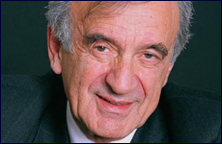

My unexpected encounter with Prof. Elie Wiesel gave me a glimpse into his regal soul.

I didn’t meet Prof. Wiesel, as he liked to be called, until well into my fourth decade of life. Until then, I viewed him as a moral witness to the Holocaust, prolific writer, secular Jew and a poetic soul. His message seemed to speak to the common denominator of our creation in the image of o-d, and how the Holocaust both betrayed and imposed unending wounds on the collective spirituality of mankind.
However upon meeting Prof. Wiesel, I encountered an individual that was quite different of what I had anticipated. In the Fall of 2005, I accompanied leaders and benefactors of the Hasidic communities of Tzfat to Prof. Wiesel’s private office near Park Avenue. We were electrified by his regal bearing. He emerged from behind his desk, surrounded by what seemed like thousands of volumes of writing, research and Jewish seforim, books.
We presented him with a gift of an ArtScroll volume of the Jerusalem Talmud. As he cradled it in his arms, he told us that he studied Talmud each and every day and would not allow a day to pass without immersing his mind in the holy words of the Talmudic Sages.

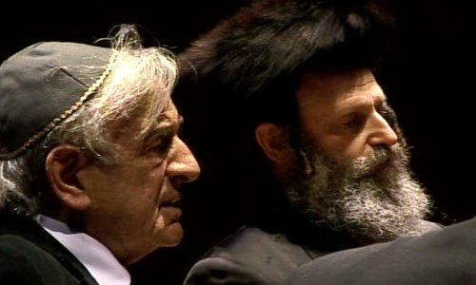
Professor Elie Wiesel and Rabbi Efrayim Koenig

Our goal was to convince him to accept an honorary award from the Tzfat Fund, associated with the Breslov community, with whom he had shared a special relationship. Although in that meeting he identified himself as a Vishnitzer Hasid, having grown up in the Carpathian village of Sighet, his love and fascination for Rebbe Nachman as a historical figure, storyteller and writer enchanted him. He wrote wistfully about the private moment that he and his family shared when he visited the gravesite of Rebbe Nachman of Breslov, a man with whom he greatly resonated.
He accepted the invitation to attend the dinner. But it wasn’t just an appearance to accept an award. We designed an evening that would present a dialogue between Prof. Wiesel and Rabbi Efrayim Koenig of Tzfat, on the issues of faith after the Holocaust, Hasidism and the perseverance of the State of Israel in the face of ongoing suffering and persecution.

“What saved my life was Torah study.”
My role was to facilitate a dialogue by translating into Hebrew, Prof. Wiesel’s comments, so that Rabbi Koenig could understand them and respond in his native Hebrew, and then to translate Rabbi Koenig’s remarks from Hebrew to English so that the sophisticated New York audience, could hear and understand. On that night he answered the question of how he identifies himself as a Jew.

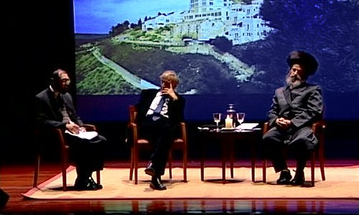

One of the themes discussed was Rabbi Koenig’s view of a complete and simple faith in the face of the horror and atrocity of the Holocaust without question, vs. what Prof. Wiesel described as a “wounded faith,” a Jeremiah-like lament or kina, that bemoaned, in G-d’s presence, the tragedy and destruction that had befallen His chosen People. Regarding the world today he said that evening, “We are all on a train racing to the precipice, the abyss. The only thing we can do is pull the alarm-and we must pull the alarm.”
He also told the audience that he identified himself as a hasidic Jew devoted to Torah study. “What saved my life was Torah study. After the war, the moment I arrived at an orphanage in France, the first thing I asked for was a masechet, a Talmudic tractate I had brought with me when I entered the camps. I would not be who I am today without the influence of Rava and Abaye, Rabbi Akiva, Rebbe Yishmael and actually, the Baal Shemtov. I have never given up learning... I learn Torah every day because that is who I am. So I am a Hasid in the best sense of the word, despite the fact that I don’t look like it. Perhaps if there had been no war, I would be wearing a shtreimel today - and I say this with nostalgia.”
Especially in his later years, Prof. Wiesel chose to reaffirm his childhood identity as a young Vizhnitzer hasid. I am told that he relished the opportunity to lead the prayer services at the modern Orthodox Fifth Avenue Synagogue using the hasidic nusach and nigunthat he remembered from his youth. He transported the amud in Manhattan to a shtibel somewhere in the village of Sighet, Romania. The sounds were identical, and so were his feelings.
I came to understand that Prof. Wiesel’s regal way, the honor that he received from world leaders across the globe, was intrinsically bound to the shining presence of his unique Hasidic soul, His essence to them reflected a small spark of the glory from our most royal Jewish ancestors. In the eyes of world leaders he was graced with cheyn(charm) akin to Joseph in the eyes of Pharaoh. In his moral writings they saw reflection of the universally lauded wisdom of Solomon, and in his emotional and poetic eloquence they heard an echo of the Psalms of King David.
Prof. Wiesel’s legacy is more than the Holocaust. It is a demonstration of how a Jewish soul, tormented by the pains and the suffering of his People, can shine a reflection of God’s holy, hidden light – the light that lifts our human depravity from darkness and inspires us to live moral, honorable, decent lives; to protect and defend the helpless and respect the traditions and wisdom that God implanted into His holy Torah and to the souls of His People, Israel.
The Jewish People’s role is to be light unto the nations, we all aspire to it. Prof. Wiesel, the Vizhnitzer Hasid from Sighet, embodied it. May his memory be a blessing.

Reprinted from the Aish.com website. Originally published on July 4, 2016.

Thessaloniki’s Mayor Wants His Greek City to Remember Its [Once] Vibrant Jewish Past
By Ron Kampeas

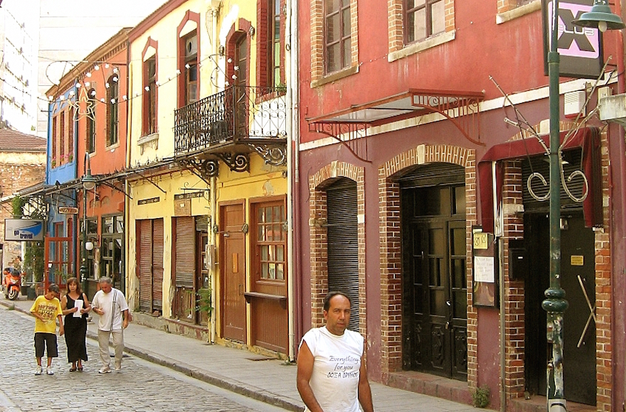
A street in the Ladadika neighborhood, which used to be the Jewish quarter in Thessaloniki, Greece. (Wikimedia Commons)
WASHINGTON (JTA) – “I am proud to be a Vlach,” says Yiannis Boutaris, the mayor of Thessaloniki, Greece’s second largest city.
Ostensibly, we’re here at the Washington Hilton to discuss Boutaris’ bid to put the Jewish back in Thessaloniki, a city — perhaps best known as Salonika —once home to the largest numbers of Jews in Greece.

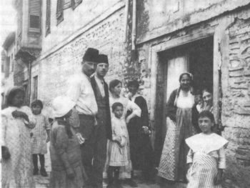
Thessaloniki was a haven for Jewish refugees from the
Spanish and Portuguese inquisitions. (Wikimedia Commons)

But I’m the one who brought up the Vlachs, a dwindling minority of speakers of an ancient Latin dialect, scattered throughout the Balkans. When he ambles over, I greet him with the “Ci fac?” I have learned from my wife’s family. Pronounced “Tzi fatz,” it more or less means “what’s up?”
His eyes widen a little. “Gini!” he says, he’s fine. He looks at his aide, Leonidas Makris, with a look that suggests, “I thought you told me this guy was Jewish?”
I explain my connection, through marriage, to the Vlachs, insular shepherds whose descendants, starting a century ago, assimilated throughout Balkan societies. He asks me where my wife is “from.” I know better than to say Washington, and I tell him Perivoli, the tiny village in the Pindar mountains where our family has summered. He smiles, recognizing the village as one of a constellation of mountaintop Vlach summertime refuges, even before I have completely pronounced it.
Boutaris, a youthful, wiry 74, was here in June to be honored by the American Jewish Committee at its annual Washington conference. He is among 508 American and European mayors who have signed on to the AJC’s Mayors Against Anti-Semitism pledge.
Boutaris stands out among the mayors, though, for his commitment to his city’s Jewish meaning. At his most recent inauguration, he wore a yellow patch reminiscent of the ones forced on Jews during the Holocaust. It “was received as a definite position against the Golden Dawn,” Greece’s anti-Semitic, ultranationalist party, he said.

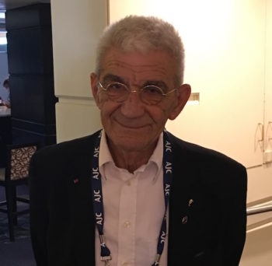
Yiannis Boutaris, the mayor of Thessaloniki. (Ron Kampeas)

“Everyone knows what the yellow star was,” he said.
The gesture also infuriated the city’s powerful and at times intrusive Greek Orthodox leadership.
Boutaris, a vintner by trade, enjoys recounting his bouts with his city’s prelates. He recalls his first election campaign, spearheading an alliance of left-leaning parties in 2010. “I said in a public speech, ‘the archbishop acts like the mujahedin!’” he said, referring to the Muslim jihadis in various countries.
On Thessaloniki’s national day, October 26, the archbishop warned him, “‘you will never see the municipality chair’!”
The next month, Boutaris won the election handily. Of the archbishop’s expressed enmity, he says: “I think this helped a lot,” although he hastens to add that he has since achieved a détente with the church.
Boutaris’ city, an Ottoman haven for Jewish refugees from the Spanish and Portuguese inquisitions, was famous for centuries for its Jewish plurality. Its reputation for tolerance diminished when the city was riven by nationalist struggles as the Ottoman empire collapsed in the early part of the 20th century, and then by a devastating fire in 1917 that drove many Jews to emigrate.
There remained a vibrant community nonetheless, even as the ethnocentric Greek nationalist movement exerted pressure on minorities – Turks, Jews, Vlachs – to repress their languages and identities and become Greek. Two of my Jewish grandparents were born there. In 1941, the Nazis occupied the city and in short order deported over 95 percent of the community to death camps and labor camps. Salonika’s Jewish past is a faint echo now, recalled only in the occasional neighborhood name – like the Modiano market, named for a prominent Jewish family.
Boutaris, like the other 188 European mayors who signed onto the AJC pledge, casts it as a means of containing the anti-Semitism reemerging on their continent.
Boutaris and the other signers “are individually and collectively sending a powerful, if not unprecedented, message to their larger communities,” David Harris, the AJC CEO, told JTA in an emailed statement.
He and Makris, his assistant, are not comfortable discussing Greece’s status, according to Anti-Defamation League surveys in 2014 and 2015, as the continent’s most anti-Semitic country. Some 67 percent of the population hold anti-Semitic views, the more recent survey said. The mayor and his assistant believe the survey is vastly exaggerated.
Makris tries to explain the results as a product of a deeply pessimistic Greek political culture, where poll respondents are likely to believe the worst about their leaders, immigrants, minorities, their next-door neighbors — just about everyone — but otherwise behave in a welcoming manner.
“There is an ambivalence among Greek people,” he says, noting how Greeks simultaneously cast the flood of refugees from Syria as a burden — and yet have turned out en masse to assist them.
Boutaris says that Israel’s conflict is keenly felt in a country that has ancient ties with the Arab world, and that has been influenced in recent decades by close relations between Arab nationalists and the Greek left. “Greeks wonder why they can’t find a way of living together,” he says of Israel and the Palestinians.
Yet the obsession with Israel among some Greeks clearly frustrates Boutaris, in a way that Israel’s leaders would appreciate. Every country deals with internal and external threats, he says, some in ways that make Israel’s actions pale by comparison. “You have to sit down and see what’s happening in Syria!” he exclaimed.
There is a deeper, more resonant dimension to Boutaris’ Jewish outreach, one that aligns with his origins as a Vlach, a people disappearing into Greece’s forcefully monolithic culture.
Boutaris wants Greeks to remember that their country was once not so mono-cultural, that there were other peoples that once thrived here. He has proposed a monument to the Young Turks, who emerged in Thessaloniki in the first decade of the 20th century and whose uprising eventually led to Turkey’s transformation in the 1920s into a secular state.
His focus in Washington is raising awareness about a Jewish cultural center he hopes to found. (The city has a small Jewish museum.) He has raised $20 million so far; he needs another $5 million or so for operating costs.
The one thing he does not want it to be is another Holocaust memorial; instead, he wants a monument to a community that thrived in Thessaloniki for 500 years and that helped define the city.
“Enough with the Holocaust, enough with the mourning, although we will never forget,” he says. “We want to bring up the Jewish heritage, which should not stop with the Holocaust.”
I bring up with Boutaris another personal connection to Thessaloniki: an incident from my first visit to the city, in 1996, that still haunts me.
A newly met Greek friend plied me and my then fiancée with a little too much retsina, the sweet and potent Greek white wine, during a visit to his house. When I conked out and lay down, I overheard him, through a haze, ask my fiancée what had become of me. She told him I was sleeping it off, and he laughed and began to sing “Durme, Durme,” the Jewish Ladino lullaby that at one time would have been familiar to the city’s Jews and non-Jews alike.
I asked our Greek friend afterward if he understood the lullaby’s Jewish origins; he had no idea. It was a song. It was another echo of a disappeared Jewish city.
Boutaris gets it, before I have even finished pronouncing “Durme, Durme” – he knows the lullaby. “Attention must be paid” might as well be his mission statement. “No one knows what Thessaloniki could have been,” he says, “if it hadn’t lost 95 percent of its Jewish community.”

Reprinted from July 5, 2016 release of the JTA (Jewish Telegraph Agency.)

Pool Rules: No Running,
No Eating and, Three
Times a Week, No Men
By Sarah Maslin Nir

Under slate-colored light slanting from the skylights, the women entered the city pool on Wednesday morning, its oxidized copper ceiling lending a mint-green cast to the water’s surface. Their swimming outfits would have been considered prudish even by the standards of 1922, when the pool was built. They swam in dresses, some with long sleeves. One paddled in thick black tights. Inside the locker room, wigs sat upside down on window ledges and benches while their owners swam with heads under ruffled swimming caps or knotted silk scarves.
The swimmers were Hasidic women, who abide by strict codes of modesty and who go to the Metropolitan Recreation Center in Williamsburg, Brooklyn, for an unusual feature: It is one of two city swimming pools with gender-segregated hours. The other is the St. John’s Recreation Center in Crown Heights, Brooklyn.
Although Wednesday was the urbanite’s summer solstice — the day that New York City’s 55 outdoor pools opened for the season and children could, at last, carom into the chlorine — the swimming season at the placid indoor pool in Williamsburg lasts all year. But a tempest has been threatening it, and the women who have long seen the lap pool as a sanctuary are awaiting a decision that city officials now say is imminent about the future of the segregated swimming sessions.
For 20 years, the center has blocked off female-only hours to accommodate the area’s large Hasidic population. The pool has no male-only hours, and some Hasidic men swim during the hours that are open to all genders. An anonymous complaint was lodged recently with the city’s Human Rights Commission, which sent a notice to the parks department this spring saying that the policy might violate a city law barring gender discrimination in public accommodations.
A public furor soon ensued.
For critics, the pool’s segregated hours inappropriately create a religious exemption at a public facility, a violation of the separation of church and state. But defenders of the hours contend it is a fair accommodation for a minority group, akin to wheelchair ramps, that truly makes the pool a municipal space for all — at least at their appointed hour.
The Human Rights Commission and the parks department said the agencies had been in talks and planned to announce their decision as early as this week.
Women’s hours are held three times a week during the summer months. At 10 a.m. on Wednesday, a lifeguard’s whistle squealed. “Everybody out,” she said.
In fact, the message was just for the men. The women’s hours would begin at 10:30 a.m. (There was a half-hour break in between.) Swimming freestyle in the lane marked “Slow,” Tim Main stopped and gripped the pool ladder, peeling off his goggles. He turned to the nearest pool-goer and threw up his hands. “I hope this goes all the way to the Supreme Court,” he said before climbing out and shaking off.
“The idea of being kicked out from swimming time isn’t really the issue,” Mr. Main, 56, said later, now dry and standing on Bedford Avenue in front of the brick pool house. “It’s the creeping of religious stricture into public space.”
Behind him, inside the recreation complex, a lifeguard pulled closed the thick plastic curtains to obscure the swimmers from the lobby during the women’s hours.
“Here in New York, where we have people from so many different backgrounds, the idea of being culturally sensitive is something that everybody talks about,” said State Assemblyman Dov Hikind, a Democrat who represents the heavily Hasidic area of Borough Park and has opposed ending the sessions. “You might think, ‘Wow, why should the city have to bend over to do this?’ But there is a lot of argument that this is all part of reasonable accommodation.”
But Donna Lieberman, executive director of the New York Civil Liberties Union, took the opposite view.
“People who have a religious objection to men and women, boys and girls, swimming in the same pool at the same time have every right to their beliefs and to limit their swimming in accordance with those religious beliefs,” she said. “But they have no right to impose a regime of gender discrimination on a public pool.
“What we have here is the imposition of a religious dogma to the detriment to the rest of the city,” she added.
Gripping a yellow pool noodle, Miriam Kahn, 77, treaded water in a pink dress and a pink ruffled swimming cap on Wednesday morning. “In our religion, women don’t go to no beach, don’t go to no movies, nothing,” she said in a thick Israeli accent. “Can’t we have this something?”
Other cities have accommodated religious preferences for single-sex swimming. In Toronto, a similar program at a public pool that catered to Muslim women drew praise for offering that population a rare chance to learn to swim. There are similar programs elsewhere in the United States.
Only 45 swimmers at a time are permitted at the pool in Williamsburg. Most days, Ms. Kahn said, there is a line of women waiting their turn, including the occasional Muslim woman. On Wednesday, the lanes were full of women in calf-length, denim-colored dresses with three-quarter sleeves. The only thing that vaguely identified the outfits as seaworthy was a palm tree or a beach ball embroidered on the chest.
In a black frock, Tzurtie Kahan, 66, swam up. Hasidic men, she explained, go to synagogue, to Torah study, to work. Women like her have few opportunities to socialize, she said. “This is a freedom country,” she said in English inflected with a Yiddish patois. “Can’t we practice our religion? Can’t there be space for us?”
She, too, had a complaint about the women’s hours at the pool: They are too brief.

Reprinted from the June 30, 2016 edition of The New York Times with the headline “A Battle Over Gender and Religion, at the Pool.”

Women-Only Swimming
Gets Green Light in
Hasidic Brooklyn
By Josh Nahan-Kazis

Despite complaints from civil libertarians and the New York Times editorial board, women-only swimming hours used largely by Hasidic Jews will continue at a public swimming pool in Brooklyn.
In a decision first reported by the local news site dnainfo, the New York City Commission on Human Rights will allow the Parks Department a limited exemption from city gender discrimination rules to continue to allow the women-only swimming hours.
“I’m just a very happy guy today, because they did the right thing,” said New York State Assemblyman Dov Hikind, who pushed hard to allow the women-only hours to continue.
The number of hours put aside exclusively for the use of female bathers will be cut from just over seven hours per week to four hours per week under the new arrangement. Hikind told the Forward he would fight to increase those hours.
Critics of the women-only pool hours expressed dismay at the city agencies’ decision. “It really kind of undermines the purpose of the law to have this kind of exemption,” said Erin Harrist, a senior staff attorney at the New York Civil Liberties Union, which has opposed the women-only hours. Harrist said that the exemption was clearly a religious accommodation. “I think it can be very dangerous to cut away at what is a law that is aimed generally at trying to get equality,” Harrist said.
The Williamsburg pool, located near on the edge of a Hasidic neighborhood that is home to tens of thousands of ultra-Orthodox Jews, has had women-only swim time for two decades. The hours are meant to accommodate the religious needs of Orthodox women, who will not bathe in front of members of the opposite gender.
“Especially women who have a lot of children, that type of exercise [swimming] is very healthy for them,” said Rabbi David Neiderman, director of the United Jewish Organizations of Williamsburg, in a June interview. “Depriving that…it hurts.”
The hours were nearly suspended in May, when the Commission on Human Rights found that the women-only hours could violate city laws against gender discrimination. Outrage from Dov Hikind, who represents Boro Park, put the suspension on hold. A New York Times editorial in June that opposed the women-only hours in early June, followed by a string of stories in the local and national press, drew broad attention to the issue.
In a statement announcing the decision, the Parks Department did not mention the particular needs of Orthodox women. “Women-only swimming hours provide an important accommodation to New Yorkers who may feel more secure and comfortable in a single-sex environment,” the Parks Department statement read.
In her own statement, Commission on Human Rights chair Carmelyn P. Malalis said that the commission had granted the Parks Department a limited exemption from rules barring gender discrimination after “balancing the impact on the broader community.”
“Maintaining limited women-only swim hours at these pools will allow all women and girls to enjoy the pool without being asked to compromise their religious beliefs or affiliations and will have a minimal impact on other community members’ ability to access the pool,” Malalis said.
Reprinted from the July 7, 2016 email of the Forward.

