Brooklyn torah gazette
Yom Tov Shavuos 5777
Volume 1, Issue 27 (Whole Number 27) 6 Sivan 5777/ May 31, 2017
Printed L’illuy nishmas Nechama bas R’ Noach, a”h

For a free subscription, please forward your request to keren18@juno.com

The Connection of Shavuos
And Hashgacha Pratis

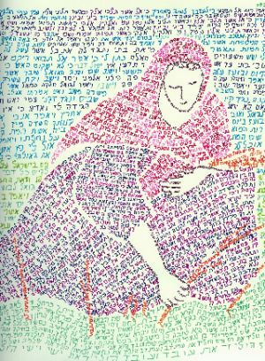

The Aseres HaDibros begins with "I am Hashem your G-d… who took you out of Mitzrayim." The commentaries ask, shouldn’t the Ten Commandments begin with "I am Hashem your G-d… Who created heaven and earth"? Isn't creation a greater miracle than yetzias Mitzrayim?
The meforshim answer that yetzias Mitzrayim has a unique edge, because it teaches us hashgachah pratis. It proves that even after creation, Hashem continues to lead the world. One might claim that Hashem created the world and then left it for the rules of nature (as many nations of the world think).
The miracles of yetzias Mitzrayim verify that Hashem continues to lead the world, and especially the Jewish nation, with hashgachah pratis. This is the reason the Ten Commandments begin with, "I am Hashem your G-d… who took you out of Mitzrayim."
The Rosh writes, "Trust in Hashem with all your heart, and believe in His hashgachah…. Believe that He sees everything that happens on earth, and He knows the deeds of man… He knows their thoughts… If one doesn’t believe in [in the hashgachah pratis that we learn from yetzias Mitzrayim] he doesn’t believe in “Anochi Hashem Elokecha/I am the L-rd Your G-d” either.
This is the central pillar of the entire Torah." (Orchos HaRosh 1:26) When one believes in hashgachah pratis, he knows that everything is for the good. There are hard moments; times when Hashem's hashgachah seems to be concealed from us, but we believe that even then Hashem is with us, and His continence is shining on us. When we look back, we can often see the wonders of Hashem's providence, and we discover that even in the hardest times, Hashem was always there with us. The Chasam Sofer zy'a (II Droshos p.299) says that Megilas Rus (which we read on Shavuos) teaches us this lesson. Megilas Rus tells that Naomi returned to Eretz Yisrael after her husband and two sons died. She was alone in the world, besides for her daughter-in-law Rus. She felt helpless. She felt that her only hope was her wealthy relative, Boaz, who should help her. This is the reason Noami and Rus traveled from Moav to Beis Lechem. She wanted to be near where Boaz lived.
Because of Naomi's extraordinary tznius [modesty], she never planned to speak directly with Boaz, to ask him for help. (Indeed, there is no reference in the pesukim that Noami ever spoke with Boaz.) Her intention was to speak with Boaz's wife, tell her about her poverty and plight, and Boaz's wife would relay the message to her husband.
However, just when Naomi came to Beis Lechem, Boaz's wife died. As the Gemara (Bava Basra 91) teaches from the passuk "when they came to Beis Lechem, the entire city was in an uproar." The Gemara explains, "The city was in a tumult, because everyone came to bury Boaz's wife, who was niftar that day." When Noami saw this, she felt her last hope was shattered. Therefore, when people greeted her, she said "Don’t call me Noami. Call me bitter, because Hashem made me very bitter" (Rus 1:20).
But everything proved to be for the good, because this situation resulted in Rus marrying Boaz. Now Noami was Boaz's mother-in-law; all her needs would be taken care of. Furthermore, from this marriage, Rus gave birth to a boy who would support Noami in her old age. As the women said to Naomi "[this child] will revive you and he will support you in your old age" (4:15).
From this child, Dovid Hamelech, Shlomo HaMelech, and even Moshiach will come. So what appeared to be a grave problem, proved to be for her benefit. The roshei teivos of Noami's Hebrew words, [heh – lamed – shin – mem] "Hashem made it very bitter for me," spell Shlomo, because what appeared to be bitter was actually setting the way for Shlomo HaMelech's birth who would build the Beis HaMikdash. Everything turned out being for the good, as Hashem's hashgachah stands behind everything that occurs in life.

Reprinted from the Shavuos 5776 email of Torah Wellsprings: Collected Thoughts from Rabbi Elimelech Biderman as compiled by Rabbi Boruch Twersky.

Do You Really Believe that The Torah is Historical?
By Aron Moss

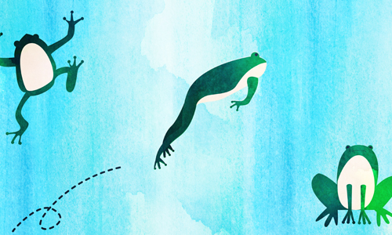

Do you still hold on to the belief that the Torah is Divine? Literary experts and historians have compared the Bible to other writings of 3,000 years ago (when the Torah was supposedly given by G-d) and say that its style doesn't fit into the literature of that time frame, and must have been written much later. How can you ignore a fact that has been scientifically proven?

Answer:
Did you hear the joke about the recent study on frogs? Scientists took a sample of over 100 frogs of various species and did the following test:
They placed each frog on a table, crept up behind it and shouted, "Jump!" The frog jumped.
Then they cut off one leg, and again shouted jump. It jumped, although not as far.
They then cut off a second leg and told it to jump, and then a third, each time observing that the frog responded, but jumped smaller distances.
Finally they cut off the fourth leg and again shouted "Jump!" They were amazed to find that in every case the result was the same. The frog did not move at all.
The conclusion: When you cut off a frog's legs, it goes deaf. It is scientifically proven.
We all come to the conclusions that we want to believe. When the experts find that the Torah is too advanced for its time, they conclude it must have been written later than claimed. When I study Torah, I conclude that it is still ahead of its time, because it was written by G-d for all times and all places. Even the parts that seem archaic and outdated, when explained on a deeper level, have powerful messages that I often feel are speaking directly to me. They are relevant and inspiring to me, right here, right now.
Many have tried to either prove or disprove the Torah's divinity. Neither attempt will be successful. G-d wants us to have free choice. If we listen to His word, it is not by force. To maintain balance, there will always be valid arguments to discredit Him and His Torah. We can choose to buy those arguments, or see beyond them. Then, when we open ourselves to the Torah's message, the choice to do so is coming from within.
G-d has given you a mission. How you respond is totally up to you. You can be as deaf as a legless frog, or you can take a leap in response to your higher calling.

Reprinted from the current Chabad.Org website.
Shavuot and the Unity
Of the Jewish People
Adapted from a letter of Rabbi Menachem Mendel Schneerson, the Lubavitcher Rebbe, zt”l

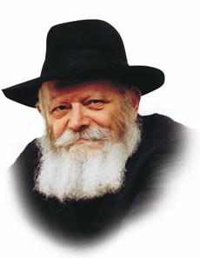
Torah from Sinai begins with the Ten Commandments, of which the first two: "I am G-d, your G-d" (the root and foundation of all positive mitzvot) and "You shall have no other gods" (the root and foundation of all prohibitions) proclaim the Unity of G-d.
A precondition to the Giving of the Torah was the unity of the Jewish people (as it is written, "And Israel encamped there facing the Mountain"-- in the singular form, indicating, as our Sages explain, "as one person with one heart").
The essence of the Giving of the Torah is to realize in the material world the Unity of G-d, through the "one nation on earth," the Jewish people, fulfilling the 613 mitzvot of the one Torah.
At first glance it is difficult to understand how such unity can be achieved, considering that G-d Himself created mankind as diverse individuals, differing in their opinions ("as they differ in their faces so they differ in their minds"), living in a world which He likewise created variegated as to climate and physical features. How can a whole nation attain true unity within itself and bring unity into such a diversified world?
The explanation is to be found in the verse, "And they stood themselves under the Mountain (Mount Sinai)"--all of the 600,000 adult men, their wives, sons and daughters. This means that, as they were about to receive the Torah, all submitted themselves to it so completely, that mundane matters ceased to exist for them, as it were; their self-effacement (bitul) and joy of receiving the Torah left room for nothing else. And since the "Mountain" was the same for all, and all were permeated with the same feeling of self-effacement and joy, this brought true unity to all the individual Jews, and also unity into the world, through the one Torah.
The Jewish people began with one family, that of our ancestors Abraham and Sara, and ever since then the Jewish family has been the foundation of our people. In the family, too, each member is a separate individual, with a particular function and purpose in life assigned to him and her by Divine Providence.
Unless there is unity in the family, there can be no unity of the Jewish people. How is family unity achieved? In the same way as mentioned above: When all the members of the family accept the One Torah from the One G-d in such a way that the Torah and mitzvot are the only essential thing, and all other things are merely secondary, and have a significance only insofar as they are related to the essence--then there is true unity in the family.
In attaining this family unity--bearing in mind also that Jewish families are the component parts of the Jewish people, hence the basis of the unity of the Jewish people, as mentioned above--the Jewish mother and daughter have a most important part, being the Foundation of the Home, as has been underscored on previous occasions.
Needless to say, the said unity must be a constant one, without interruptions; this is to say, it must be expressed not only on certain days of the year, or certain hours of the day, but in every day of the year and in every hour of the day. This means that a Jewish home must be wholly based on the foundations of the Torah and mitzvot, and so permeated with the spirit of Torah dedication and the joy of mitzva that this should be reflected also in the conduct outside the home, in the street, and in the entire environment.
Herein lies the essence of the "integrity" and unity of the Jewish family and of Jewish family life.
It is hoped that this point will be brought out with the proper clarity and forcefulness, together with its aim and purpose--its realization in daily life, in keeping with the basic principle of our Sages of blessed memory: The essential thing is the deed.

Reprinted from Issue #219 of L’Chaim Weekly for Parshat Bamidbar 5752/1992.

Shavuos – an Overview
By Rabbi Yair Hoffman

PREPARING FOR SHAVUOS
Shavuos is called Z’man Matan Toraseinu. Originally, this event occurred in the Hebrew year 2448 (3324 years ago). As we know, Rav Dessler in his Michtav M’Eliyahu explains that time does not flow as a straight line, but rather as a circle. The day of Shavuos which is the 6th of Sivan is, therefore, the very day that we received the Torah.
Similarly, the Nesivos Shalom explains that just as the Torah is eternal, so too is Kabalas HaTorah eternal. Each and every year there is a new Kabalas HaTorah. In other words, Shavuos is not just a commemoration of our receiving the Torah – it is receiving it once again.
Receiving the Torah is monumental. The entire essence of the nation of Israel is only for Torah (Sefer HaChinuch 273). The entire universe, heavens and earth, were only created for the sake of the Torah (ibid). Receiving the Torah, therefore, requires much preparation. Indeed, the Torah tells us in Parshas Yisro that we needed to prepare for three days – “Heyu nechonim l’shloshes yamim (Shmos 19:15).”
One of the preparations that we make for receiving the Torah is that we learn Pirkei Avos on every Shabbos between Pesach and Shavuos. The Midrash Shmuel explains, “One who will be learning Torah must first know its method of study and how to treat Torah. Therefore, so that the heart of each member of Klal Yisroel will be ready to accept Torah with a complete heart and to properly observe it, they enacted the learning of Pirkei Avos.”

ZENITH OF OUR GROWTH
Let us also recall that Shavuos represents the zenith of our spiritual growth. When we left Mitzrayim we were on the lowest level of Tumah – impurity. In a matter of 49 days we experienced record spiritual growth to the point where the nation of Israel at the time was greatest generation that ever lived.

NO LIMIT TO OUR MITZVOS
We should also be aware that there is no limit to the heights and growth we can accomplish in our ruchniyus – indeed in any Mitzvah. This can be seen from a passage of the Targum Yonasan on Sefer Rus. Boaz tells Rus that he is aware of both how she came and joined up the nation of Israel, and also of all the Chessed that she had performed with her mother-in-law. The Targum Yonasan on this Pasuk explains that because they were written next to each other and said in the same breath, these two Mitzvos were equal to each other.

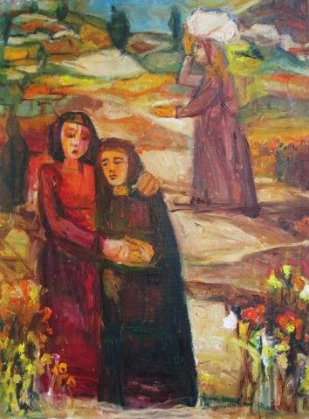

This is somewhat mind-boggling. Rus was a princess of Moav, a very powerful nation. It is a remarkable notion that one of the top women in society would give it all up to become a lowly member of the Jewish nation that must take Tzedakah. Is this lofty Mitzvah equal to the mere Chessed that she does with her mother-in-law?
The answer, according to Rav Henoch Leibowitz zt”l. is that there is no spiritual limit to any Mitzvah that we perform. If we do a Chessed, any Chessed, with the right intentions and Kavannah – it can be equal to the greatest of Mitzvos.

EREV ROSH CHODESH IS PREPARATION TIME
The Shla HaKadosh explains that Erev Rosh Chodesh Sivan (Monday Before Shavuos this year) is a special time of preparation in terms of Teshuvah, Tefillah and Tzedakah. This may be based upon the Rashi in Parshas Yisro (19:1-2) that the nation of Israel did Teshuvah on this day when they travelled from Refidim.
The Psukim in the Torah give us the pre-history of Matan Torah:
On Rosh Chodesh Sivan itself Klal Yisroel entered Midbar Sinai, a place wherein Har Sinai is located.
On the second of Sivan Moshe was told and gave over to Klal Yisroel the two Parshios of “Atem Ra’isem” and “You shall be for Me a nation of priests and a holy nation.” This was when they answered, “Everything that Hashem spoke – we shall do.”
On the third of Sivan Moshe related to Hashem the words of the nation. Moshe was then told of the Mitzvah of separating.
On the fourth of Sivan Moshe was told to go to the nation and sanctify them. He then told them to prepare themselves for three days.
The Mechilta (Parshas Yisro) explains that part of the preparations involved the utter unity of the nation – VaYachon Sham Yisroel –b’lev echad k’ish echad – with one heart, like one man. It is clear from this Mechilta that there are levels of Dveikus and holiness that cannot be achieved alone but only through a joint and communal effort. We achieved this level at that time. It was through this unique achdus that we merited to say “Naaseh v’Nishmah – we will do and then we will listen.”
Ultimately Hashem placed the very mountain above them like a barrel. The verse tells us that they stood under the mountain – “vayetzatzvu betachtis hahar” (Shmos 19:17) Rashi explains– “Kafah aleihem har k’gigis.”

THE THREE DAYS OF HAGBALLAH
“The essence of these days,” according to the Shaar HaMelech, “is to separate ourselves from all the vanities of this world to be prepared to greet Hashem. In each and every year we should look at ourselves as if we are preparing ourselves for Kabalas HaTorah on the mountain of Sinai.”
The separation means to focus on things spiritual, and avoid an emphasis on aspects of the physical world that take us away from concentrating on Hashem and upon our relationship with Him. Our brachos should therefore be recited with more intensity and concentration, we should avoid unnecessary window shopping and looking at catalogues. Rather, our focus should be on three more important things: 1] improving on Davening, 2] on focusing more on the life lessons inherent in our Torah studies, and 3] upon Chessed. Each of these three brings us ever closer to Hashem Yisbarach.

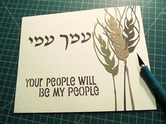

OTHER NAMES OF SHAVUOS
Another name for the Yom Tov of Shavuos is Atzeres. There are actually two Yomim Tovim with this name. Both of them have a unique and special quality to them that no other Yom Tov has. Shavuos is achieving a state of being alone with Hashem. The Bais Avrohom explains in terms of the Dveikus that can be achieved through the Yomim Tovim that Pesach is considered like the period of engagement and Shavuos is like the very wedding itself. When the mountain was placed upon the nation of Israel like a barrel – it was likened to a Chuppah.
The closeness to Hashem that we achieve at Matan Torah makes Shavuos the ideal time to celebrate the first fruits of the Seven Species with which Eretz Yisroel is blessed. During this time the first fruits were harvested and brought in decorated baskets to the Beis HaMikdash. Thus, another name for Shavuos is Chag HaBikkurim (the Festival of the First Fruits).
Shavuos is also the time when we celebrate the abundant wheat harvest that Hashem has given us. This is why it is called Chag HaKatzir (the Feast of Harvest). It is because Shavuos is also the beginning of the wheat harvest that we bring the shtei haLechem (two loaves) as a meal-offering in the Beis HaMikdash.

SHAVUOS CUSTOMS

No Bloodletting or Testing
The Talmud (Shabbos 129b) tells us that a celestial damager was sent out against the nation of Israel on the day before Shavuos. It’s name was T’voach. By virtue of Klal Yisroel having accepted the Torah, they saved themselves from the destructive fate of T’voach. On the eve of Shavuos we do not engage in any form of bloodletting because of the dangers involved. Indeed, the sages forbade doing so on every Erev Yom Tov on account of Shavuos. The Minhag is cited by the commentators (Darchei Moshe CM 468:3) and the custom in Klal Yisroel is to avoid it unless there is medical need.
Some people have the custom to sleep on Erev Shavuos in order to be able to stay up the entire night on Shavuos. The Mogain Avrohom (OC 290) quotes the Sefer Chasidim that when Erev Shavuos falls on Shabbos, it is forbidden to say that one is resting so that he or she can be awake for the night of Shavuos.
The Minhag of Grass and Trees in Shul
There is a Minhag mentioned by the Ramah in Shulchan Aruch (OC 494) to place grass, flowers, and trees in Shul on Shavuos. One explanation for this is found in the words of the Levush (Rabbi Mordechai Yaffe):
It commemorates the grass that surrounded Har Sinai at the time of Matan Torah. As the verse states, “the sheep and flocks may not graze..” The indication is that grass grew there. It is a worthwhile Minhag to continue because it helps us relive the experience at Har Sinai – an experience that we actually go through once again.
Another explanation is that it commemorates the bringing of the Bikkurim the first fruits, which were made from baskets woven and decorated from and with grasses and flowers (Ziv HaMinhagim).
Another explanation is that Moshe Rabbeinu was saved on the banks of the Ye’or which had grassy knolls (Chiddushei HaRim – the Gerrer Rebbe).
The Brisker Rav explained that the decorations are a minimum form of decoration and show us that the only means in which one can acquire Torah is if we are satisified with the minimum and not pursue luxuries and other forms of consumption. Grasses are mentioned in this vein in the Gemorah Eiruvin 22a by Rabbi Adda Bar Ahava ( Moadim L’Simcha p. 402).

The Minhag of Milchigs
The Ramah mentions that it is the custom to split the meal on Shavuos, where the first half of the meal is comprised of dairy foods and the second half is comprised of meat foods. Although it is no longer the custom to split the meal, we do have the custom to eat dairy foods on Shavuos. The reason for this custom is to remind us that when we received the Torah we were taught the laws of preparing the meat in the proper, kosher manner. Since we were unable to this immediately, we consumed only dairy foods at the time.

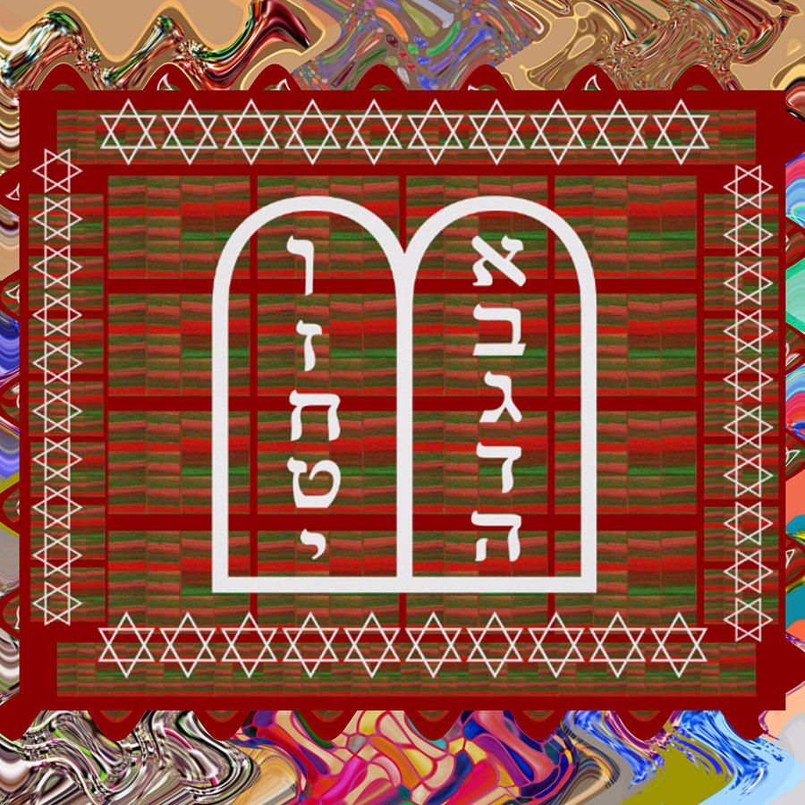

Waiting for Nightfall
Although generally we are permitted to bring in Shabbos or Yom Tov slightly earlier than is required, in regard to Shavuos the custom is not to pray immediately but to wait for nightfall. The reason is that we want to count the Omer completely and perfectly. Doing so would entail making sure that the last day is complete.

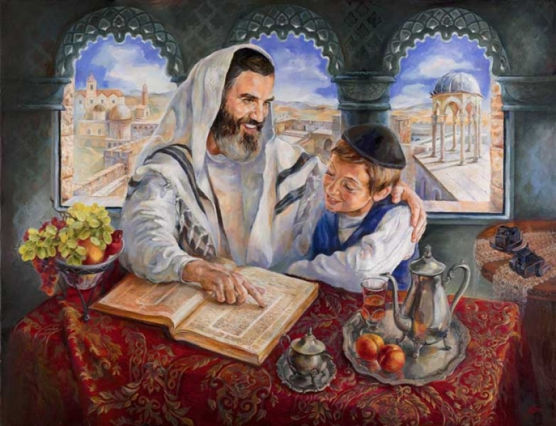

The Minhag to Stay Up All Night
Although the custom is not mentioned in the Talmud nor in the Shulchan Aruch, the custom has developed in Klal Yisroel to remain awake the entire night of Shavuos and to study Torah. The Seforim HaKedoshim explain that one who stays up all night studying Torah merits “Gilui Shechina” revelation of Hashem’s Divine Presence on that night.
The Kaf HaChaim (OC 494) writes that women who have the custom of counting the Omer can indeed partake in perfecting the Tikkunim involved in the Mitzvah of Sfiras haOmer by learning at night as well. Other Poskim explain that there was no Minhag for the women to stay up as well.

Shavuos Davening
The Shacharis and full Hallel of Yom Tov are recited. The reading of the Aseres HaDibros takes place on the first day of Shavuos. This is followed with Mussaf and the Birkas Kohanim. On the second day Megilas Rus is read before the reading of the Torah. It is preceded with the Piut of Akdamus.

Why We Read Megilas Rus
There is a debate among the Poskim as to whether our custom to read the Megillah of Rus on Shavuos is a full-fledged obligation or a Minhag. The reason why we read the book of Rus is to teach us that Torah is only given through hardship and poverty (Yallkut Shimoni 596). Another reason is that the entire episode took place during the Zman HaKatzir – and Shavuos is known as Chag HaKatzir too. A third reason is so that we will have read all three parts of the TaNaCh on the day of Matan Torah (Otzer HaMinhagim).

The Piut of Akdamus
The Piut (supplication poem) was written by Rav Meir Ben Yitzchok Shliachtzibbur, a Rishon that is often quoted by Rashi and Tosfos (See, for example, Rashi on Tehillim 73:12 and Tosfos RH 11a). It is a double Aleph Bais poem that describes the greatness of the Creator of the world, the nature of Malachim, and the loftier stature that the nation of Israel has above the angels themselves. One section of it describes how, kavyachol, Hashem is longingly desirous of Klal Yisroel learning Torah and desires their prayers. It ends with the statement that who hear (and absorb the depth and meaning of the piut) will merit to be among that group that will merit fantastic miracles on the great day.
The Piut is recited in Aramaic so that the Malachim will not understand it, hear it and take it for their own use. It should remain special for the Jewish people alone. It is the only Piut which is recited while the Sefer Torah itself is lying on the Bima. This demonstrates how very special it is.
Yizkor
On the second day of Yom Tov (the first day in Eretz Yisroel) after the Torah is read, a special prayer of Yizkor is recited as is done on all second day Yomim Tovim. We daven for and pledge Tzedakah in the merit of those in our family who have passed on. It is the custom in Klal Yisroel for everyone who still has both parents to leave the shul during the recitation of Yizkor.

YOM TOV HALACHOS
Like on Shabbos, there exists a prohibition of performing Malacha on Yom Tov. The admonition against certain Malachos should be used as a means of coming closer to Hashem as well. What is Malacha exactly, and how can it be used as a tool for greater closeness to G-d?
Malacha is not defined as work, necessarily. Malacha is defined as a certain, specific type of creative act. More precisely, Malacha is defined as the specific creative acts that were necessary to create the Mishkan, the resting place for Hashem’s concentration of the Shechina Presence here on earth.
Our refraining from such creative acts on Shabbos and Yom Tov is the collective flag of the Jewish people. Just as any nation is proud and salutes its national flag, so too is the observance of Shabbos and the holidays the flag of the Jewish people. The flag symbolizes and embodies our belief that the world was created for a purpose by a kind and benevolent Being who rewards good and punishes evil. A focus on this idea will cause us to become ever closer to Him. Mere contemplation of it when we refrain from Malacha achieves this end.

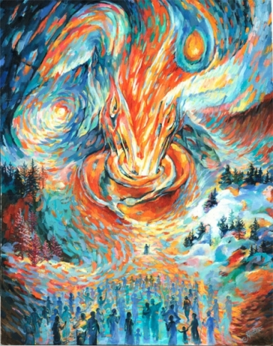

While the definition of Malacha is the same for both Shabbos and Yom Tov, the Torah made some exceptions for Yom Tov. The Torah states that actions that are necessary for people to eat are permitted on Yom Tov. This is called “Ochel Nefesh.” Not all actions, however, are permitted for Ochel Nefesh purposes. If the food preparation could have been done with equal freshness and results before Yom Tov, and one had the time opportunity to do it then, then it may only be done with a shinui on Yom Tov itself. There are some Malachos on Yom Tov that are forbidden or very different even when it comes to food preparation.
It is also important to know that one may never do Malacha on Yom Tov during a Bain HaSh’mashos – twilight that immediately followed a Yom Tov. Why is this so? Because we do not know exactly when the day changes from one to the other. It is forbidden to do Malacha on Yom Tov for another day. Thus we might be doing Malacha on Yom Tov for another day which is forbidden.
One is also, of course, not permitted to perform any Malacha on the first day of Yom Tov for the second day of Yom Tov – even if the preparations involve no Malacha. This is called Hachana and something in which we must be very careful. The Yom Tov is very special and acts performed on it must be limited only to the needs of that Yom Tov.
May it be Hashem’s will that we merit a complete and full Kabalas HaTorah this year!

Reprinted from the June 10, 2016 website of Yeshiva World News. Originally published in the 5 Town Jewish Times.

