A Moment with Rabbi Avigdor Miller Zt"l #347

(Rosh Hashana before
Yom Kippur, Why?)

Parshas Nitzavim 5776

This email is transcribed from questions that were posed to Harav Miller by the audience at the Thursday night lectures.
To listen to the audio of this Q & A please dial: 201-676-3210
QUESTION:
Why is Yom Kippur not before Rosh Hashana, so we will be able to enter Rosh Hashana clear of sin?
ANSWER:
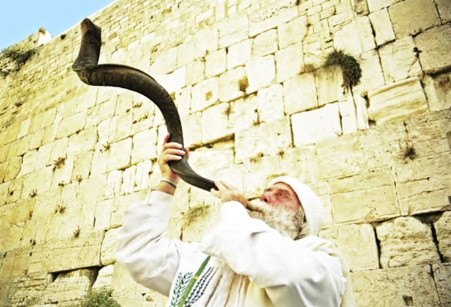
Here is a man who needs an operation on his bladder, or maybe also on his ulcer, or maybe he needs an operation on a number of things. But instead, we are sending an expedition to his house with a lot of noise and a lot of people are running towards his house, trucks are making a tremendous clamor with sirens to put out the fire. This man needs a lot of operations so why waste time? The answer is, first you have to put out the fire otherwise he will never live to see the operating table. First thing is to save his life if his house on fire. So you say no! Let the fire wait, lets first make an operation on this, an operation on this, later you'll put out the fire...It won't work that way.
Therefore the first thing is Emunah in Hakadosh Baruch Hu, that's emergency, that's a fire. If you forget about Hakadosh Baruch Hu, you forget Anochi Hashem Elokecho, then what good is all the rest? What good is it to eat kosher if a man is an atheist, even though he doesn't say so but he is so? If he doesn't believe in Bereishis Boroh Elokim what good is it to go further? That's why it's put in the beginning of the Torah.
And that's why Rosh Hashana must come first, to bring us to to do teshuva in the fundamental, the foundation of everything, then we're ready to talk about the details.
Question #49

QUESTION:
How does one repent for certain sins, that he knows he will repeat?
ANSWER:
That's a question that is being always asked. And the answer is as follows. If a man smokes forty cigarettes everyShabbos, and he decides he’s going to smoke only thirty nine, that's a fortunate man. That's called a Miktzas Teshuva. A little bit of Teshuva, which is the easiest thing to do, is the biggest obligation. To stop all forty, not so easy for him, but to stop the fortieth, YES. And therefore, if you can stop even a little bit of your sin, then you must do it, and it’s the biggest obligation, that's the easiest thing to do.
And so any sinner, even though he's a confirmed Chotai, if he’s able to make a resolve, at least one little bit of that sin he won't do anymore. Let’s say, he does a sin ten times a week, now he’ll do it nine times a week; he makes up his mind no more then nine times, he is a LUCKY man. If he neglects that opportunity, he’s in great sakona; Hashem is very angry at him. The tenth time was easy to avoid. And so everybody can do a Miktzas Teshuva.
That's why we say Hashivainu Avinu Lesorasecho, Hashem bring us back to your Torah, that's Teshuva we are asking for,Teshuva, for repentance. Then we say, V'Hachzirainu B'sehuva Shelaima, then we’re asking for a perfect repentance. First we are asking for a little bit of repentance, any kind of repentance, a little bit at least. Then once you ask for a finger, you ask for the whole hand, too! Then we say give us a full repentance.
Question #51

QUESTION:
What should we think when we see the fish during Tashlich?
ANSWER:
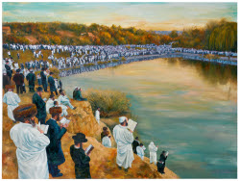
You know what I think? When you pass a fish store and see the fish in the window, there's a good time to stop and look, don't wait for Tashlich. The fish in the window come from the ocean. That fish comes together without Shadchonim, they're Porim V'rovim Bayom, they get married in the ocean and they produce offspring, and it's for one purpose, to give us more fish to eat. It's a Nes, how fish meet each other in the depths of the ocean and they're able to copulate, and produce some more fish, it's a Niflaos Haborei, you have to marvel at it.
The fish doesn't have any air and still it breathes with its lungs. It's able to take out from the water the dissolved oxygen, fish must have oxygen. They are so built that they can use oxygen dissolved in the water and it lives without lungs, except the lungfish. And so when you look at a fish, it's a special Briah, Chesed Hashem.
Fish of course is a Taanug, that's why all Jews eat fish on Shabbos, it's part of the happiness of Shabbos in order to learn theChesed Hashem.
And so I say, you don't have to wait for Tashlich, when you pass a fish store and see big juicy fish lying there, a big carp, a big salmon, a big trout, take a half second and take a look. AAH; what a wonder it is that it happened in the middle of the ocean, they came together and produced such tasty tidbits for the people to enjoy and to appreciate the Chesed Hashem.
Good Shabbos To All

