**Parshas Ki Savo-ושמחת בכל הטוב**

**זה השולחן אשר לפני ה'**

The Ribono shel Olam gave us a beautiful land – ארץ חמדה טובה ורחבה. Eretz Yisroel, the envy of the world, has it all. Even if they are not the super-sized Meraglim fruits, we are still amazed at the huge and delightfully sweet fruit we can enjoy, even nowadays. Oh, how I look forward, on visits to Eretz Yisroel, to those one-of-a-kind Lachmaniyot. Do vegetables anywhere else, compare to the delicious tomatoes and other produce that you can pick up in any Makolet?

Yet, this is ארצנו הקדושה, the land that is at the spiritual core of the universe. All Kedusha emanates, flows and radiates to the rest of the world, from Eretz Yisroel. It is there, that we can and we are meant to, truly shine as the עם הקדוש, as the פסוקים here state. We are the עם סגולה that Hashem designated, לתתך עליון על כל הגוים לשם לתהלה ולתפארת. How do we reconcile this ושמחת בכל הטוב - imbibing from the delight of the land, with focusing on our mission of להיותך עם קדוש לה'? We usually see indulgence in גשמיות as a hindrance to attaining spiritual perfection. Even later on in the Parsha, where we are told of all the Brochos for fulfilling the Torah, we are promised bountiful wealth and success. Perhaps, the incentive should have been, as listed in the beginning of the sixth Perek of Pirkei Avos – כל העוסק בתורה לשמה זוכה לדברים הרבה.

R’ Chaim Volozhin, zt”l, in Ruach Chaim on this week’s Perek of Pirkei Avos, attempts to resolve the paradox of the Yid who strives for Ruchnius and Aliyah, while existing in a Gashmiusdik environment. Certainly, there are those who live a life of absolute פרישות, enveloping themselves entirely in the upper spheres of דביקות בה', while eschewing all but the most minimal and vital material needs. But what of the everyday Baal Habayis, or even the distinguished and respected Gedolim V’Chachomim, who are not impartial to enjoying the “Geshmock” of a good meal? How do we intermingle earthly comforts with עליה in Avodas Hashem, two polar opposites?

The one piece of furniture in our homes, that defines the צורה of the “Yiddisheh Shtub”, the בית נאמן בישראל, is the table. Our tables, have always served as the center of all activity for every family. The “Tish” is not merely a utility for meals. שולחן דומה למזבח. There, we bring together, Torah, Avodah and Gemilus Chasodim, all in one place. That is the venue for making our guests feel at home, where we receive distinguished visitors and distribute Tzedaka. It is there that we plan and gather for Simchos, learn with our children and where our children can see the indelible image of a father or grandfather sitting and learning, as well. Of course, it is at our table that we soar to the heights of Oneg Shabbos and Simchas Yomtov, bringing along and aloft, those who never had that taste of the truly good life. It is also where we look forward to imbibing of כל טוב מעדני עולם, savoring all good things, indulging our senses and satisfying the discerning palate. הכיצד, how do we “Farentfer” this סתירה, this apparent inconsistency?

The Mishna says, those who eat at a table where no words of Torah are spoken, כאילו אכלו מזבחי מתים. However, if a meal is accompanied with Divrei Torah, that table becomes a vehicle that transports us to the heights of closeness with the Shechina – זה השולחן אשר לפני ה'. R’ Chaim Volozhin says, it is not a contradiction. This dichotomy of Gashmiusdik gratification and spiritual attainment, can be brought into harmony, by rendering materialistic, earthbound pursuits into a support and adjunct to our Ruchniusdikeh goals. Come to the table of Hashem, where you pursue the study of Torah and grow in Yiras Shomayim. Eat and enjoy, so that you may be satisfied and fortified, obtaining the stamina you need for Avodas Hashem. “Ess Tatteleh”, come eat, so you can learn with a Geshmock and with gusto. Even more, says R’ Chaim, when your Gashmius is לשם שמים, like this, the food you eat attains the Kedusha of a Korbon to Hashem, shedding the earthly components of what you eat. Therefore, the Ruach Chaim guarantees, any of the vast array of ill effects, from the food we eat, that can be harmful to a person’s health, will fall away, similar to the experience of eating the מן in the Midbar, where nobody suffered from illness.

I can personally attest to that, B”H. When I first learned this, a couple of years ago, I resolved, bli neder, to learn one Mishna by every meal. Bli Ayin Hara, half of Shisha Sidrei Mishna later, my visits to the Gastroenterologist and the accompanying complaints and concerns, have all but disappeared! Try it, you’ll like it.

Have a wonderful and Geshmock Shabbos, yk

**L’Ravcha D’Milsa Weekly Almanac**

**Thursday, Parshas Ki Savo – 19 Ellul**

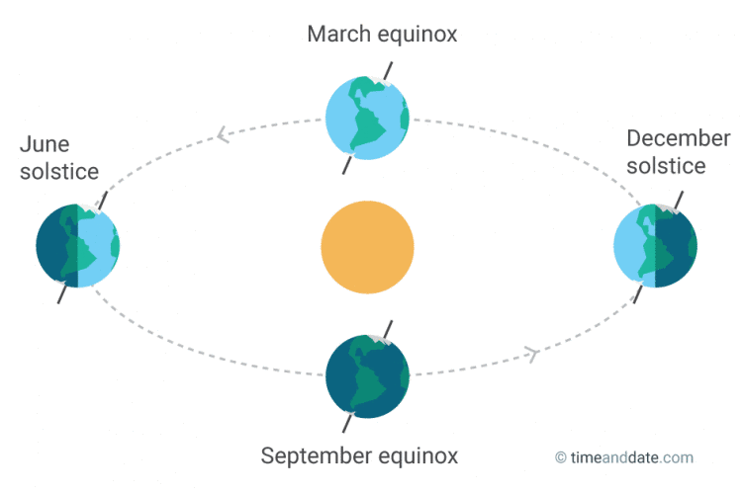***Autumnal Equinox*** *– 10:21AM EDT. The equatorial midpoint of the Sun’s position, in Earth’s annual rotation around the Sun, from the longest day of the year, the Summer Solstice, to the shortest day of the year, the start of Winter – in the Northern Hemisphere. Vice Versa for the Southern Hemisphere, that now welcomes Spring.*

**The R’”I M’Orleans - Rav Yaakov of Orleans (1189**), one of the Baalei Tosefos and a student of Rabbeinu Tam, was killed with many other Jews in London during pogroms after the coronation of King Richard the Lion-Hearted,. [others say it was 3 Elul]

**Rav Moshe Zvi Aryeh Bick (1990).** Born in Medzbosz (Mezhbizh), Ukraine, but grew up in New York, he is recognized as one of the first gedolim to be raised on American soil. He studied under R' Moshe Soloveitchik at the Yeshiva Rabbeinu Yitzchak Elchanan Spektor and attended New York City public schools at night. At age 21, R' Bick was hired by a shul in the Bronx. While there, he founded schools for both boys and girls. Later, he moved to Boro Park. He was recognized as a master posek by both chassidic and non-chassidic communities.

**Erev Shabbos Kodesh Parshas Ki Savo – 20 Ellul**

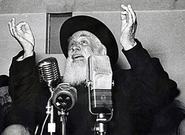 **Rav Yosef Shlomo Kahaneman, Rosh Yeshiva of Ponovezh (1969).** At the age of 14 he went to the Telshe Yeshiva, where he learned until he was twenty. He then spent a half year in Novardok, after which he spent three years in Radin under the Chafetz Chaim. Rav Yosef Shlomo Kahaneman was appointed the new rav of Ponevezh at the age of 33. He was elected to the Lithuanian parliament. He immigrated to Israel in 1940 and built Kiryat HaYesHiva in Bnei Brak and Batei Avot orphanages.

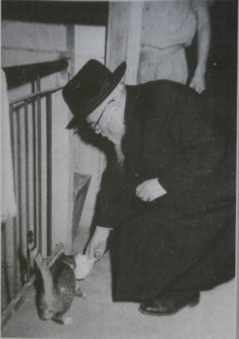 **Rav Eliyahu Lopian (1970),** author of Lev Eliyahu; mashgiach of Kelm; Rosh Yeshiva of Yeshiva Etz Chaim in London, and mashgiach at Kfar Chassidim. R' Shalom Schwadron was one of his talmidim. Reb Elyah moved to Israel in 1950, when he was 76 years old.

**Shabbos Kodesh Parshas Ki Savo – 21 Ellul**

**Rav Yehonasan Eybeshutz (1764).** Born in Cracow, he became head of the Prague yeshiva at the age of twenty-one. In 1741 he became Rabbi in Metz, and in 1750 he became Rabbi of Altona/Hamburg/Wandsbeck (AHU), where he had major disagreements with Rav Yaakov Emden. He was learned in many areas, including halacha, kabbalah, philosophy and science. He was the author of many halachic works, as well as collections of sermons and unpublished works on kabbalah. Thirty of his works in the area of halacha have been published. His works included Urim V'tumim, Kereisi Ufleisi, Yaaros Dvash, and Ahavas Yehonasan (a commentary on the weekly haftorahs).

**Monday, Parshas Nitzavim– 23 Ellul**

[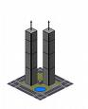](http://images.google.com/imgres?imgurl=http://i181.photobucket.com/albums/x48/poshbakerloo/superapolis-1.jpg&imgrefurl=http://www.skyscrapercity.com/showthread.php?t=479869&usg=__5j8Mq62lIAELpTbWQBUwOQxHTgU=&h=290&w=234&sz=16&hl=en&start=15&um=1&tbnid=XLkClZILtFd5cM:&tbnh=115&tbnw=93&prev=/images?q=twin+towers+pictures&imgtbs=t&imgtype=clipart&hl=en&rls=com.microsoft:en-us:IE-SearchBox&rlz=1I7DKUS&sa=N&um=1)**Rav Yosef Baabad, the Minchas Chinuch (a commentary on Sefer Hachinuch), Rav of Tarnapol, Poland (1874).** His “last name” is an acronym for B'nei Av Beit Din.

**Yartzeit of 9/11**

**24 Ellul – Tuesday, Nitzavim**

Preparations for construction of The Second Bais HaMikdash get underway.

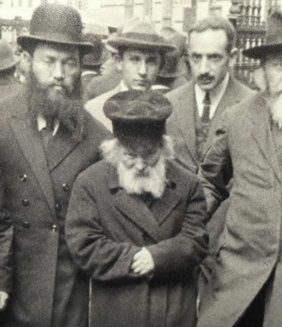 **Rav Yisrael Meir Kagan of Radin - The Chofetz Chaim, zt”l** (1933)

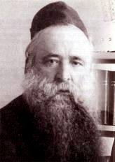 **Rav Yechezkel Abramsky (**1976), Dayan in Slutsk and London, and Chief Dayan of the British Empire. He learned at the Beis Yosef yeshivah of Novardok under the Alter, Rav Yoizel Horowitz, as well as at Telz, Mir and Slabodka. He eventually became a close talmid of Rav Chaim Soloveitchik of Brisk. Rav Yechezkel spent the first half of his life serving as a rav or dayan in various communities, and in 1924, he became rav of the Slutsk, with a kehillah of over ten thousand Jews. After the Russian revolution, Rav Yechezkel fought desperately against the Communist decrees to destroy religion, and he was sentenced to five years in Siberia, in 1929. In 1931, he was released, and the Chief Rabbi of the British Empire, Rabbi Joseph H. Hertz, persuaded him to serve as Av Beis Din in London. In 1951, Rav Yechezkel moved from London to Eretz Yisrael, where Rav Eizik Sher invited him to give regular shiurim in Slabodka in Bnei Brak. Rav Yechezkel wrote twenty-five seforim in his lifetime, the best known being his monumental Chazon Yechezkel, a commentary on the entire Tosefta.

**25 Ellul- Wednesday, Nitzavim**

Day 1 of Maasei Berashis- Fire, Water, Heaven, Earth, Light

**R’ Elazar ben R’ Shimon Bar Yochai (102 CE)**

*An amazing, fearsome event of great magnitude will happen on this day, B’Acharis Hayamim.*

*(Zohar HaKadosh, Parshas Balak)*

Subscription to the weekly Timely Messages Dvar Torah/L’Ravcha D’Milsa Weekly Almanac at

[timelymessagesweekly@gmail.com](mailto:timelymessagesweekly@gmail.com) and now available for download at [www.parshasheets.com](http://www.parshasheets.com)