SUPPLEMENTARY Stories
For Parshas ki savo 5777
Printed L’illuy nishmas Nechama bas R’ Noach, a”h
Vol. 1, Issue #14 (Whole Number #14) 18 Elul 5777/Sept. 9 2017

For a free copy, please forward your request to keren18@juno.com

Schmoozing, Shopping
And Dining on Pico Blvd.
By Sherri W. Morr

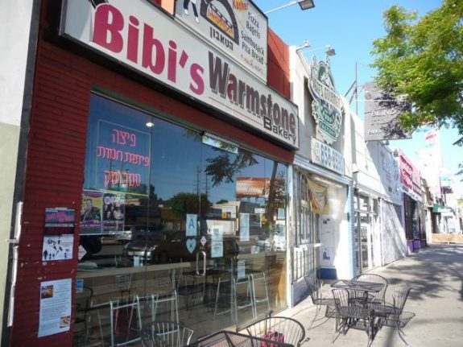

When I lived in the Pico Robertson area in the late 1960’s and the 1970’s one could not consider eating let alone dining out on Pico Blvd. Actually if you kept kosher and lived in the area you could starve to death on Pico Blvd. Trust me there was no place to eat.
In fact Pico Robertson was then known as an area, not the ‘hood.’ Yes it had many modern orthodox families but no one really considered it back then a neighborhood. It’s not as though you saw so many people rushing around on Friday afternoon buyingchallah and flowers for Shabbat. The area was close to Beth Jacob and to B’nai David, Beth Am and Mogen David, but that was it. There were no Young Israel’s every few blocks. And trust me not a sea of Jews after shul on Shabbos waiting to cross Pico and Beverly Dr.
But still, make no mistake, one could tell; it was burgeoning into what I came to refer to as the 90035 ghetto.
Many New York families were relocating here, some from the upscale area known as the 5 Towns on Long Island. They were not used to living in a desert of no luxury kosher caterers or decent restaurants to take the family out to dinner. And Israelis, those who could go into any restaurant in Jerusalem and not worry over what they could eat, they wondered what the problem was with ‘no place to eat out.’
There was a small somewhat shleppy restaurant called Tel Aviv on Fairfax, so one could get kosher meat there, like a rib steak, or lamb chops but it was not a very attractive restaurant, with no attention ( or knowledge) to presentation. Many people ate fish out and some would travel great distances (like Ventura) to enjoy a nice filet of sole (often requested that it be grilled in foil) dinner without worrying who might see them. Even then Pico Robertson residents were a bit judgmental when it came to kashruth.
After all you had to drive to Fairfax to buy a kosher challah at a shomer shabbos bakery. When Pico Deli opened they used to arrange for challah that could be picked up Friday afternoon from the Fairfax shomer shabbos bakeries.
Fast forward to the 21st century. It’s not even believable. You can get burgers, sushi, pizza even tacos-all kosher and the restaurants are shomer shabbos. If the line is too long, no worries walk further east, or further west, and like magic another sushi place is in front of you with a shorter line. At fancy restaurants like Pats or Ditmas patrons can dine on Petrale fillet of sole or a rib eye steak. N
atalie Trattoria has the best Chilean sea bass this side of the Gulf of Mexico, and the pastries and cappuccino at Delice’ make you feel as though you are in a café in Paris. You no longer have to scour the kosher world to find an attractive and delicious Bar Mitzvah or wedding cake. They are fighting each other for your business, right here in Pico Robertson.
Did I mention the schmoozing? Who I might ask works the room better than Jews? No one. Especially when they are out, being fed amazing kosher food and not being perceived as different. They are at home on Pico Robertson, and there is something to be said for that! Tzitiz out, kipot in abundance, it’s a new anthropological happening for orthodox Jewry in LA.
Synagogues and Jewish day schools have been born as a result of such happy schmoozing. The community needs more than one Young Israel. Where do you think these ideas are born? Not in a stuffy board room, but at a grand table at La Gondola where the see and be seen crowd hangs out solving life issues of modern Jewish orthodox families. When the Israel University deans and presidents visit Los Angeles and Beverly Hills donors they know the best places to be seen. When the big wigs from the federation want to cultivate the frum, it’s no longer happening at Nibbler’s (it should rest in peace) where they could get a tuna sandwich, they now end up at Got Kosher or Bibi’s enjoying a grilled tuna melt sandwich with pesto.
If you need milk on shabbos forget about buying it on Pico Robertson. Everything is shut, locked up tight. Back in the day one could become a little anti Jewish by shopping in the grocery stores on Pico. So much shoving, hollering, fighting over carts, and products. It was far from pleasant let alone civilized. But now because there is a choice, one could go to Ralphs after all and peruse the kosher aisles, and the kosher take out. Just because you are frum you do not have to put up with rudeness or sloppy service.
Pico Robertson has a presence. A panache, a statement of not only is it OK to be frum, its preferred. Why shop at a mega store like Ralph’s or even Gelson’s when you can support Jewish businesses? All those owners and their employees, whether it’s a super-size Kabob by Faraj or a small, individual Wine and Nuts (where they also have the best soft serve ice cream) they are here to serve and support Jewish life and Jewish continuity … nothing wrong with that. And certainly nothing wrong with supporting them because in the end, everyone benefits, Jews and non Jews. Thousands of Jewish nonprofits operate out of Los Angeles and they will be the first to tell you, we need all the friends we can get.

Sherri has spent the last several decades working & consulting in nonprofit management, both in and out of the Jewish community. Currently she is the Director for the West Coast Region of American Society of University of Haifa. Prior to this she was director for the Western States for Jewish National Fund.

Reprinted from the Parshas Va’eschanan 5776 email of the AJOP (Assocition of Jewish Outreach Professionals) UPDATE. The article originally appeared in the 08/14/2016 website of e Jewish Philanthropy.
When the Spanish Inquisition
Expanded to the New World
By Rich Tenorio

At the New Mexico History Museum, a new exhibit shows how hidden Jews fled to the colonies after 1492, but still couldn’t escape persecution

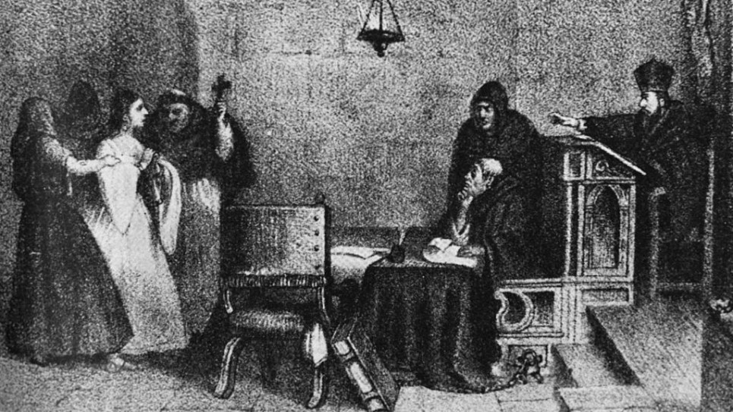
'A Hearing Before the Inquisition,' engraving by Mexican artist Constantino Escalante. (Public domain)
Centuries before New Mexico became a US state in 1912, it was a frontier of the Spanish Empire. In that role, it became a link in the story of the Sephardim — the Jews of Spain who were forced in 1492 to convert to Christianity or leave their homeland.
Now, in an unprecedented combination of the Old World and the New, a Santa Fe museum exhibition is telling the story of the Sephardim, with a focus on the conversos — Jews who formally converted to Christianity and their descendants — who escaped to the Spanish colonies of Mexico and New Mexico.
Fractured Faiths: Spanish Judaism, The Inquisition, and New World Identities is on display at the New Mexico History Museum through December 31. In this comprehensive exhibition, viewers can see artifacts borrowed from over 20 institutions from Europe and the Americas — many brought together for the first time.
Among the exhibition’s jewels is one of just two documented Spanish copies of the Alhambra Decree, the 1492 edict signed by King Ferdinand and Queen Isabella, who ordered the Sephardim to convert or leave within 90 days.
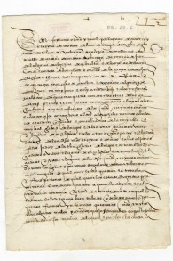
One of just two copies of the Alhambra Decree, declaring the
expulsion of the Jews; Granada, Spain, 31 March 1492. (Courtesy)

“It’s what started the whole movement, the diaspora,” said Josef Diaz, chief curator of the exhibit. “To think you had only three months to convert and change your entire belief system or flee. It’s very powerful. It’s a scary, powerful document. That’s the one that just moves me the most.”
There are other crucial images: architectural columns recalling the Moorish style of Santa Maria la Blanca, a 12th-century Toledo synagogue that became a church; Inquisition records of Dona Teresa de Aguilera y Roche, a 17th-century New Mexico governor’s wife jailed under suspicion of being Jewish; 20th-century gravestones from Catholic cemeteries in New Mexico with hints of Jewish roots.
“I think it’s essentially reifying an identity, through documents and artifacts, of the history of the diaspora,” said Frances Levine, a former director of the museum who helped conceptualize and develop the exhibit. “From the moment in 1492 when the writ of expulsion was issued, [it started a] chain of events and migrations that will ultimately bring you to New Mexico.”
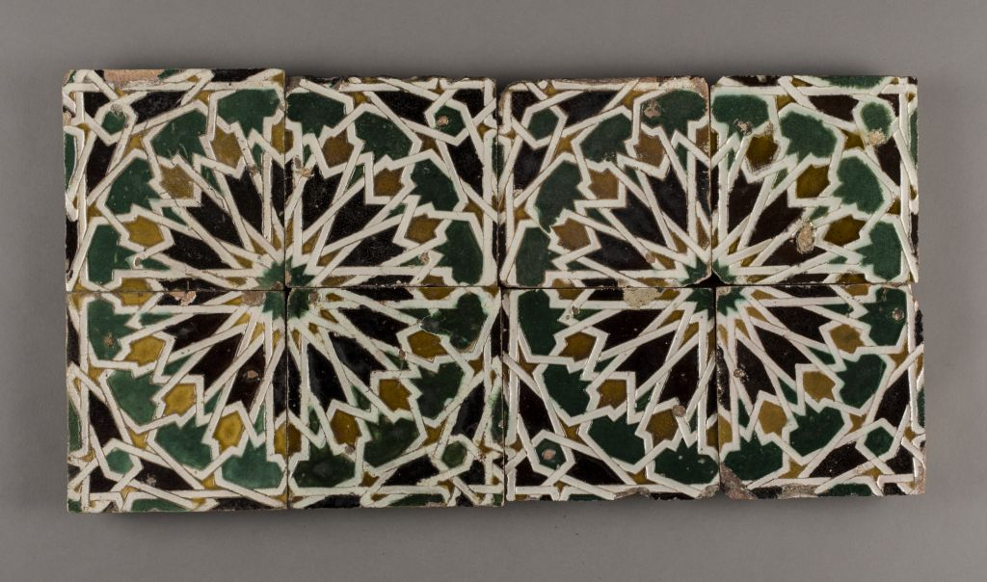
Beautiful handmade tiles once bedecked the El Tránsito synagogue, one of Spain’s oldest. Turned into a Catholic church after the 1492 expulsion, it is now a museum in Toledo, Spain. The tiles show Islamic influences in their design. (Courtesy)
Stucco fragments and tiles show the beauty of Nuestra Senora del Transito, a 14th-century Toledo synagogue. And there are the architectural details that evoke Santa Maria la Blanca.

The origin story
The origins of the Sephardim date to the destruction of Jerusalem’s Second Temple in 70 CE, when Jews are recorded as having fled to the Iberian peninsula.
“It really speaks to why Spain is its own kind of biblical Holy Land, at least for this people,” said Roger Martinez-Davila, a guest curator of the exhibition and a professor at the University of Colorado at Colorado Springs.
Around the year 1000, he said, “Sephardic Jews were doing quite well under Islam, and to some extent Christianity.”
The exhibit begins with Golden Age glimpses, such as a copy of “The Guide for the Perplexed,” the philosophical document written by Rabbi Moses ben Maimon, better known as Maimonides.
“We have a wonderful designer for our museum,” Diaz said. “She dreams along with me. [It was a] wonderful thing to recreate, a fairly complex building with arches and capitals.”
But as Christian kings began the Reconquista, or reconquest, of Spain, the Jews’ situation worsened. After pogroms across Christian Spain in 1391, an estimated 100,000 Jews were killed, 100,000 converted and 100,000 emigrated. Martinez-Davila said that while these numbers are “probably incorrect,” they give “a sense of scale.”

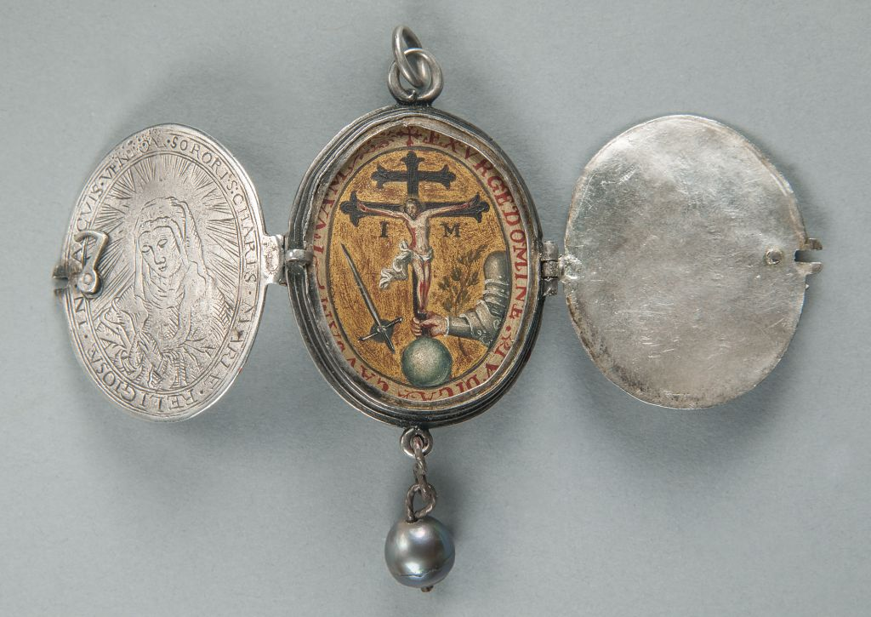
Locket with Inquisition emblem, Mexico, seventeenth century, Unidentified artist; Silver, gold, and oil on copper. (Courtesy)

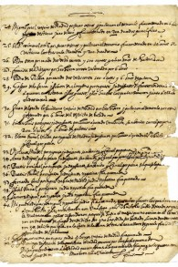
A register of blasphemers, heretics and Jews by the Holy Office of Toledo, Spain, 1632; Ink on paper. (Courtesy/ New Mexico History Museum)

Just over a century later, in 1492, Ferdinand and Isabella completed the Reconquista, conquering the last Moorish kingdom of Granada and its citadel, the Alhambra. The monarchs issued the Alhambra Decree on March 31, 1492.

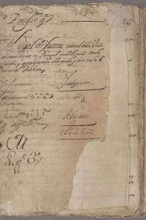
Carvajal Records: Manuel de Lucena, Carvajal family Inquisition records, Mexico City, Mexico, 1594. (Courtesy of The Bancroft Library, University of California, Berkeley)

Rabbi Neil Amswych of Temple Beth Shalom in Santa Fe has visited the exhibit three times. He recalled his shock upon seeing the decree.
“[You] came face to face with the document that changed everything,” he said. “I must admit that I was not expecting to see it and was not surprised to quickly find myself holding back tears.”

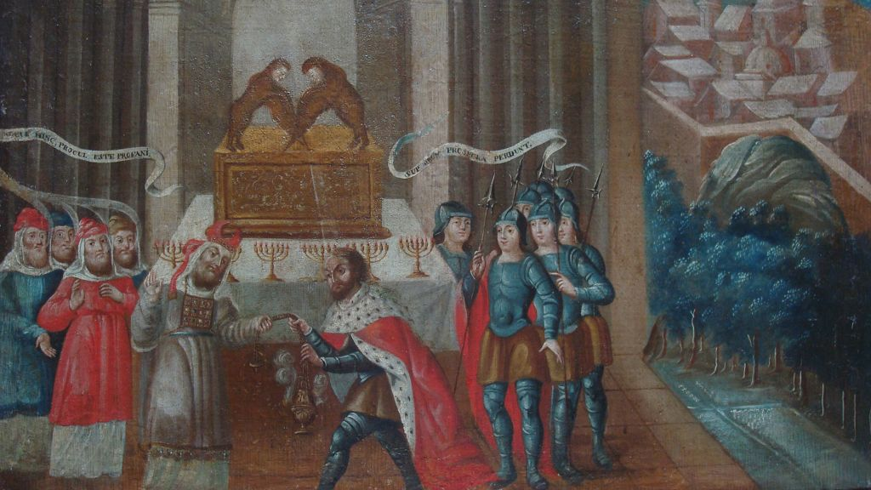
David and the Priest Ahimelech; Mexico, early eighteenth century; This piece by an unidentified artist is notable for its combination of the Arc of the Covenant, a menorah, and the respectful depiction of a Jewish priest. (Courtesy/ The New Mexico History Museum)

“I don’t know what I would do if I was faced with that question, that option: stay and convert or flee,” Diaz said. “Those people who did stay and convert did practice in secrecy. Many did choose to flee.”
Sephardim left for Portugal, Amsterdam, the Ottoman Empire and North Africa. (Portugal expelled its Jews in 1497.) But as the 15th century ended, Sephardim also considered the New World that Columbus had reached across the Atlantic.
The number of Jews who left for the New World can only be estimated. That was because of the restrictions of 1492.
“After the Alhambra Decree is issued, it was illegal to be Jewish anywhere in the Spanish world,” Levine said. “[It was] on pain of death. If you were Jewish, you were quite clandestine anywhere in the Spanish Empire.”
Anyone suspected of practicing Judaism risked the wrath of a new, terrifying organization: the Spanish Inquisition.
Established in Spain in 1478, the Inquisition began active investigations in 1480. The next 40 years would see a wave of persecution of crypto-Jews, or conversos who secretly practiced Judaism, in Spain and to some extent in the Americas, Martinez-Davila said.

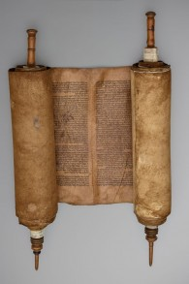
A circa 16th-century Sephardic Torah scroll from Spain. (Courtesy)
He added that Inquisition officials included “a lot of people of Jewish descent,” such as the grand inquisitor Tomas de Torquemada.
“They were the worst of turncoats,” he said.
A 1507 copy of the Libro Verde de Aragon from Belchite, Spain, shows names of those executed for heresy against the Catholic faith.

“A book naming all those killed by the Inquisition struck deep like the lists of Jews who were taken to concentration camps by the Nazis five hundred years later,” Rabbi Amswych said.
The Inquisition spreads to the colonies

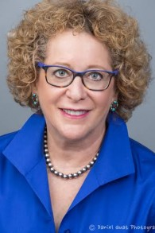
Frances Levine, former director of the New
Mexico History Museum. (Courtesy)

“Most people don’t think of the Inquisition operating in North America, that it just operates in Spain,” Levine said. “But the power and authority of the Inquisition went with conquest. Anywhere in a Spanish colony, the Inquisition appeared with it.”
In Mexico City during the 1590s, a second wave of persecutions arose, stretching over a decade. Its victims included Don Luis de Carvajal, a colonial governor of New Mexico, and his family.
“[Carvajal] was one of a family of Judaizers,” Martinez-Davila said, using a technical term with which the Inquisition charged crypto-Jews. “His whole family was executed, burned at the stake. Two escaped to the Ottoman Empire. He was the most celebrated case. We have letters from him. He fully confessed: ‘I was Jewish, I was holding Shabbat services, Friday night services.’”
Yet, Martinez-Davila added, “parts of [Carvajal’s] extended family were running the Inquisition. One side would be very Catholic, and to protect their position inside the Inquisition, and the royal government, [they would be willing] to execute family members.”
Carvajal died in prison in 1591. His family’s Inquisition records, from Mexico City in 1594, are part of the exhibit. In 1596, the Inquisition put 46 conversos on trial, including members of Carvajal’s family who were burned at the stake.

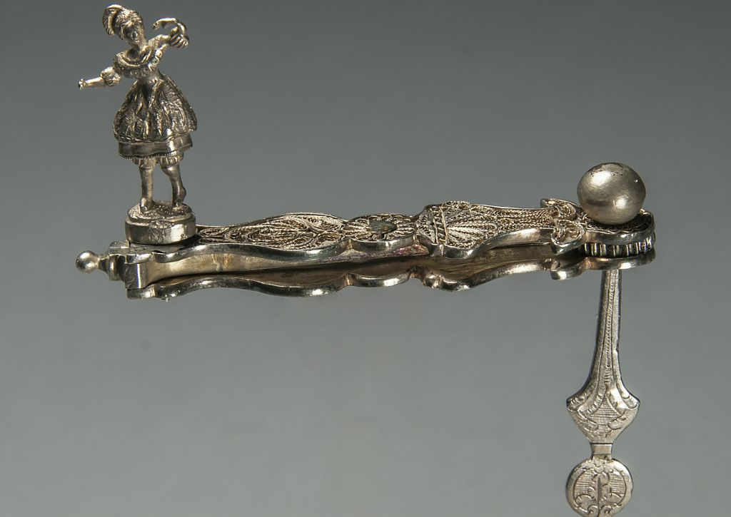
This Purim noisemaker from 17th century Mexico is small enough so as not to make much noise. It could also pass as a Catholic ‘matraca.’ (Courtesy)

In 1601, 45 more conversos were executed. Between 1574 to 1603, there were 115 people accused of Judaizing.
“They are not enormous numbers, but they are pretty big, with colonial society being measured in the tens of thousands,” Martinez-Davila said.
Mexican paintings in the exhibit show autos-da-fe, “public processions [in which] those convicted of heresy [would be] either convicted or do penance or be executed,” Martinez-Davila said. “It must have really occupied society, with the horribleness of the gladiatorial games.”
Over a half-century later, another infamous trial in New Mexico
Dona Teresa de Aguilera y Roche was born in Italy, the daughter of the governor of Cartagena in present-day Colombia and an Irish mother. Young Dona Teresa was educated in Italy and Spain.
In the 1660s, the possibility of being Jewish placed her in an Inquisition prison.
Her husband, Don Bernardo Lopez de Mendizabal, was the governor of New Mexico, and according to Levine “quite unflattering” in general and “quite abusive” to his wife.
The governor clashed with Father Alonso de Posada, the father-custodian of the Franciscans, who sought revenge when Don Bernardo’s term ended in 1662.
“The incoming governor took the side of Father Posada, and arrested governor Mendizabal and Dona Teresa, as well as four of Mendizabal’s allies,” Levine said. “In a way, Dona Teresa [faced] guilt by association… Father Posada says, at one point, that her crime is being married to [Mendizabal].”

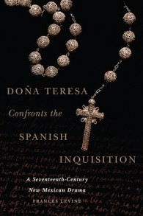
Cover of Frances Levine’s new book, ‘Dona Teresa Confronts
the Spanish Inquisition.’ (Oklahoma University Press)

And, Levine said, accusing her of being Jewish was the “only way Posada could act [through her] against the governor.”
The former governor and his wife were imprisoned in Mexico City, where Don Bernardo died in September 1664. One of his sergeants faced humiliations of his own.
“Surgeons discussed whether marks on his foreskin indicated he was circumcised,” Martinez-Davila said.

Dona Teresa’s struggles had only begun.
“The crimes she was accused of were failures of religious practice,” Levine said. “Changing linens in her house on Friday as preparation for the Sabbath. [Using] onion skins on her feet seems to her maid [like a] ritual. She was accused of being harsh with her maids when they go to church, speaking ill of the friars, and accused of being a Jew.”

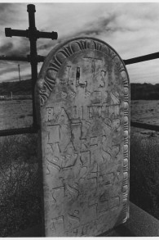
‘The Five Commandments in Hebrew Letters,’ shows Jewish influence in a Catholic cemetery in the Middle Rio Grande Valley, 1905. Photo by Cary Herz. (Courtesy)

“She is tenacious,” said Levine, whose biography of Dona Teresa was published in July. “She was educated, well-traveled, had certainly seen more of a worldview than anyone [else] did. She was the daughter of a colonial governor, from a very highly-placed, highly-connected family. That — her education and family connections — gave her exposure, confidence.”
Dona Teresa made many appearances before the court, and personally wrote her defense dossier, displayed in the exhibit.
“One page is in her very own handwriting,” Levine said. “You almost feel, it’s palpable, she’s in her own prison cell, writing furiously, crossing out [words].”
Although the museum opened in 2009, it has a link to Dona Teresa — it operates alongside the Palace of the Governors, a 17th-century adobe structure that was Spain’s base in the American Southwest.
“She was arrested [in] 1662 in the very building where I had my office and worked for 12 years,” Levine said.
On Christmas of 1664, the Inquisition dismissed Dona Teresa, not finding her guilty or innocent. She sued the Inquisition for recovery of property, and sought to clear her name and that of her family from the charge of being Jewish.
Levine said that neither Dona Teresa nor her family were Jewish, although Martinez-Davila said she came from Jewish lineage.
“I don’t know if we ever will know,” Martinez-Davila said.
Trying to find the pioneer Jews
Previous exhibitions in the museum have attempted to discover the elusive ancestries of the Jews of New Mexico.
In the late 1990s and early 2000s, the Palace of the Governors held an exhibit on the Jewish pioneers, which helped advance a conversation about identity.
“People were asking for more, audiences were asking for more,” Levine said. “That exhibit was about European Jews. They wanted us to look at conversos, Sephardis, Sephardic Jews in the New World.”
Levine calls the subject “a very, very contentious, very important topic in New Mexico history.”
Around that time, Levine traveled to Toledo and visited the Museo Sefardi at Santa Maria la Blanca.
“Standing in front of the writ of expulsion, for the first time I understood what began the Jewish diaspora from Spain and Portugal,” she said. “It might have been that moment in Spain, 2002, 2003, standing in front of the writ of expulsion, where the seed was planted.”
In 2010, she and Diaz began working on their exhibit, eventually bringing in Martinez-Davila. They borrowed 95 percent of the materials from institutions that included the Biblioteca Nacional de Espana in Madrid, the Museo Sefardi, the Museo Franz Mayer in Mexico City, and the Hispanic Society of America and the Jewish Museum in New York.
“Because Spain only allows documents out of the country for six months, we had to shorten the exhibit,” Diaz said. “We were hoping for one year. Six months is what the government allowed us to do.”
Martinez-Davila said the curators had considered a traveling exhibit, “but there were very, very demanding contracts and loan agreements. We can’t keep many pieces past December.”
And, the Spanish institutions had individual requirements.
Inquisition.’ (Oklahoma University Press)
“Crates had to be a certain temperature, [certain] age requirements, with special planes and trucks to hold that humidity,” Diaz said. “Oftentimes we had to have exclusive couriers, members from an institute in Spain on the same jet.”
“I’m so proud to be associated with what [Diaz and Martinez-Davila] brought together,” Levine said, calling the exhibit “masterful.”
Rabbi Amswych agrees.
“I feel that the exhibit asks questions not just of people of faith — particularly Jews — about how they might respond in the face of terrible choices, but also questions to all of us about our own humanity and how quickly we can forget the humanity of others,” he said. “It is a moving and powerful exhibit that graces and enriches Santa Fe with its presence.”
Of the three experts who helped create the exhibition, two are now elsewhere.
Levine is in St. Louis, where she has been the head of the Missouri History Museum since 2014. Martinez-Davila is in Madrid, as a fellow at the Universidad Carlos III.
They both returned for the opening. Levine returned again on July 24 to discuss her new book, “Dona Teresa Confronts the Spanish Inquisition.”
“They had to turn people away and sold all the books the store had,” she said. “It is gratifying that people seem hungry for more than even the Fractured Faiths exhibit holds. Doña [Teresa’s] voice lives long after her sad trials.”
New Mexico has tried to turn a page on its colonial past. Today, Santa Fe is home to a Jewish population that includes Temple Beth Shalom and Rabbi Amswych. And the exhibit, in its last section, examines Jewish traces in the state population from the 19th century onward. These include images from the late New Mexico photographer Cary Herz, such as the “Five Commandments” on a 1905 gravestone in a Catholic cemetery.
“I think it is a continuing story,” Diaz said, adding that people in New Mexico are “just now self-identifying, realizing through family research, genealogical research, that they do come from a converso background, a family of Jewish descent. They trace it back to Spain.”
In February 2014, the Spanish government passed legislation allowing the descendants of the Sephardim to pursue dual citizenship. However, Martinez-Davila said, “then they changed the rules. There was an examination on the constitution, and a language exam. So as quickly as the door opened, it practically closed.”
But in Santa Fe, the doors to the Fractured Faiths exhibit are wide open.
“We took the story, which is so difficult for people to talk about, which had been ridiculed,” Levine said. “We embraced their identity, this moment in history, and it’s at the state history museum of New Mexico. It’s huge.”

Reprinted from the August 17, 2016 email of The Times of Israel.

