

Insights from shiurim by Rav Moshe Boyer shlit"a in the "Veyoatzeinu" courses on Understanding the Nefesh



**Parshas Matos-Masei**

**כ"ח תמוז תשע"ז**

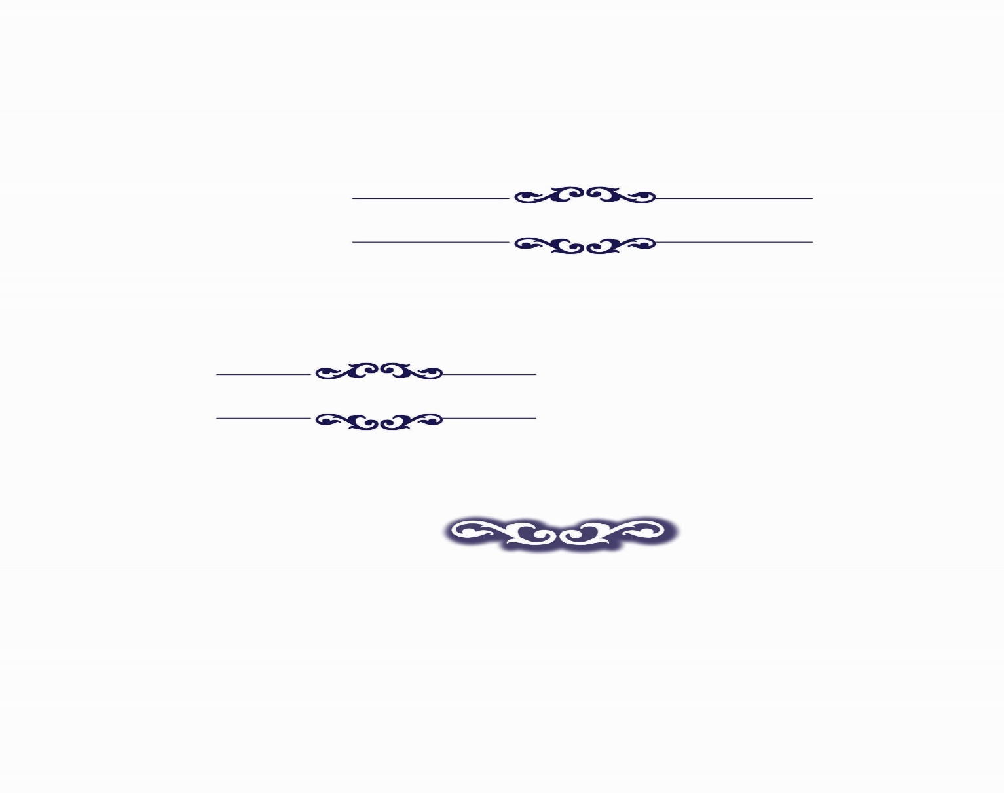

**Chinuch in our Generation**

**Accepting Rebuke**

Moshe Rabeinu hurls extensive rebuke to the members of the tribes of Gad and Reuven, ten complete verses of harsh words, sharp as a razor. He calls them a group of sinners who have turned away from G-d and who are destroying the nation with their actions. The members of Gad and Reuven humbly listen - and remain silent! They make no effort to interrupt the accusations, nor to ward off the suspicions. Only after Moshe Rabeinu finishes, do they clarify their perfectly kosher intentions.

Why didn't they immediately rise up and declare to Moses, "Rebbe, Heaven forbid! Do not suspect us even for a moment, we had no negative intent!" Why didn't they say a word to defend themselves against the rebuke?

We learn from the Gadites and Reuvenites that even if you are right and you can defend yourself, it is worthwhile to receive reproach! Even if you are not the address of the words being thrown at you, there is benefit to bowing your head, and listening to the words willingly, and only then to reply. By humbly subordinating himself and keeping quiet in these situations, a person practices "acceptance”. This virtue enables him to be a receptacle for the Torah and for positive character traits. On the other hand, someone who constantly brushes off every claim against him, gets used to being always right. He becomes blown up with pride in himself, and he gets used to not accepting rebuke and to not listening to the opinions of those who are greater than him. In the end he remains empty since he is unable to bend down and listen, to accept someone else's words.

There is a story about the Koznitzer Maggid who went to learn in the Beis Midrash when he was a child. His father warned him not to stay out late at night because he was worried about the mischief that took place under cover of darkness. The young boy became engrossed in his learning and didn't notice the shadows of night spreading over the world. He sat bent over his Talmud until dawn came. In the morning the child arrived home to his father who had been worrying all night about what kind of places his son was wandering around in the dark. Out of his great love he gave him a good beating, and also scolded him with fierce words.

The child absorbed his father's wrath in silence, didn't protest his innocence, nor did he insist that he was right. He bowed his head, as if welcoming his father's rebuke. Later, the Koznitzer Maggid described how at that moment he absorbed tremendous energies of longing for the good, of nullifying one's will to be subservient to His will. These were great, defining moments that placed him on the straight path He concluded: “It does not matter if you are right, willingly accept the rebuke!”

There is another great virtue of accepting rebuke even if appears to be unjustified and unfair. It can be perceived as G-d's spirit afflicting him through the voice of the rebuker. Since G-d controls every single act that takes place in this world, even if the rebuke was mistaken, G-d arranged for those words to reach his ears. The recipient should make an effort to find relevance in the message being sent to him. Taking seemingly irrelevant words and toiling to identify the personal message by contemplating what G-d wants from him, is fulfilling the verse בכל דרכיך דעהו "Know Him in all your ways" – even the ways which appear as strange. In the merit of this contemplation, a person attains והוא יישר אורחותיך "and He will straighten out your paths".

Furthermore, every bit of shame and pain that a person experiences brings atonement for his sins. Sometimes, G-d wants to give someone a present but his misdeeds prevent him from receiving the bounty. Then the Almighty in His goodness sends that person a small amount of shame (i.e. one of his friends or family members gets angry with him and rebukes him unnecessarily.) This shame atones for his sin while opening up the gates of bounty.

It is now clear, that even if the rebuke itself is both unjustified and addressed to the wrong person, there is a threefold benefit to a person bowing his head and listening to the words. He gains the virtue of nullifying his will, he absorbs the message of a voice calling to him from Heaven, and his soul is purified by the atonement of his sins.

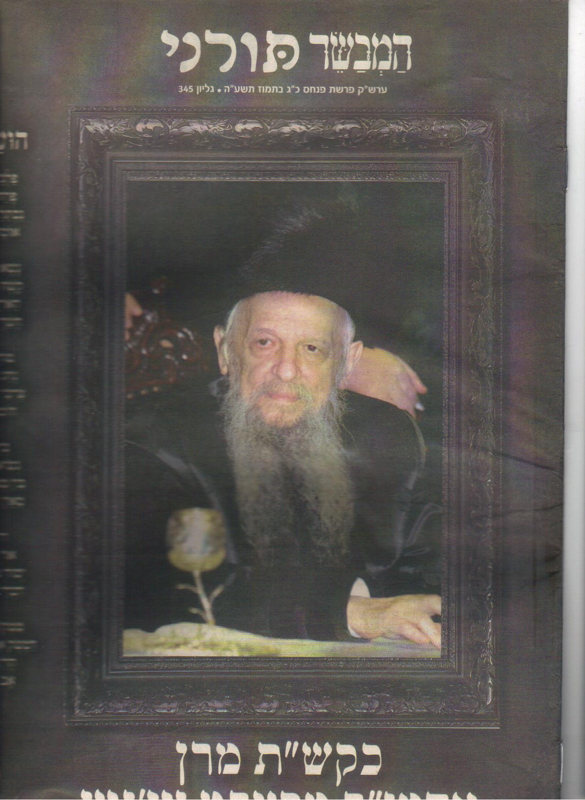

**Bnei Reuven and Gad's Caution Not to Steal**

The purpose of Bnei Yisrael leaving Egypt and receiving the Torah was for them to fulfill the promise to our forefathers that they would settle in Eretz Israel, keep the mitzvos there and build the Beis Hamikdosh. They experienced Hashem’s care and providence with many miracles – Plagues and handing over of Egyptian wealth, Splitting of the sea and Divine Revelation at Sinai, Manna and much much more. Suddenly, on the verge of entering the promised land of Israel, the Reuvenites and Gadites made a surprising about-face: "We don't want to cross the Jordan". Why? Wealth! "This land is advantageous for livestock, and your servants have livestock". How could this be? How could they swerve from the essential goal of living in Eretz Israel - for the sake of greener grass?

More surprising is Moshe's response: "If you do this, as long as you join in the battle … you will have fulfilled your obligation." He doesn't attempt to convince them to change their minds and enter Eretz Israel, he just makes a condition with them that they shouldn't discourage the rest of the nation. Why didn't Moshe try to persuade them to cross the Jordan with everyone else?

Furthermore, the Reuvenites and Gadites phrase their request to Moshe as if to say that he himself is the one who decides. "If we find favor in your eyes", " Your servants will do whatever our master commands." Is Moshe the one who decides? Isn't it Moshe’s role to convey the request to, and the response from, the Almighty?

The solution is based on the Ar”i Hakadosh’s revelations concerning reincarnation of souls (Shaar Hagilgulim). Inasmuch as Moshe Rabeinu was a reincarnation of Hevel (Abel), and Reuven (along with his tribe) were reincarnations of Kayin (Cain), the interaction between them served as a rectification (*tikkun*) of the interaction between Kayin and Hevel. The Midrash Rabba (Bereishis 22:7) describes their argument over Hevel’s twin sister. Kayin said, “She is mine to marry because I am the firstborn!” Hevel said “She is mine to marry because she was born with me! At that point, Kayin arose (and killed Hevel)." The *midrash* explains that the root of Kayin's sin of murder is theft. Rectification of Kayin's sin of murder, requires amending its root, the sin of theft.

The Mishna teaches that you may not raise *behema daka* (sheep and goats) in Eretz Israel because they wander into other people's fields to graze, causing their owner to be guilty of stealing. The Reuvenites and Gadites had huge herds sheep. They approached Moshe out of concern that instead of rectifying Kayin's sin, they would be perpetuating it. They approached Moshe with the following suggestion. "If we enter Eretz Israel we are very likely to be constantly transgressing the sin of theft, and we will miss the opportunity to rectify Kayin's soul. We implore you, the reincarnation of Hevel, to allow us to settle on the eastern side of the Jordan River where the river will serve as a natural impassable barrier for our herds of sheep, who will not graze in other people's fields. Even though we will lose the immense spiritual benefits of Eretz Israel, at least we will gain the possibility of earning our living in an honest manner, which is of paramount importance."

Once it became clear that their motivation was *leshem shamayim*, and they were not sinners, but rather G-d fearing men, Moshe agreed to this step. Indeed, if a person's *bein adam lechavero* is incomplete, his *avodas Hashem* is also incomplete. It is even worth giving up the spiritual advantages of Eretz Israel if living there involves transgressing *bein adam lechavero*.

The lesson for us is very important. It is preferable to give up on many spiritual opportunities as long as you maintain your honesty and integrity. If a spiritual improvement involves a chance of theft or of offending another person, it is better not to go for it! Unfortunately, there are people who separate between their *avodas Hashem* and their daily lives. Although they try to maximize their Torah and davening, their *bein adam lechavero* is sorely lacking. These people don't realize that that their bad *middos* undermine the entire foundation of their spiritual structure. We learn from the Reuvenites that it is preferable to give up on many spiritual opportunities as long as we don't deviate from the straight path.

Furthermore, those who think that they can attain things through tricks, cheating or deceit, must understand that twisting the truth will not lead them to satisfaction. It will distance them from the goal. As it says, ראשית חכמה יראת ה', the beginning of wisdom is fear of G-d. By ensuring that we earn our *parnassa* honestly, without any trace of theft along the way, we will be feeding our families with honest bread, enabling and empowering (instead of interfering with) their growth and development as *ehrliche,* G-d fearing adults.

With the encouragement, blessing and guidance of great rabbinical mentors, Rav Moshe Boyer has spent years researching Torah sources that deal with understanding the structure of the *nefesh* and probing its awesome depth and breadth.

Today his shiurim around Israel to separate groups of men and women are in great demand throughout the Haredi communities and are attended by thousands. Participants regularly comment on the life-changing effect which Rav Boyer’s wise and perceptive insights have had, strengthening their personal *avodas Hashem*, including their personal relationships - towards themselves, their spouses and children. Even non-religious professionals have repeatedly expressed amazement at Rav Boyer’s source-based insights, many of which they incorporated for use in their own portfolios. Some even abandoned the methods of their profession in favor of what they learned from Rav Boyer. Success speaks for itself!

Our generation is blessed with material abundance unknown in world history. Paradoxically, this abundance has led to rampant dissatisfaction, unhappiness, depression and other emotional illnesses throughout the world. Recent generations created the psychological profession to address this need and to help people be happy and functional.

With no other choice the Torah observant Jews in need of such services had to turn to these professionals and even be trained with their methodology to address the growing need in our communities as well. Needless to say, these approaches are based on an attitude to life, goals and direction which are frequently at odds with the Torah, sometimes in obvious ways and many times in subtle and insidious ways.

Rav Boyer set out to provide an exclusively Torah-based alternative. Pushed and encouraged by his own rabbinical mentors, he recently established "**Veyoatzeinu Kevatchila**" to train *metaplim* to counsel and guide, to uplift and to realign each individual to healthily negotiate their own personal life journey as an *Oved Hashem*. His passion for his mission of widely sharing these methods and experience is leading him to include English speakers.

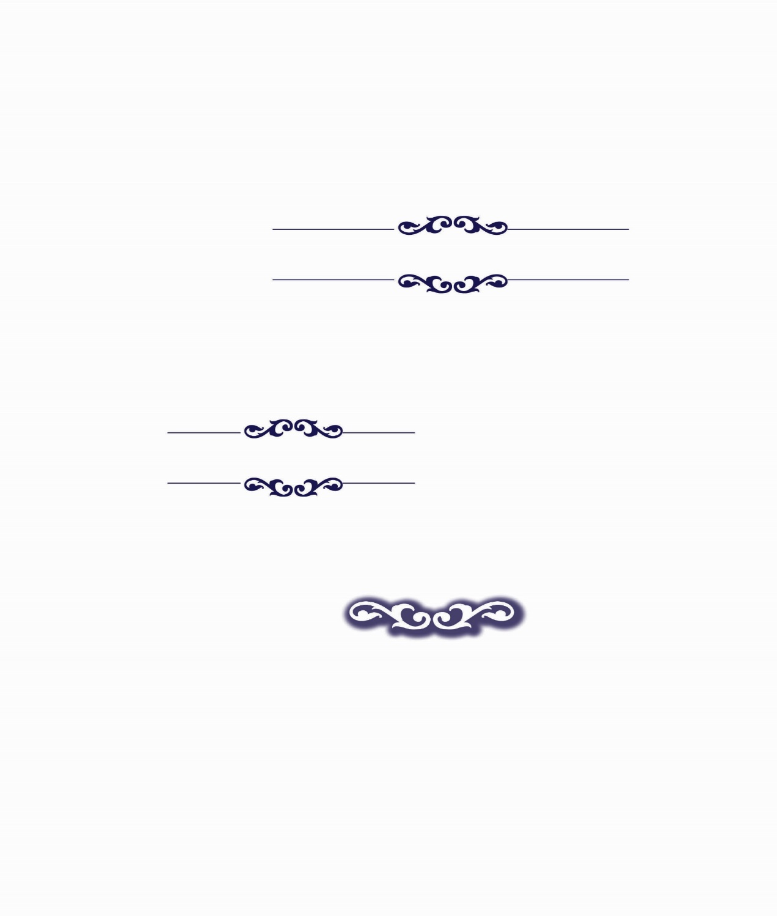

**From the Editor**

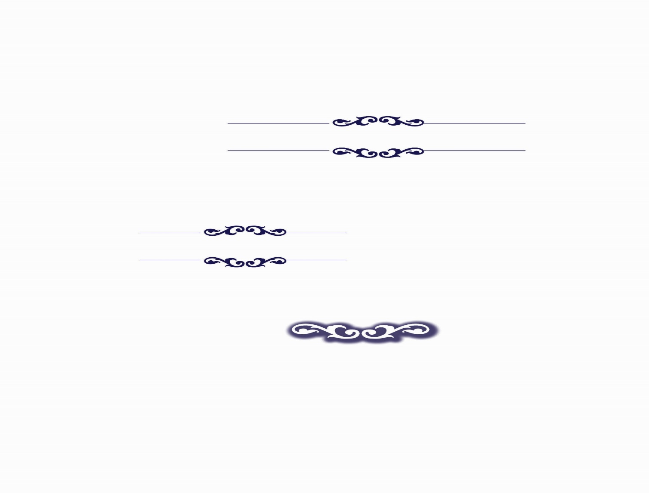

**Treasures for the Soul in Parshas Hashavua**

