SUPPLEMENTARY Stories
For Parshas devorim 5777
Printed L’illuy nishmas Nechama bas R’ Noach, a”h
Volume 1, Issue #8 (Whole Number #8) 13 Devorim 5777/August 5, 2017

For a free copy, please forward your request to keren18@juno.com

Living After My
Mother's Murder
By Rabbi Avraham Lapine
Co-director of Chabad at MU (University of Missouri – Columbia)

Following unrest in Missouri, Shliach Avraham Lapine went back to the brutal murder of his mother in Crown Heights. Crown Heights born Rabbi Avraham Lapine is the Director of Chabad of University of Missouri (MU / Mizzou) and Mid-Missouri. He published the following article in the Columbia Daily Tribune:

Our campus community is undergoing a much-needed period of healing. Racial protests, discriminatory bias and a toxic atmosphere of disunity have torn apart the fraternity of our school, threatening the core values upon which the University of Missouri were founded.
As a Mizzou religious leader, I counsel students who turn to me for guidance. They seek advice about how to repair past damage and look for direction to forge a healthier and more tolerant path forward. There is no one correct stance, one sure approach, yet I feel that my life experiences — both as a religious representative as well as a personal victim of racial violence — have provided me with invaluable insight into repairing a fractured society.
I grew up in the Crown Heights of the '90s, an ethnically diverse Brooklyn neighborhood that, during the beginning of that decade, experienced unprecedented levels of racial tension. The 1991 riots are etched into my childhood memories, my upbringing being wrought with feelings of agitation and unrest.
It was only months later, on Feb. 6, 1992, that, as a 5-year-old returning home from elementary school, I was informed of the murder of my mother (Pesha Leah Lapine) by a black man in an act of cruel hatred and bitter violence.

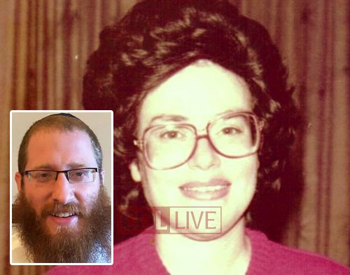
Rabbi Lapine (inset) and a photo of his mother Pesha Leah Lapine, Hy”d

How was I to move forward, to maintain my inborn respect for all of mankind, after experiencing firsthand the human cruelty that had torn my innocent life apart?
The following is my take on the matter, and the insight I have gained from my own life experiences.
The issues facing our community are reflective of a failing in modern society at large: the inability to treat another who is of a different background, race, religion or opinion with an equal degree of respect. Contemporary sociology has turned our perspective of humanity into a rigid caste structure, where an individual's positioning in the societal hierarchy is determined by a variety of factors, the majority of which are beyond the control or choice of the individual they are used to classify.
A dramatic perspective shift is necessary to counter such ingrained divides.
The Biblical reasoning against harming one's fellow man — whether physically, emotionally or psychologically — is given as, "For in the image of G-d, He made man."
Man's value is not, as modern society is so wont to purport, a product of social status; nor is man's value a product of upbringing, religion or skin color; man's value is a result of his being created in the image of G-d, the knowledge of which suffuses his being with an inherent sense of worthiness and respect. The stronger we identify with this G-dly portrayal of human import, the greater our appreciation and tolerance for others will become, even for those whom, externally, we might appear to differ.
These values that have defined my outlook on humanity were communicated to me by my own mentor and teacher, the Rebbe, Rabbi Menachem M. Schneerson, whose passing was commemorated this year on July 9. The Rebbe's entire being embodied the values prescribed by the Torah, his life being wholly dedicated to promoting a greater awareness of G-d, love and respect for a fellow, and to building a better world.
The Rebbe, too, had firsthand experience of the extent of human depravity, losing his brother to the Nazis and his father to Soviet persecution. Notwithstanding the brutality he was personally dealt, the Rebbe remained resolute in his conviction regarding the innate nature of man — namely, that it was the image of God, in all of its purity, that defined the core of human existence.
The Rebbe did not hide his optimistic perspective, and he used every opportunity to impress his view upon others.
In an encounter with David Dinkins, New York City's first black mayor, the Rebbe expressed his hopeful dream that "in the near future, the ‘melting pot' will be so active that it will not be necessary to underline every time," when speaking of others, " ‘They are Black', ‘They are White', ‘They are Hispanic', because they are no different. All of them are created by the same God and created for the same purpose: to add to all good things around them."
After the 1991 riots — which were instigated by a tragic motor accident resulting in the death of a young black boy and led to the horrific murder of a Jewish student by a mob of young black men — the Rebbe expressed his hope to Mayor Dinkins that the mayor would be able to bring peace to the city.
The mayor added, "to both sides," which the Rebbe corrected, explaining, "We are not two sides; we are one side. We are one people living in one city under one administration and under one G-d. May G-d protect the police and all the people of the city."
In the face of the tragic murder of one of his students and followers, the Rebbe's response was not finger-pointing and culture-blaming; his response was a call to unite, to highlight our similarities over our differences and to draw upon our shared mission in bringing otherwise disparate communities together.
It was the optimistic vision of the Rebbe that charted the course of my youth and fortified me with the necessary strength to overcome my tragic loss. It would become my mission, I decided, to promote a universal message of peace, tolerance and mutual respect, values that would serve as the greatest legacy to my mother's blessed memory.
It is this perspective that inspires my work as a religious leader at Mizzou. I strive to share this message of a collective responsibility, shared by all of mankind, toward building a better world — regardless of one's upbringing, religion or race.
Our motto of "In G-d we trust" is not a replacement of "E Pluribus Unum." It is its justification and rationale. "From many" can come "one" when society will appreciate that we are all, in truth, "one nation under one G-d."

The above article was published in The Columbia Tribune on July 10, 2016. Parts of it were reprinted in COLLIVE.com website on July 11, 2016.

Flight From Syria
By Shlomo Rizel

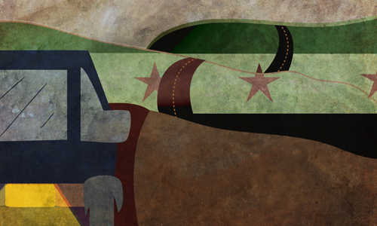

Yom Tov Gindi of Kfar Chabad tears up every year on Passover when he reads in the Haggadah:
Therefore we all have to thank You, to praise You…who did these miracles for our fathers and for us—You took us from slavery to freedom, from grief to joy, from mourning to holy days, from darkness to great light.
As one who has gone from virtual imprisonment to freedom, he understands perfectly well what these words mean, and how much one has to praise G-d every day.

The Situation Deteriorates
Yom Tov’s story begins in Aleppo, a city in northern Syria. Aleppo had been the center of Jewish life in Syria since the Second Temple era. The Gindis arekohanim, and were one of the most esteemed Jewish families.
Before the establishment of the State of Israel in 1948, the Jews lived relatively undisturbed in Syria, but when Israel declared independence from British rule and Syria attacked Israel during its war of independence, Syrian Jews entered a dark era.

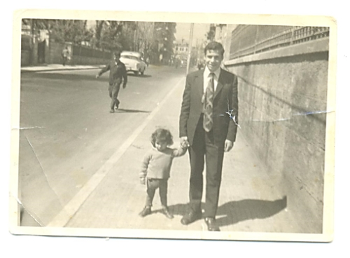
Yom Tov Gindi walks with a nephew in Syria.

First, the movements of Syria’s 55,000 Jews were severely limited. Although the government officially stopped issuing passports to Jews, for fear that they would flee to Israel, 90% managed to leave the country by the end of 1964.
Then it all got complicated. The 5,000 Jews left in the country couldn’t get out, even with passports, and needed written permission just to travel from city to city.
“In spite of the obstacles, the sound of Torah study never ceased in Aleppo, even at the worst of times,” Yom Tov says. “In my school, which was just one of the Jewish community’s many institutions, we studied Torah from morning to evening, even on Shabbat. Every child knew large parts of the Bible, Mishnah and Talmud by heart.”
The infamous Mukhabarat (secret police) ruled the country uncontested, but they were exceptionally hard on the Jews. “For all practical purposes, we were imprisoned. Because of the restrictions imposed on us, I was 17 years old before I left the city for the first time. There were tens of Mukhabarat officers watching the 2,000 Jews of Aleppo; each was responsible for a different street. Each of them recognized all the Jews on his beat. They knew a lot about each of us; they were in and out of our houses all the time. They would stop and search us if they had the smallest suspicion that something was wrong. They especially watched to see if we were preparing to escape to Israel.
“For example, the first time that I went to Damascus, I had to present myself at the Mukhabarat offices to request a travel permit. I had to fill out a detailed form describing why I had to travel and where I planned to stay in Damascus. A few days later, they called me back to receive the special visa that only Jews needed, and instructed me to take a specific taxi, leaving from a specific place. They told me that as soon as I got to Damascus, I was to present myself to the local Mukhabarat office. And I had to do the whole thing over again when I went back home.”

Constant Fear
Sometimes, interviews with the Mukhabarat involved several days of imprisonment, or broken bones. The worst instances involved families whose children had managed to flee to Israel—the parents could be tried and imprisoned for several years.
“I remember my friend’s father coming back on a Thursday from the Mukhabarat offices after an investigation that had gone on for several days, during which he’d been beaten repeatedly. That Shabbat, he died of his wounds.”
Yom Tov continues, “Sometimes, people are inclined to belittle the situation of Syrian Jews by comparing it to what was going on in Russia under Stalin, where the situation seemed much harder. There, the Jews who studied Torah and built mikvahs were exiled to Siberia or shot for treason. On the other hand, although in Syria we were allowed to practice our religion, every Jew felt the heavy hand of the government. In Russia, whoever toed the line was left alone and could be part of the establishment.”
He stresses that their lives were shrouded in fear, and explains that there was no Arab country in those days in which the Jews had it as bad as they did in Syria. So why did the Syrian government force its Jews to stay, if they hated them so? Yom Tov explains that they were afraid that their Jews would go to Israel, join the army, and use their fluency in Arabic to fight Arabs. “They figured that as long as they had us, they were preventing the Israeli army from getting even stronger.”
In spite of the difficulties, every year tens of Jews would “disappear,” and the Gindis knew that they too would leave Syria at the earliest possible opportunity.
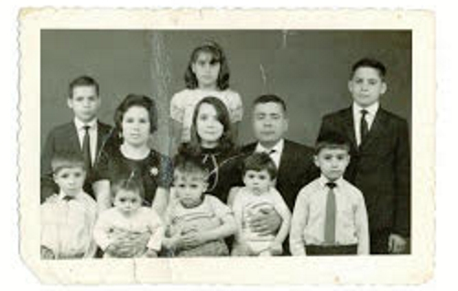
The Gindi family

They Almost Escaped
“The truth is that we could have left Syria at the end of the ’60s. My father,Yaakov, contacted a local smuggler who, it was said, could get us into Turkey, which was the country closest to Aleppo. He’d already paid him several thousand dollars, but a few hours before we left, Rabbi Yosef Shasho came to our house. He was a relative, and he was upset with my father for wanting to flee. He told him that if we left, my father’s brother would be imprisoned and sent to jail immediately, and his wife and children would have to be supported by other families. My father heard what he had to say. Instead of arguing or sidestepping, he went into his room, took off his traveling clothes, and let us know that we weren’t going anywhere.

“I remember turning to him and asking what had happened, and when he let me know that we wouldn’t be leaving, I burst out crying. I felt like I’d been sentenced to many more long years in prison. At 10 o’clock that night, the smuggler came to ask us if we were ready. My father told him that we weren’t going, and that he was prepared to forfeit the money he’d already paid. The surprised smuggler tried to convince him to change his mind, but my father insisted that he wasn’t going and that the discussion was over.
“We had to go around collecting all the furniture that we’d given away to our relatives and friends. But a week later, we saw that we’d experienced a miracle. The family we’d been planning to go with had been caught and imprisoned. We later learned that the smuggler had been caught earlier by the police, and in exchange for leniency he’d agreed to hand over the families that were trying to escape. So we were saved by my father’s good-heartedness.”

The Murder
Five years later, in 1973, when more and more Jews were fleeing and there were almost no students left in Yom Tov’s class, he realized that he had to do something. The Mukhabarat was more aggressive than before, as the number of people fleeing was growing. They announced that every Jew who was caught would be punished severely, and if someone got away, his parents would be punished. In spite of that, Yom Tov never stopped thinking about following in the footsteps of his oldest brother, who had already left. “I wasn’t worried about my parents, because I thought I knew how to absolve them of responsibility: my father would go of his own volition to the police station and let them know that I’d left home and hadn’t returned.”
The reason he decided to leave then was an incident involving relatives of the Gindis, the Katzavs. An Arab had knocked on the Katzavs’ front door, and when Mr. Katzav opened the door, the Arab shot him to death. “The Mukhabarat didn’t leave us alone. They followed us to the mourner’s home to listen to our conversation. This incensed me, and I yelled at them to leave.” The tension was thick, and Yom Tov could have been arrested and charged, but the Mukhabarat agents were feeling uncomfortable, and they left without doing anything to him. “That was the moment that I decided that I was going to leave Syria. I was sick of living like a prisoner,” he says.
Yom Tov contacted a local smuggler and arranged a meeting. They met in the marketplace, and agreed that Yom Tov and his two sisters would go the next night to the smuggler’s home, which was above the market, and go from there to Lebanon. The next day, crying bitter tears, the threesome said goodbye to their family. Then they wandered around the marketplace, to make sure no one was tailing them, before they went to the smuggler’s house. The young Gindis received forged Syrian identity cards bearing their pictures, and were told to memorize the identification numbers inside.
That night, the smuggler phoned for a taxi to Beirut. There was a breathtaking moment when they left the city on their way to the interstate leading to Beirut. A commander of the Mukhabarat group that Yom Tov had yelled at in the Katzavs’ house stopped next to them at a traffic light. Miraculously, the agent didn’t look around and didn’t notice Yom Tov. “If he’d recognized me, I’m sure that our escape would have been foiled, and we would have been in for some very bad treatment.”
The taxi drove southwest for five hours to the Syrian-Lebanese border. There was absolute silence in the car, to make sure the driver wouldn’t know whom he was driving. When they got to the border, the smuggler took their passports to border control and explained that the people he was with had fallen asleep during the long trip. “We were intensely anxious, but we closed our eyes and pretended to be asleep. Those few minutes were the longest in my life. I felt a spotlight shining on me. The light stayed on my face for several seconds and then moved on. When the light was gone, and the border patrolman’s footsteps were receding, I knew that we’d been saved.
“A few minutes later, the smuggler came and told the driver that we could cross into Lebanon. We still pretended to be asleep, but we could hear perfectly well the gate lifting and the driver putting his foot to the gas pedal. When we crossed the border, we knew that finally we were free.”

An Emotional Homecoming
An hour later they were in a safe house in Beirut, drinking steaming cups of tea. At six in the morning the smuggler dropped them off at the city’s central synagogue and disappeared.
Even though they’d successfully escaped Syria, their journey wasn’t over. Now they had to hide in the synagogue in Beirut, as there was danger that confederates of the Syrian Mukhabarat would capture them and return them to their homeland. “A year earlier, a young man from Aleppo wandered too freely in Beirut and was captured. That was enough to warn us that the shadow of the Mukhabarat still loomed over us.”
For a full month they hid in the synagogue and didn’t go out. Then the Mossad (Israeli intelligence service) arranged to evacuate them to Paris. This is the only part of the story Yom Tov refuses to tell, since the details are still secret. A short time after they arrived in Paris they flew to Israel, and four and a half hours later their dream came true—they landed in the Holy Land and bent to kiss the ground.

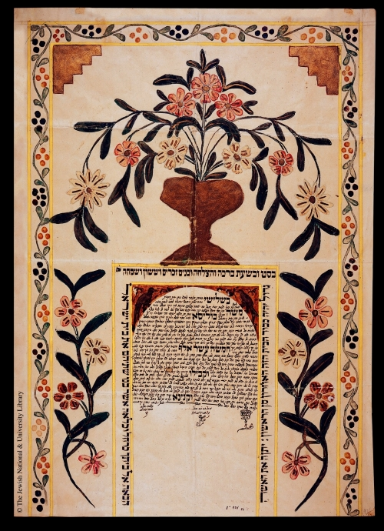
A Ketubah from Syria.

“The most touching moment in the new land was seeing a soldier enter a synagogue for prayers. . . . Then I knew that I was finally in a Jewish land.”
But as he was acclimating to Israel, first in an immigrant absorption center in Mevasseret Zion, then as an aircraft engineer in the air force, and still later as a resident of Kfar Chabad, his parents were suffering in Syria.
“The day after we left, my father went to the police station to let them know that I and my two sisters were missing. The police, who understood immediately what was happening, took him to be interrogated by the Mukhabarat. But there was a mini-revolution going on in Syria at the time, which helped him—he was forgotten in the holding cell. A few days later, my uncle, who was also being held because his children had fled, paid the Mukhabarat a fortune for his freedom, and he had my father included in the ‘deal.’”
His father managed to escape Syria only several years later, when he had to fly abroad for “medical treatment,” with one of the first passports issued to Jews in decades.

A few years later, Yom Tov’s mother and her six children remaining in Syria managed to enter Turkey and reunite in Kfar Chabad with Yom Tov and his brother Avraham, who had come to Israel before him and established residence there.

Russia and Syria
Except for 20 or 30 souls, all remaining Jews left Syria when Hafez al-Assad opened the doors in the early ’90s.
Yom Tov concludes with one last thought: “A few years ago I found the transcript of a speech that the Lubavitcher Rebbe gave in his synagogue, ‘770,’ in the year 1990. In it he predicted that the gates of Russia were about to open, and he also mentioned that Syrian Jews would soon receive their freedom. The opening of the gates of Syria was an open miracle. Thank G-d, we are free!”

Reprinted from the Parshas Chukat 5776 email of Chabad.Org. Magazine.

