Parshas Reieh –ראה אנכי נותן לפניכם היום ברכה וקללה
Living with ברכה
Why does the Torah emphasize the understanding of ברכה וקללה, as something to do היום? How much contemplation is needed, to see that one thing is ברכה, while the alternative is קללה? I heard from my brother, הי"ו, that RavEliyashev, zt”l, wrote that having a perfect memory of all life’s experiences, is not such an advantage. A person will always recall all his failures and disappointments. The pain and trauma of tragic loss and upheaval would never diminish. One might think it an advantage, though, that the blessings of good times and חסדי ה', would always be fresh. We would be ever appreciative and inspired, with our הכרת הטוב to the Eibishter, always in the fore. However, RavEliyashev pointed out, human nature being such as it is, a person’s enthusiasm and appreciation never lasts for long, especially in the face of sad and bitter recollections. With a perfect memory, a person would ultimately slip back into reflecting on and obsessing about all the bad things.
How then, do we manage to balance the appreciation for good times and the bitterness of life’s disappointments? By focusing on היום – making the best of today. I hope to celebrate this day’s successes, while setting aside yesterday’s frustrations. What was, was. “Farfallen”, as we say in Yiddish. Let’s go on with היום, and face forward.
ברכה and קללה, are also subject to a person’s perspective. One may “have it all”, yet it’s no ברכה, if he is always fearful of loss and whatever else the future holds. Some people don’t have it so good, yet, somehow they feel blessed with the small things in life.
Before there was the entertainment and Geshmock of Lipa Schmeltzer, my family had Uncle Lipa. He was always the life of the party. Ours, was a close-knit family. We were forever getting together and enjoying each other’s company. He loved kitzelling the kids with his whimsical limericks and sayings. The grownups weren’t spared from his antics either. His energy and spark, was easily discernable in his learning as well. How he loved a good Vort. He would repeat it and explain it, like some people enjoy recounting the play-by-play of some memorable baseball game. Uncle Lipa loved following baseball too. Yet, when he spoke of whom he idolized and venerated, he spoke of this Rov and that Rosh Yeshiva. He recounted the Shiurim he attended or gave, and was always proud of the opportunities he had to rub shoulders with distinguished TalmideiChachomim. He was always interested to hear what we were learning. When any of us kids spent a Shabbos with Uncle Lipa, we would be treated to Seudos replete with learning and Divrei Torah.
Uncle Lipa lived to 102, with the Brocha of R’ ShayalehKeristirer, ztvk”l. He was born to a world in turmoil, moving through two world wars and the obliteration of the idyllic life of Hungarian Yiddishkeit. He was married before the war, but lost his wife and only child, a five year old son in Auschwitz, along with his beloved parents and most of their children and grandchildren. He married again, in DP camp, but lost his second wife and baby daughter to illness, shortly after. He had no children from his third marriage. After my aunt passed away, he remained a widower for the last, many years. Left alone in the world, he moved from Washington Heights to Boro Park, to be close to us, his only remaining family. There, he grew old and suffered from failing sight and hearing. Yet, he remained sharp as ever, always coming alive when he shared a Vort or asked about our learning. Uncle Lipa was brought to מנוחה נכונהtoday, in Eretz Yisroel, as these words were being written.
Was this a life of ברכה or קללה? Says the Torah, את הברכה אשר תשמעו אל מצות ה'. ברכה is, to be a person who lives a life of תשמעו אל מצות ה'. Uncle Lipa, despite the upheaval and sadness, was usually upbeat and positive. He was busy with a life of תשמעו אל מצות ה'. והקללה אם לא תשמעו אלמצות ה' – someone may have everything good in this world, yet, if he chooses the path of לא תשמעו אל מצות ה', what is his life worth?
Did Uncle Lipa have a life of hardship? No question. We should never know from it. Did he have a life of ברכה? Most assuredly. He and all the Survivors, of that great generation, lived and continue to live with היום – today is my best opportunity to move forward. What was, was. “Farfallen”. They are the אשר תשמעוYidden, who are eternally proud and grateful for the Nachas of new generations of שומרי תורה ומצוות, who will continue living with ברכה, עד ביאת גואל.יהי זכרו ברוך. Have a wonderful Shabbos and a Gebenshtחודש, yk
L’RavchaD’Milsa Weekly Almanac
Thursday, Parshas Rieih - 28 Av
Yom Kippur KattanMukdam
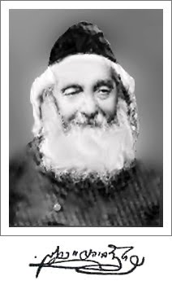
Rav Naftali Tzvi Yehuda Berlin, the Netziv, (1817-1893). He was born in Mir, the son-in-law of Rav Isaac, son of Rav Chaim of Volozhin (1749-1821) he married the granddaughter of Rav Chaim Volozhiner when he was 14 years old. In 1849 the Netziv was appointed Rosh Yeshiva of Volozin, a position he held for 40 years. Volozhin was forcibly closed by the Russians in 1893. He wrote HaamekDavar, a commentary on the Chumash, HaamekShe’elah on the She’eltos of RavAchaiGaon, and MeshivDavar, a collection of his responsa. Among his children were Rabbi Chaim Berlin and Rabbi Meir Bar-Ilan.

Rav Avraham Chaim Ades (1848-1925), born in Halab (Aram Soba), Syria, among the most ancient Jewish communities in the world. According to tradition, Jews lived there even before the destruction of the first BeisHamikdash. As a youngster, Rav Avraham studied under RavMordecahiAbadi and Rav Ezra TawillHakohen. At the age of 20, he married the daughter of Rav Moshe Swed, rav of Aram Soba. In 1896, Rav Avraham immigrated to EretzYisrael and settled in Yerushalayim. Soon after his arrival, he learned at RechovotHanahar, a kabbala yeshiva in the Bucharian neighborhood. Among his students were Rav Yosef YedidHalevi, Rav Shlomo Raphael Laniado, Rav Ezra Chamawi, Rav Ezra Attia (later to become rosh yeshiva of Porat Yosef), and Rav Yaakov Katzin.
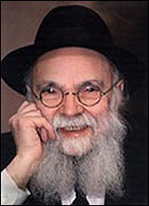
Rav Avraham Yaakov HaKohen Pam (1913-2001). Rav Pam’s father, Rav Meir, was a product of Soloboka and Radin. As a child, Rav Pam studied in Kovna. His family later moved to the United States, where his father was appointed to the faculty of Rabbenu Chaim Berlin yeshiva. At thirteen, he began to study in Torah VoDaas. He became very close with the rosh yeshiva, RavDovidLebowitz, and R’ ShragaFeivelMendelowitz. After his marriage, he taught at Torah VoDaas for 60 years. After the petirah of Rav Moshe Feinstein, he was appointed president of ChinuchAtzmai in the United States. He was also a member of the presidium of the largest Torah organization in America, Torah Umesorah. He founded the Shuvu organization for the chinuch of Russian children in EretzYisrael.
Erev Shabbos Kodesh Parshas Rieih – 29 Menachem Av-Erev Rosh ChodeshEllul
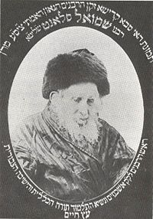
Rav Shmuel Salant, Rav of Yerushalayim (1816-1909). Born in Bialystok, Russia, his father passed away soon afterwards, and he was sent off to study in Salant, Lithuania, where it had already been arranged that he would eventually marry Toiba, the oldest daughter of Rav Yosef Zundel of Salant, from whom Rav Shmuel took his surname. Soon after his marriage, Rav Shmuel moved to Volozhin, where he was appointed magid shiur. He made aliyah in 1841. From 1848 to 1851, Rav Shmuel served the Yerushalayim community as a meshulach. In 1878, he was voted as the chief Ashkenazi rav of Yerushalayim to replace Rav Meir Auerbach who had just passed away.Rav Shmuel Salant managed to unify the many groups of Azhkenazim of Yerushalayim, and to lead them successfully for 50 years.
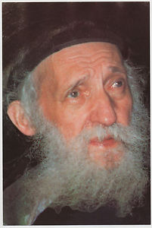
Rav Eliezer Zusia Portugal, the SkulenerRebbe (1897-1982), from a small town, Sculeni (Skulen), in what was then northeastern Romania (now Ukraine). Just 18 years of age when his father died, he became Rav of the town, a position he held for 20 years. The thenSadigererRebbe persuaded the Rebbe to relocate to the large Jewish center of Chernovitz, home to a Jewish population numbering many thousands, to oversee Jewish education there. Toward the end of World War II, in March of 1945, he found himself, along with other holocaust survivors and displaced persons, in the Russian-governed town of Czernovitz, Bukovina. Rav Portugal was particularly known for his work on behalf of Holocaust orphans and for his spiritual resistance against Romania's communist government. In 1962, he launched the crowning glory of his life's work - the Torah network of Chesed L'Avraham in EretzYisrael, which eventually expanded to a number of Chesed homes and schools for hundreds of children from various tragic backgrounds, as well as a countrywide network of afternoon programs for children in public schools. Hundreds of thousands of children have gone through its ranks.

Sunday, Parshas Shoftim-2 Ellul
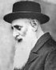
Rav Eliezer Hager of Vizhnitz, the Damesek Eliezer, born to the “AhavasYisrael” of Vizhnitz, a small town in Bukovina on the eastern slopes of the Capathian Mountains. He married Chava, daughter of Rav Yitzchak Meir of Kapishnitz (1891-1946)

Monday, Parshas Shoftim-3 Ellul
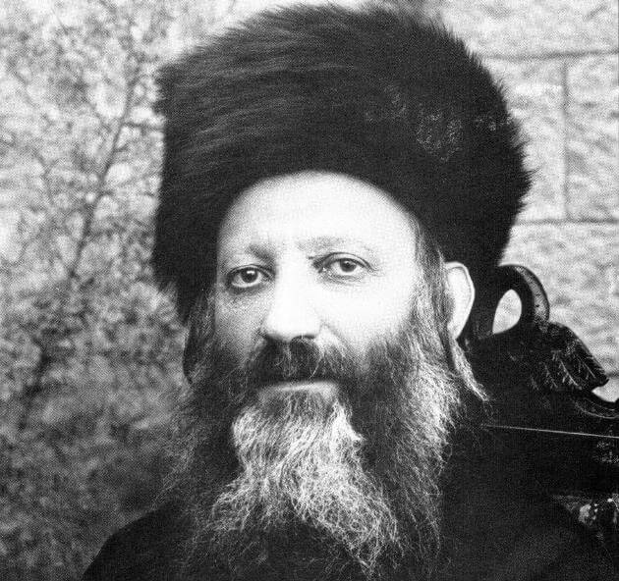
Rav Avraham Yitzchak Kook, (1865-1935). Chief Rabbi of Israel for 19 years of his life. The first chief rabbi of what was then Palestine, Rav Kook was perhaps the most misunderstood figure of his time. Born in Latvia of staunch Chassidic and Misnagid stock, he retained throughout his life a unique blend of the mystical and the rational. He was a thorough master of the entire Halachic, Midrashic, philosophic, ethical, and Kabbalistic literature. He saw the return to EretzYisrael as not merely a political phenomenon to save Jews from persecution, but an event of extraordinary historical and theological significance. Rabbi Hutner once said that Rav Kook peered down on our world from great heights and hence his perspective was unique. Above all, Rav Kook pulsated with a sense of the Divine. Though keenly aware of the huge numbers of non-observant Jews, he had a vision of the repentance of the nation. His concept of repentance envisioned in addition to the repentance of the individual, a repentance of the nation as a whole; a repentance which would be joyous and healing. He refused to reject Jews as long as they identified themselves as Jews. He called for and envisioned a spiritual renaissance where "the ancient would be renewed and the new would be sanctified."
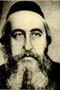
Rav Moshe Friedman (known as “RavMoishenu”) of Boyan-Cracow (1881-1943). A son of Rav Shalom Yosef of Husyatin and great-grandson of RavYisrael of Rizhin, he married his cousin, Miriam, whose father, Rav Menachem Nachum of Boyan-Tchernowitz, was the son of the Pachad Yitzchak of Boyna. After the wedding, they lived with the Pachad Yitzchak in Boyan for 13 years. In 1934, Rav Meir Shapiro of Lublin passed away, and RavMoishenu replaced him. He lived in Cracow, and then Tarno in 1940. On the 2nd of Elul of 1943, he and 7000 Jews of Tarna were sealed into cattle cars and taken to Aushwitz; the survivors of the trip, including RavMoishenu, were gassed to death.

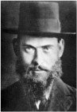
RavShragaFeivelMendelowitz (1886-1948). Pursuing his dream, to “dot the American continent with Hebrew day schools," he founded Torah Umessorah, and he established his "BaisHamidrashl'Mechanchim" in Monsey, NY, as well as Yeshiva Torah Vodaas.

Tuesday, Parshas Shoftim-4 Ellul
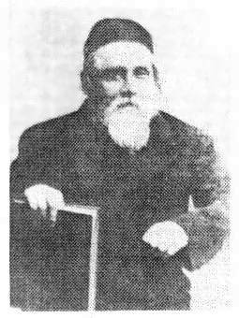
Rav Meir Simcha Hakohen of Dvinsk, the Ohr Someach and MeshechChochma (1843-1926). In a famous near prophetic passage written before 1926, he presents a brilliant theory of Jewish history in exile and refers to those who forget their origins and think “Berlin is Jerusalem”, and are doomed to destruction (B’chukosai). R' Meir Simcha served as Rabbi of Dvinsk for nearly 40 years. R' Meir Simcha was a strong supporter of the settlement of EretzYisrael and greeted the Balfour Declaration with enthusiasm. In 1906 he was offered the position of rabbi of Jerusalem but bowed to the entreaties of his congregants to remain in Dvinsk.

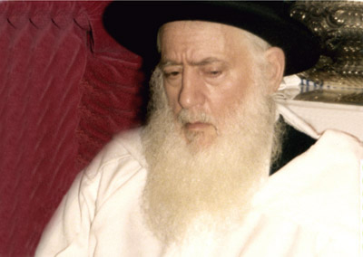
Rav Moshe Aharon Pinto (1995), heeding his father’s command to avoid temporal pleasures, secluded himself in his home for forty years and living on almost nothing but scraps of bread dipped in oil. After these 40 years, he traveled, explaining, “Hashem created a beautiful world. What will I tell Him when He asks me after 120 years whether I witnessed and appreciated the wonders of His creation?” Rav Moshe Aharon’s descendants have printed and distributed thousands of copies of the “Perek Shira” that describes how every creature is part of a worldwide symphony of Hashem’s praise. Rav Moshe Aharon’s oldest son, Rav Chaim is the rav of Ashdod, and Rav Chaim’s son, RavYoshiyahu Yosef, has created the “ShuvahYisrael” organization, which draws many youngsters back to Torah and mitzvos. Another of Rav Moshe Aharon’s sons, Rav Yaakov, traveled to America after Rav Moshe Aharon’s passing and founded the Pinto Center in Los Angeles during the 1980s. He is president of the “Netivei Chaim veMoshe Pinto” Institutions that he and his brothers established in Ashdod, which include a beismedrash, a supermarket and kitchen for the needy, a publishing house, and much more.

Subscription to the weekly Timely Messages Dvar Torah/L’RavchaD’Milsa Weekly Almanac at
timelymessagesweekly@gmail.com and now available for download at www.parshasheets.com

