Parshas Chukas –אדם כי ימות באהלזאת התורה
Living Torah
What is the most important thing in your life? Undoubtedly, your health, family and happiness are life’s priorities. Yet, I am sure, any observant Yid with a semblance of אמונה פשוטה, will acknowledge that Torah is above all else. כי הם חיינו ואורך ימינו. It’s not just a slogan. The Gemara in Brochos relates how Pappus ben Yehuda questioned the wisdom of R’ Akiva’s defiance of the Roman authorities. R’ Akiva continued to conduct Shiurim in public, despite the threat of execution for Torah study. R’ Akiva responded with the famous Moshol of the wily fox who tried to coax the fish to jump out of the river onto dry land, to escape the fisherman’s nets. We thought foxes are smart, answered the fish. If our lives are in danger in the water, where we thrive, how foolish to think that we are better off on land, where we are sure to die. So too is our destiny, explained R’ Akiva. We cannot live without Torah – כי הוא חייך.
The great Telzer Rosh Yeshiva, R’ Mordechai Gifter zt”l, asked why a whole story of a fox, fishes and nets was necessary to explain that a Yid’s life is worthless without Torah. Why didn’t R’ Akiva just get to the point,without the Moshol? We can’t live without Torah!RavGifter explained that this Moshol adds a deep insight on the world “out there”. When a fish does end up out of the water, it flips and jumps around before it becomes still. If you didn’t know better, you would think this fish is jumping with excitement, now that is not held back by the current of the water. It is waving its fins and tail around, seemingly getting a feel for a life of freedom. The sad truth is, this fish is in the throes of death. These movements are a last desperate attempt to connect with a source of sustenance. RavGifter saw in that fish, the person who made the unfortunate choice of jumping out of the life-giving waters of Torah, and is now casting about in a dry, arid world, devoid of Kedushah. His cavorting and enthrallment with life’s pleasures, appear like he is finally alive and free to imbibe of the colorful, exciting world, beyond the BaisHaMedrash. Sadly, though, this Neshomoh is desperately and futilely flittingaround to find a life source that will serve as an adequate replacement for the Torah that this Neshomoh so urgently needs for its nourishment. That search will never end in true happiness. By being disconnected from Torah, he is doomed to filling his years in this world with pursuits of minimal value, with little to account for, at the end of his days.
R’ SholomShvadron, zt”l used to tell over the KelmerMagid’s imaginary tale of the two hour reprieve extended to the Niftorim in the vast, ancient cemetery of Biyalostok. For two hours only, all the dearly departed of Biyalostok, were permitted to rejoin the ranks of the living. Family members ran to embrace their long lost, loved ones. Youngsters were thrust into the arms of great and greater grandparents. The returning souls were entreated to come home and dine or visit with long-separated or newly introduced relatives. A carnival atmosphere ensued. Yet, the Niftorim would have none of it. Only two hours and the minutes are ticking by. The throng of revived Yidden headed, en masse, to the Shuls, Yeshivos and Batei Midrashim and commenced learning whatever they could lay their hands on. When they were all filled to capacity, they ran into the houses to seek out a sefer, any sefer, to learn from. There was no time to waste. Little attention was paid to family and friends. Of what value is there to mundane and trivial, fleeting interests and concerns? With only minutes to spare, all else is insignificant and inconsequential. We have to “chap arein” while we can. We have a chance to grab what we can of Torah, the most precious commodity. We can’t afford to waste this small gift of precious time.
What about us? Should we squander our days and years, just because time is on our side? “Un VerVais?” – and who knows, the Magid would conclude, chillingly.
R’ Akivacountered Pappus ben Yehuda’s skepticism. You are overflowing with wealth. You are a person of great importance and influence. The world, it seems, is in the palm of your hand. Those who cling to Torah, however, are forced into hiding. We are victims of persecution and the subject of ridicule. It seems a bleak existence. Yet, we are truly alive. Maybe all the action seems to be out there and it feels like you are living life to the hilt. Torah, though, is Toras Chaim. It’s where the action really is.
Have a wonderful Shabbos, yk
L’RavchaD’Milsa Weekly Almanac
Erev Shabbos, Parshas Chukas - 9 Tamuz
There is a Mesorah that some individuals fast on Erev Shabbos Chukas for theburning of 24 wagonloads of Seforim in France in 1244 that took place on ErevShabbos Chukas. The day corresponded with the already tragic day of 9 Tamuz.However it was pinned to Erev Shabbos Chukas after the GedolaiHador entreatedthe heavens to find the cause of this calamity through a שאלת חלום, a mystical dream query. The responsewas דא גזירת אורייתא, the Targum of the opening words of the week’s Parsha – זאת חקת התורה
The walls of Yerushalayim were breached by the forces of Nevuchadnetzar and TzidkiyahuHamelech was captured as he tried to escape through a tunnel leading to Yericho. During the seventy years of GalusBavel this day was observed as a Fast Day. After the breaching of the walls on 17 Tamuz by BayisSheini, that day was established for fasting for both incidents in order to avoid two fasts so close together. The Yerushalmi states that 17 Tamuz was the actual date of both breachings only this was mixed up in the confusion of the difficult times then.
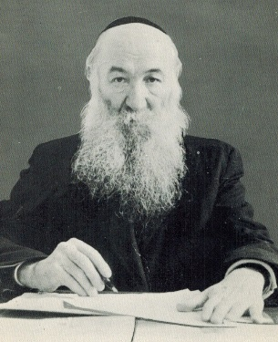
RavZalmanSorotzkin,
LutzkerRav, author of OznaimL'Torah (1966).

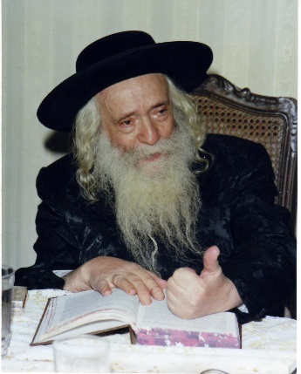
RavYekusiel Yehuda Halberstam, the KlausenbergerRebbe(1994), great-grandson of the Divrei Chaim of Sanz. He spent most of World War II in concentration camps. During his last 15 years of life, he founded Kollelei Shas in EretzYisrael and America. These Kollelei Shas were intended for premier avreichim who were already known for their sharp intellect and hasmada. The goal of the kollel was that in the course of three years, the members had to complete the entire Shas. Every member had to obligate himself to be tested on 75 blatt Gemara with Tosafos each month and know them by heart! The, in 1983, at his house in KiryatSanz, Netanya, he laid the cornerstone for what would ultimately become MifalHaShas, where avreichim would learn 30 blatt of Gemara with Tosafos with a built-in review program and be tested monthly on the material learned. Having survived the horror of witnessing the murder of his wife and their 11 children, Reb Yekusiel vowed to dedicate his life to welfare and good health of all Jewish children. He founded Laniado Hospital in Netanya in 1975 after 15 years of fund-raising. His vision of a proper Jewish hospital was confirmed in 1990, as it was one of the only hospitals in Israel to have every employee working during the 127-day doctors’ strike. After his petira, his eldest surviving son, RavZviElimelechHalberstam, became the new SanzRebbe in Israel, as well as President of the Hospital.
Sunday, Parshas Balak – 11 Tamuz
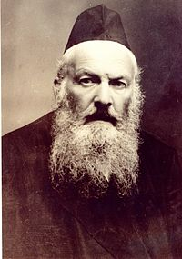
RavElchononBunim Wasserman
Author of KovetzShiurim, KovetzHeorot, KovetzMaamarim and IkvesaD'Meshicha. He learned at Telshe under Rav Eliezer Gordon and Rav Shimon Shkop, then lived with and learned from R’ Chaim Soleveitchik from 1897 to 1899. He learned from the Chafetz Chaim 1907-10, becoming his closest disciple, then went to Brisk to be Rosh Yeshiva. He became Rosh Yeshiva of Brananovich after WW1 in 1920 until he was murdered Al Kiddush Hashem in 1941.

Monday, Parshas Balak- 12 Tamuz
Rabbeinu Yaakov ben Asher, the Baal Haturim (1340), son of the Rosh. The many commentators on the Tur include those of Rav Yosef Karo (the Beis Yosef), Rav Moshe Isserles (Darkei Moshe), RavYoelSirkes (The BeisChadash), Rav Yehoshua Falk (DerishahuPerishah), and Rav Yosef Escapa (the Rosh Yosef), who deals with only a part of the work. The Chida comments that without a proper study of the Tur and its commentaries, one cannot begin to determine halachah.
Wednesday, Parshas Balak – 14 Tamuz
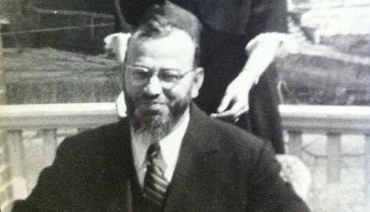
Rav Yaakov HaleviRuderman, (1901-1987) Rosh Yesiva of Ner Israel, Baltimore. Born on Shushan Purim in 1901 in Dolhinov, Russia; studied in Yeshivas Knesset Yisrael in Slobodka, then headed by RavNossonZviFinkel (the Alter) and Rav Moshe Mordechai Epstein. Among his colleagues in Slobodka were Rav Reuven Grozovsky; RavRuderman's first cousin, Rav Yaakov Kamenetsky; RavAharon Kotler; Rav Yitzchak Hutner; In ~1926, RavRuderman published his only written work, AvodasHalevi. In 1930, RavRuderman joined his father-in-law, RavSheftel Kramer, at the latter's yeshiva in Cleveland. In 1933, RavRuderman moved to Baltimore and founded the Ner Israel yeshiva, leading that yeshiva for 54 years until his passing. His death in 1987 followed less than one-and-a-half years after the passing of RavKaminetzky and Rav Moshe Feinstein. Posthumously, RavRuderman's students have published two volumes of his teachings: Sichos Levi contains mussar/ethical insights based on the weekly parashah, while Mas'as Levi contains lectures on the 19th century work MinchasChinuch and other Tamudic and halachic insights.
Thursday, Parshas Balak – 15 Tamuz
Rav Chaim ben Atar, the Or HaChaimHakadosh, (1696-1743). Born into a well-respected family in Sali, Morocco, Rav Chaim spent his early years learning with his grandfather, whose name he shared. Rav Chaim's dream was to go to Israel. With 30 followers he arrived in Israel, four days before Rosh HaShanah in 1742 and settled in Acco. Rav Chaim and his students spent Yom Kippur in the cave of EliyahuHaNavi on Mount Carmel. Purim was spent in Tzfat and Miron, where a great deal of time was spent studying the holy Zohar. On the 15th of Elul of 1743, Rav Chaim finally arrived in Jerusalem with his group. He immediately established a yeshiva called KnessesYisrael and second secretive yeshiva for the study of Kabbalah. One of his new students was Rav Chaim Yosef DovidAzulai, the Chida, who at that time was only 18 years old.
RavAryehLeibGinzberg, the ShaagasAryeh (1695-1785). Born in Pinsk, he was the son of Rav Asher, Av Beis Din of Pinsk. When he was still young, his family moved to Minsk. A widow in the city had a complete set of the Shas in her home and would loan masechtos to any talmidchacham who needed them. When AryehLeib was still a child, he borrowed masechtos from her. Thus, every day, he would complete one masechta, and then ask her to exchange it for a different one. In 1725, when he was only thirty, RavAryehLeib was invited to serve as the Rosh Yeshivah of Minsk, but the laypersons forced him out, since he was unashamed to rebuke them when he felt that it was necessary. Shortly afterwards, he was invited to serve as Rav of Volozhin (where he authored ShaagasAryeh), and later in Metz, Germany. Prior to his petirah, the ShaagasAryeh made a siyum of Shas, which he had reviewed one thousand times during his lifetime.
Subscription to the weekly Timely Messages Dvar Torah/L’RavchaD’Milsa Weekly Almanac at
timelymessagesweekly@gmail.com and now available for download at www.parshasheets.com

